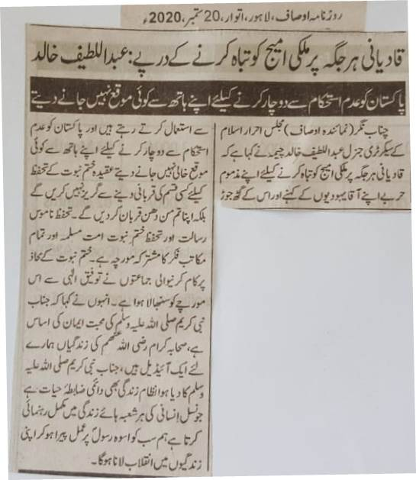
Qadianis strive to ruin the image of country everywhere: Abdul Latif Khalid
They don't waste any opportunity of destabilizing the country.
Chenab Nagar (Ausaf Correspondent) The secretary general of Majlid Ahrar e Islam has said that Qadianis frequently use nefarious tactics to ruin the image of country with the instructions and nexus of their Jewish masters. We will not step back from scarifying anything for the protection of the faith of Khatm e Nabuwat. Protection of Khatm e Nabuwat and honour of Holy Prophet PBUH are the joint trenches of Muslim community and all schools of thoughts. With the blessings of God, servants of Khatm e Nabuwat has controlled that trench. Devotion to Holy Prophet (PBUH) is a base of belief. Lives of the companions of Holy Prophet (PBUH) are ideal for us. System that was blessed by Holy Prophet (PBUH) is everlasting. It guides us in all parts of life. We will have to bring revolution in our lives by following the footsteps of Holy Prophet (PBUH).
(Daily Ausaf, Lahore, Sunday, 20th September, 2020)

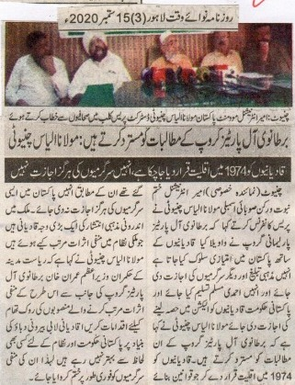
We reject the demands made by the All Parties British Group: Maulana Ilyas Chinioti
Qadianis have been declared a minority in 1974; they have no right to continue their activities
Chiniot (Special Correspondent) Ameer international Khatm e Nabuwat and member of the provincial assembly Maulana Ilyas Chinioti told the press that British All Parties Parliamentarian Group professed that Qadianis are being mistreated in Pakistan. They should be allowed to continue their religious activities and be accepted as the Ahmadiyya Muslim Community. The Government should also allow them to partake in the elections. Maulana said that we reject the demands made by the All Parties British Group. Qadianis have been declared a minority in 1974; they have no right to continue such activities in Pakistan. A major reason for disorder in the county is owed to Qadianis. They are a negative impact on the [progress] and system of the country. He said that the Prime Minister Imran Khan, who claims to follow in the footsteps of the State of Medina, ought to take action against similar ploys as aforementioned which seek to demean [this nation]. Owed to their connection with the outside world, Qadiani lobby has never been a source of peace for the system prevalent in Pakistan and thus their conniving activities ought to be stopped.
(Daily Nawa i Waqt Lahore, Page 3, 15th September, 2020)

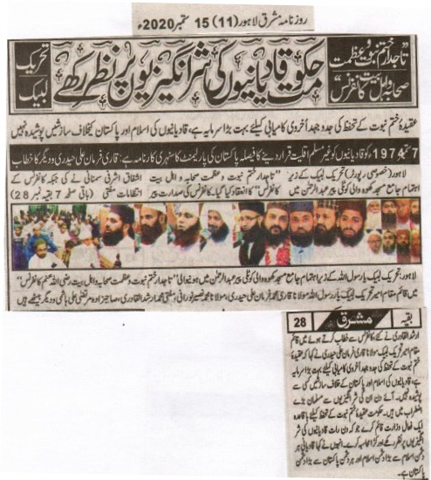

In the honour of Khatm e Nabuwat, the companions and the family of the Holy Prophet^{sa}.
The government ought to keep a look out on the nefarious activities and ploys of Qadianis: Tehreek e Labaiyak
To strive for the protection of Khatm e Nabuwat is akin to success in the Hereafter. Qadianis conspiracies against Pakistan and Islam are not hidden from anyone’s sight.
To declare Qadianis a non-Muslims entity on 7 September 1947 is a magnificent decision by the Pakistan Parliament: Qari Farman Ali Haidri and others
Lahore (Special Correspondent): A conference in the honour of Khatm e Nabuwat, the companions and the family of the Holy Prophet^{sa} was organised by Tehreek e Labaiyak at Jami Masjid Khoo Wali Kotli Pir Abdur Rehman. It was presided over by Pir Ishfaq Ashrafi Samnani and Mufti Arshad Al Qadri made the arrangements. Talking at the conference, the acting Ameer Tehreek Labaiyak Maulana Qari Farman Ali Haidri said that to strive for the protection of Khatm e Nabuwat is akin to success in the Hereafter. Qadianis conspiracies against Pakistan and Islam are not hidden from anyone’s sight. Muslims feel anxious at witnessing such activities. The government should form a ministry which should keep a lookout at all the nefarious activities and ploys of Qadianis and hold the responsible for it in the strict manner. He said that a Qadiani is the worst enemy of Islam and Pakistan.
(Daily Mashriq Lahore, Page 11, September 15th 2020)

