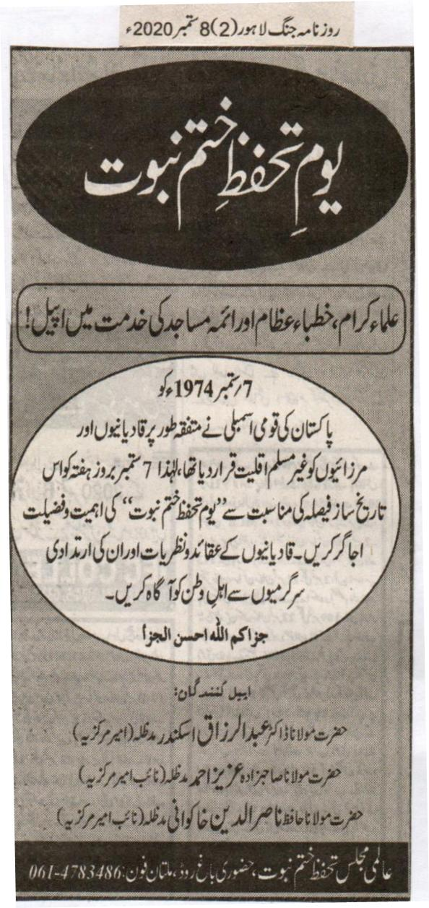
Yome Tahaffuz e Khatame Nubuwat

Appeal to Ulemas, Imams of the mosque and those who deliver sermon
On 7 September 1947, Pakistan's national assembly unanimously declared Qadianis and Mirzais non Muslim minority. Therefore, on Saturday September 7 rekindle the importance and virtue of the historic decision aforementioned. Inform people of this nation of their (Qadianis) beliefs and conspiracies.
Appeal from:
Hazrat Maulana Doctor Abdul Razzaq Sikander (Ameer Markaziya)
Hazrat Maulana Sahibzada Azeez Ahmad (Naib Ameer Markaziya)
Hazrat Maulana Hafiz Nasir ud Din Khakwani (Naib Ameer Markaziya)

(Daily Jang, Lahore, 8th September, 2020)

If someone tries to amend the law pertaining to the sanctity of the Prophet Hood, we will go to extreme lengths [to defend it]: Fazl ur Rehman
Mandate has been stolen, we will not stop; we will continue till we achieve our goals. We will also listen to the views of other parties in the all parties conference: Speech delivered in Peshawar
No one can meddle with the Khatm e Nabuwat Law; Sajid Mir, Maulana Asad Mahmood gave suggestions to leave posts at the assembly.

Peshawar (Staff Reporter): Leader Jamiat Ulema e Islam Fazl ur Rehman has stated if someone tries to amend the law pertaining to the sanctity of the Prophet Hood, we will go to extreme lengths [to defend it]. No matter what the government tries to conspire, we will serve as a wall against their ploys. The mandate that was stolen in 2018 can be witnessed today in this congregation before everyone. Hence, the government institutions need to stop [their conspiracies]. He expressed these views whilst delivering his speech at Khatm e Nabuwat Conference held in Peshawar. Maulana Asad Mahmood suggested resigning from the Assembly. Maulana Fazl ur Rehmad said that what they have began in Peshawar will not stop and the similar congregations will be held in other cities as well.. We will achieve our goals no matter what we face. For this, we will also listen to the views and opinions of the other parties at the all parties’ conference. He said that there are those who deny Khatm e Nabuwat and despite being a non-Muslim, continue to adopt Islamic principles. 40 members of the British Parliament have signed a report from the year 1954 to 2018. The report claims Qadianis as being persecuted [in Pakistan]. Why is Pakistan silent on this matter? Britian used to rule the subcontinent but our elders ensured that the British rule ended. It is surprising to see Pakistan and the rulers’ silent on the matter. Something seems vague; in fact something is definitely not right. He said that if Qadianis choose to remain as non-Muslims then we have no quarrel with them. If Sufi Muhammad and Taliban are considered traitors to this nation for not following the constitution then why aren't Qadianis considered the same? There is news of accepting Israel and defending Jews and following them. This congregation is a message to the world that it will not let anyone take control of Pakistan's constitution and Law. Allama Sajid Mir, Markazi Ameer Jamiat Ahl e Hadith said that as long as the defenders of Khatme Nabuwat remain no one can dare to lay their hand on this amendment. Maulana Abdul Qasih, Maulana Abdul Ghafoor Haider, Maulana Syed Shah Ahmad Awais Noorani, Maulana Atta ur Rehman, Maulana Amjad Ali Khan and Mufti Shahabuddin Popalzai also delivered their speeches. On this occasion, Maulana Fazl ur Rehman's son and member of the national assembly Maulana Asad Mahmood proposed everyone to resign from the assembly. Owed to intense heat during the conference, more than 50 party workers fell unconscious.
Daily EXPRESS, FAISALBAD, TUESDAY, 8th September, 2020

K P Assembly: Resolution passed against the report presented by British Parliament in support of Qadianis

Lahore (Political Reporter): Khyber Pakhtunkhwa Assembly has passed the resolution unanimously, presented by Mufti Ubaid ur Rehman member of the Assembly who belongs to Pakistan Muslim League. The resolution was against the British Parliament's report which supported Qadianis. The aforementioned resolution also criticized France and Sweden's stance and act of demeaning the Quran and status of Prophet Hood. The resolution stated that a number of members of the British Parliament prepared a report in favour of Qadianis and alleged that Qadianis were facing state sponsored persecution. The report asked the British Government to allocate aid to Pakistan only if Pakistan agrees on the terms laid out in the report. The report also demanded the Government of Pakistan to change their laws pertaining to Qadianis and that Qadianis ought to be allowed to preach their faith in educational institutions. Whereas the report laid blame on Pakistan, it did not mention Pakistan's own view and stance. Mufti Ubaid ur Rehman added that this report was not only against Pakistan but a nefarious conspiracy against all the Muslims of the world. Hence, the house demands from the Government and the Office of the Foreign Minister to ask the British Government to withdraw its report. Not only does it open avenues to disorder it is also against the sovereignty and self-interest of Pakistan. The resolution also stated that it strictly condemns France and Sweden's act of demeaning the Holy Quran and the status of the Prophet Hood. Instead of criticising it, the French President appreciated the act which hurt the sentiments of all the Muslims in the world. This House reiterates that Khatm e Nabuwat and the sanctity of the Prophet and his kith and kin are part of our faith. The matter of Khatm e Nabuwat serves as a red zone for us and we are willing to sacrifice anything for this cause. There should be no doubt in the matter. The resolution asked the Government and the Foreign Ministry to raise their voice against this act, record their protest before the Swedish and French Governments and act to stop such incidents from ever occurring again.

(Daily Express Faisalabad, Tuesday, September 8, 2020)

KP Assembly resolution terms report by British MPs a conspiracy
Nisar Mahmood
September 8, 2020
THE NEWS INTERNATIONAL
PESHAWAR: The Khyber Pakhtunkhwa Assembly passed a unanimous resolution on Monday against a report by parliamentarians from the United Kingdom in favour of Ahmadi community, terming it a conspiracy against Pakistan and Muslims.
The report compiled by some members of the British Parliament titled ‘Suffocation of the faithful’ has blamed Pakistan for the exploitation of Ahmadis and cruelties against them under the state patronage, but it did not include Pakistan’s version.
The resolution moved by Mufti Obaidur Rahman of Pakistan Muslim League-Quaid (PML-Q) and signed by members from the treasury and opposition reads, “The All-Party Parliamentary Group has blamed Pakistan for cruelties against Ahmadis under the state patronage and asked the UK government to make financial assistance to Pakistan conditional with acceptance of recommendations the report. It also demanded the government of Pakistan to amend laws in favour of Ahmadis and give them permission of preaching in the educational institutions, though Pakistan’s point of view was not included in the report. This House recommends to the federal government and the Foreign Office to get the report withdrawn from the UK Parliament so as the conspiracy against Muslims and the sovereignty of Pakistan could be foiled, and if not rooted out, this conspiracy would not only hurt the emotions of Muslims all over the world but also would cause beginning of new fitnah in the country.”
The resolution also condemned the incidents of discretion of Holy Quran and the publication of blasphemous sketches in Sweden and France. It said such attempts enjoyed the government’s patronage, which is tantamount to declaring a war on Muslims.
“The French president instead of condemnation encouraged the move. This House reiterates that belief in Khatam-e-Nabuwwat, Namoos-e-Resalat and Ahl-e- Bait is part of our faith and [we] would sacrifice everything including our lives on it. The government should strongly lodge a protest with the Swedish and French government,” the resolution added.
The House also unanimously adopted a resolution condemning the killing of a minor girl in Karachi and demanding early arrest of the culprits and awarding them exemplary punishment.
The resolution, moved by Riaz Khan of PTI and Sardar Hussain Babak of ANP reads, “A five-year-old girl belonging to a family from the Buner district was brutally murdered, her body mutilated and burnt in Karachi, which is extremely an inhuman act and the federal and Sindh government should take serious steps for the arrest of culprits and award them a severe punishment.”
The assembly unanimously passed the Khyber Pakhtunkhwa delimitation of Local Councils (repeal) Bill, 2020; while the KP Appointment of Law Officers (Amendment) Bill, 2020 and Covid-19 (Prevention of Hoarding) Bill, 2020 were introduced in the assembly.
Speaker Mushtaq Ahmad Ghani had to adjourn the session till Tuesday (today) leaving the debate on discrimination in allocation of development funds as members from the Jamiat Ulema-e Islam protested against not allowing f Naeema Kishwar to speak on her amendment to the resolution against UK parliamentarians’ report.
Despite the no permission by the speaker, she continued speaking and interrupted Sardar Babak’s speech when he initiated the debate on development funds. Babak and JUI members also exchanged arguments.
https://www.thenews.com.pk/print/711795-kp-assembly-resolution-terms-report-by-british-mps-a-conspiracy

CTD has been given the authority to tackle those who spread religious hate.
CTD has started to file cases after being given the authority. Actions will be taken in accordance with the terrorism act.
Before this, the FIA cyber crime wing used to act against those who used to spread sectarian hatred.
Lahore (Special Correspondent, Crime Reporter): The government has accorded the rights to counter terrorism department to act against those who spread religious hate. The CTD will now take legal actions in accordance with the terrorism act and file cases against aforementioned incidents. The cases are being filed from Lahore as well as the rest of Punjab. Before this, the FIA cyber crime wing was active against the parties involved in the spread of sectarian hatred on social media. Owed to their failure to take any conclusive action there were many pages on social media [which promoted sectarianism]. Consequently, the police asked the government to allow the CTD to take over the matter and their request was approved. As of now, the CTD will now file cases against bodies involved in the spread of hate and religious bigotry. They have already filed [a number of] cases. Resources say that the Punjab Cabinet has approved this request and handed over this responsibility to the CTD.

(Daily 92 News Faisalabad, Tuesday, September 1, 2020)

Pakistan cannot afford sectarianism. Implementation of foundation of Islam bill is indespensible: Shahadat conference
We cannot tolerate disrespecting of honor of companions of Holy Prophet (PBUH) and other holy personalities. Action must be taken against terrorists. Kashmir is an integral part of Pakistan. We will mortify Indian pride. Statement of Prime Minister related to elimination of sectarianism is appreciable. Elimination of terrorism through Rad-ul-Fasad operation is a landmark achievement. We all are at one stage for protection of the faith of Khatm e Nabuwat: speakers

Chenab Nagar (Correspondent) Annual Shahadat conference, organized by center of Khatm e Nabuwat Chenab Nagar, Jamiya Usmania organized at Islamic Center was concluded. First session of conference kicked off with the recitation of Holy Quran at 10 am. Afterwards, Qari Ahsan and Qari Qasim recited Naats. Qari Shabbir Usmani presided over the first session that was held from 10am to 1 pm. Muhammad Riaz Anwar Gujrati presided over the 2nd session after Zuhar prayers. During the session, Shabbir Usmani, Abu Harera, Anwar Gujrati, hafiz Anwar, Ahsan Rizwan, Muhammad Mughera, Salman Usmani, Qari Abdul Rehman, Muhammad Hanif, Ahsaan Ullah and others addressed the participants. They highlighted horrible aftermaths of amendment in law of blasphemy. They said integrity of Pakistan is the dearest to them. Muslims know how to deal with the tactics of enemies. We will strongly resist every conspiracy against the constitutional articles related to Qadianiat. Speaker said Islam condemns every kind of terrorism. Rulers must learn the lesson from the character and the way Khulifa Rashadeen ruled. They urged international organizations to take notice of barbarism with Muslims. They also asked to end curfew in Kashmir as soon as possible. Parliament of Pakistan decided that evil of Qadianiat doesn't have any affiliation with Islam. Protection of Khatm e Nabuwat is our belief. We pay homage to military leadership for achieving landmark of eliminating terrorism and breaking back of terrorists.

(Daily Duniya Faisalabad, 1st September, 2020)

