Approval to write Khatamunabiyyeen along with the name of the [Holy Prophet] Muhammad^{sa} is a welcome gesture. Maulana Allah Wasaya
Since the national assembly has approved this resolution , writing Khatamunabiyyeen has been made compulsory. Leader Aalmi Majlis Tahafuze Khatam e Nabuwat.
Toba Tek Singh (Jang Correspondent) Central Leader Almi Majlis Tahafuze Khatam e Nabuwat Maulana Allah Wasaya said that the resolution approved in the Sindh Assembly which makes it compulsory to write Khatamunabiyyeen along with the name of the last prophet of age [the Holy Prophet^{sa}] is a welcoming gesture. The members of the Sindh Assembly deserve congratulations for. Since the National Assembly have unanimously approved the resolution, writing Khatamunabiyyeen has been made compulsory and thereby it is incumbent upon the assembly to play their role in this regard. He expressed these views after he paid his condolences at the passing of Professor Abdur Rehman Ludhianwi Naib Ameer Jamiat e Ahle Hadith and a cousin to a venerable religious scholar and district leader Almi Majlis Tahafuz e Khatam e Nabuwat Maulana Muhammad Abdullah Ghaznavi Ludhianvi in Gala Mandi. Maulana Saadullah Ludhianwi deputy secretary general Pakistan Ulema Council Punjab, Mubaligh Almi Majlis Tahafuz Khatme Nabuwat Maulana Khubaib and Mufti Muawiyya Mahboob were also present at this occasion. They appreciated Governor Punjab Chaudhry Muhammad Sawar’s gesture to make the translation of the Holy Quran mandatory in order to provide degrees at Jamia and called it a step towards progress.
(Daily Jang, Lahore, (2) 18th June, 2020)
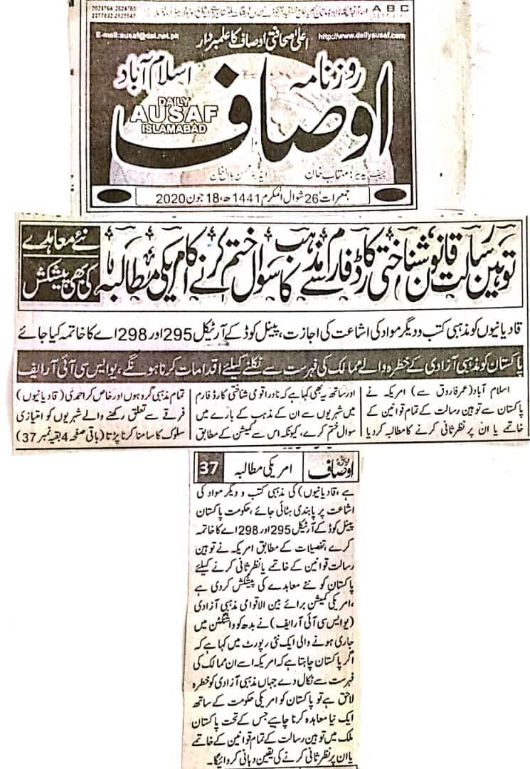
America asks to remove law of Blasphemy and section of religion from national identity card. They also proposed new law.
America asks to remove articles 295 and 298 of penal code to permit Qadianis publish their literature.
Pakistan will have to make reforms to remove its name from the list of those countries that have religious discrimination.
Islamabad (from Umar Farooq) America asked Pakistan to either remove or review all laws related to blasphemy. It also asked NADRA to remove section of religion from CNIC because all religious sects, especially Ahmadis have to face discrimination due to said law. It also asked government of Pakistan to remove articles 295 and 298 from penal codes. According to information, America has also proposed new law in place of law of blasphemy. American commission for international religious freedom (Uscirf) has said in its report, published from Washington if Pakistan wants its name to be removed from the list of those countries that have religious threats then Pakistani government should sign new contract with USA, in which it will either ensure to remove or review all laws of blasphemy.
(Daily Ausaf Islamabad, Thursday, 18th June, 2020)

Passing the resolution of writing Khatm un Nabiyeen with the name of holy prophet P B U H by Sindh assembly is a very big achievement, leaders of International Khatm e Nabuwat.
June 17 2020.
Lahore (special reporter) the central Nazim of press and publication of International Khatm e Nabuwat Maulana Aziz ur Rehman Sani, preacher of Khatm e Nabuwat Maulana Abdul Naeem, general secretary Lahore Maulana Aleem ud Din Shakir, vice Ameer Peer Rizwan Nafees, Qari Jamil ur Rehman Akhtar, Maulana Hafiz Mohammad Ashraf Gujjar, Maulana Khalid Mehmood appreciated passing the resolution of writing and calling Khatm un Nabiyeen before the name of holy prophet P B U H. The active member of Sindh assembly Mohammad Hussain and the supporter of this resolution Syed Nasir Hussain Shah provincial Spokesperson person must be congratulated so as all assembly members either they belong to the opposition or the government and declared it as the biggest achievement by the lovers of holy prophet PBUH. Sindh assembly worked as the leaders of Muslims. Passing of the resolution by Punjab assembly followed by the Sindh assembly actually reflects the ideology of Islam and Pakistan and it is our religious and national duty to protect the ideology of Islam and Pakistan.
(Daily Nawa i Waqt, Lahore, 17th June, 2020)

Decision of closing all Qadiani channels is appreciable: Aziz ur Rehman Sani and Abdul Naeem
The desecration of the grave of Hadhrat Umar Bin Abdul Aziz and his wife is very bad, Maulana Abdul Naeem.
Lahore (Special Correspondent) Central Organizer of Publishing of International Majlis Tahhafuz e Khatm e Nabuat Maulana Aziz Ur Rehman Sani, The Preacher of Khatm e Nabuat Maulana Abdul Naeem, Maulana Aleem Uddin Shakir, Pir Rizwan Nafees, Qari Jameel Ur Rehman Akhtar, Hafiz Ashraf Gujjar, Maulana Khalid Mahmood, and Maulana Abdul Aziz lauded and praised the decision of PEMRA which ordered all cable operators to close all Qadiani channels on the complaint of Mr. Farooq Mirza the Chairman of Forth Pillar Media Watchdog. Upon this landmark decision we congratulate the Chairman of Fourth Pillar Media Watchdog and all of their office bearers. PEMRA has closed illegal broadcast of Qadiani channels by making bold decision and for this we congratulate PEMRA too. Scholars also strongly condemned the desecration of the grave of caliph of Islam, Hudhrat Umar bin Abdul Aziz and his wife in Adlab province of Syria. They said that due to this tragic incident, hearts of Muslims are grieved.
(Daily Mashriq, Lahore, 2nd June, 2020)

