Atif Mian’s Hiring Would Have Been Good, Says Shireen Mazari
Naya Daur

07th December, 2019

Human Rights Minister Shireen Mazari has said that Atif Mian’s appointment as an adviser to the government would have been good as he was a leading economist, and that the issue of his appointment could have been dealt with in a better way.
Shireen Mazari made these comments while giving an interview to British journalist Mehdi Hasan about the rights of Ahmadis in Pakistan.
Mehdi Hasan pointed out that an Ahmadi spokesperson had stated that they did not have religious freedoms, and recent actions taken by authorities had made it impossible for Ahmadis to carry on with their lives.
Mazari replied that Ahmadis are non-Muslims according to the constitution, but had every right to practice their religion, come into politics, and contest elections on non-Muslim seats.
The host stated that if Ahmadis had to declare themselves non-Muslims to participate in public life, it could be said to be a form of apartheid.
Hasan then pointed out how Atif Mian, who was supposed to be a part of the economic advisory council, was asked to step down.
The HR minister replied that Atif Mian’s case was unfortunate and could have been dealt with in a better way. She added, “If we knew it would have been son controversial, we would not have moved on with it.”
She further added that she thought him joining the council would have been good because he is a leading economist.
https://nayadaur.tv/amp/2019/12/atif-mians-hiring-would-have-been-good-says-shireen-mazari/

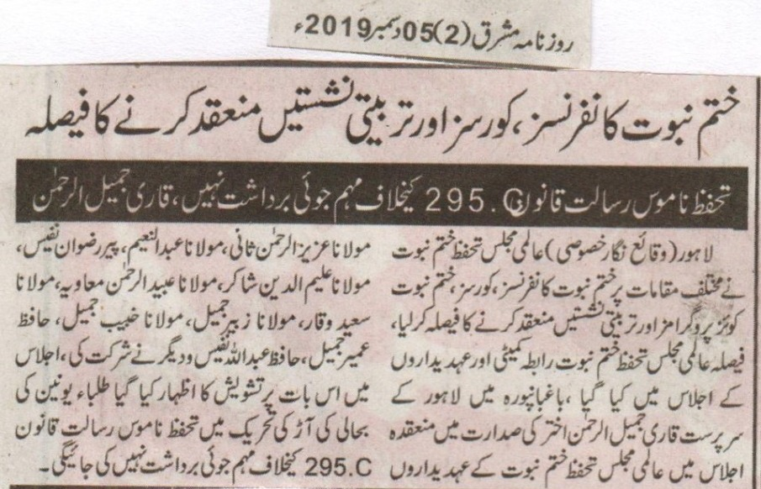
Decision of organizing Khatm e Nabuwat conferences, courses and educational sittings was made during a meeting of coordinating committee of worldwide Khatm e Nabuwat.
We cannot tolerate campaigns against 295 c law of blasphemy: Qari Jameel
Lahore (Special correspondent) Meeting of the coordinating committee of worldwide Khatm e Nabuwat movement was attended by various members including Aziz ur Rehman Sani, Abdul Naeem, Rizwan Nafees, Aleem ud din Shakir, Obaid ur Rehman Muawiya, Saeed Waqar, Zubair Jameel, Habib Jameel, Umair Jameel, Abdulla Nafees and others. Participants expressed their concerns over the campaigns against law of blasphemy under the cover of reviving students union.
(Daily Mashriq, 5th December, 2019)

