OP-ED

Islam vs official Islam: myth in Pakistan
Busharat Elahi Jamil
NOVEMBER 17, 2019
THE DAILY TIMES
“Muslim means a person who believes in the unity and oneness of Almighty Allah, in the absolute and unqualified finality of the Prophet of Muhammad (Peace Be Upon Him), the last of the prophets, and does not believe in, or recognize as a prophet or religious reformer, any person who claimed or claims to be a prophet, in any sense of the word or of any description whatsoever, after Muhammad (Peace Be Upon Him)…” (Constitution of Pakistan, 1973)
Islam is a religion of peace, harmony and brotherhood with its universal teachings and rituals. Islam has no connection with religious extremism and terrorism. However, unfortunately many Muslim assemblages are involved to defame the religion. Islam sincerely assures the religious tolerance securing the rights of every individual. But the so-called religious scholars made the religious teachings and standards difficult, rigid and controversial subjecting to their socio-political and economic drives. In the Muslim society of Pakistan a common Muslim can merely obey the religious descriptions by rigid Mullahs but not willing to do explore the religious matters himself.
Through certain legislation, State of Pakistan has been practicing the Official version of Islam in ‘Islamic Republic of Pakistan’ under the Constitution of 1973. However, the point to be cleared is that Pakistan, founded by Mr. Jinnah for Indian Muslims on August 15, 1947, is a Muslim State not an Islamic State. The very essence of its foundation was the religious freedom for the Muslims of India for they had been deprived of their basic freedom. Steadily, this sovereign State has been high jacked by religious forces with the support of so-called political and authoritarian regimes. With the passage of time, a certain religious hegemonic strata emerged and monopolized the Govt. business, education and legislation in the very name of Islam for its socio-political purposes. Currently, more than one dozen main stream religious parties in Pakistan have made it impossible to run the political business of the State, especially when their interests are at stake.
Generally, when a religion is officialised in a state, it begets a sense of inferiority complex among minority or tiny communities leading to snub their rights
In the contemporary political culture of Pakistan many political parties have the support of religious and militant wings to exercise their hegemonic rule. In fact this is not the optimistic and actual role of religious political parties. Most of these power hungry religious parties and leaderships are involved in religious fanaticism compromising the Islamic society and rituals. In fact, this is the State of Pakistan providing grounds to these religio-political accumulations. Liaqat Ali Khan’s Objective Resolution, Khatm-i-Nabuwat Movement of 1950’s, Bhutto’s role and the Zia’s policy of Islamization strengthened religio-political stratums. Many of these assemblages have empathies with Talibans or Alqaida and eager to implement radicalise ideologies, which can be devastating for Country.
The street power of Mullahs, coalition with political regimes and politics on subtle issues support the opportunistic politician, even many a times they blackmail the political regimes pressurizing the religious sensitive issues. Khadim Husain (TLP) used Mumtaz Qadari’s hanging, Asia Bibi and amendment in the electoral laws to invest in his vote bank during the campaign of General Elections 2018.Tahir-ul-Qadari used religious platform in his Dharna 2014 in Islamabad. In Pakistan, religion being the most sentimental phenomenon makes it unfortunately a “card” for political forces to overcome any socio-political scenario. This proves that now the religious political parties have been transformed into pressure groups, the opportunistic politics of JUI-F, Jamait-i-Islamic, JUI-S and Sunni-Tehrik being its worst examples.
Regrettably, religious political parties merely used the ‘religion card’ to cover the corruption, to pressurize the regimes or for any unnecessary re-conciliation for certain decision or legislation and to change the public opinion but not to improve the services sectors. Great powers mean great responsibilities. If these religious leaders would have used their influences to convince and educate for their betterment, the circumstances were a lot better.
Two major, officially Muslim sects Sunni and Shia do not accept each. The religious militant bands are also divided on the ground religious beliefs and killing Pakistanis. As a result, since 1989 more than 3000 incidents of sectarian violence have been reported in which around 5600 people were killed and 10800 injured. In this “Islamic Republic” religious forces are so much strong and hegemonic; officially various laws are the part of PPC and by exploiting these laws Mullahs can declare any person a non-Muslim or non-believer. The Issuance of the false fatwas to kill any person is a common practice. This is the major reason of insecurity particularly among the non-Muslims, which are about 7% of the population.
Officially, according to the constitution of Pakistan 1973, no non-Muslim can become the President or Prime Minister of Pakistan while they are Pakistanis and have the same worth and capabilities as Muslims. Country is deprived of get benefits from their abilities; if they are Pakistanis they should enjoy the same rights and opportunities. Mr. Jinnah in his historical speech of August 11, 1947 emphasized that “We should begin to work in that spirit and in course of time all these angularities of the majority and minority communities, the Hindu community and the Muslim community, because even as regards Muslims you have Pathans, Punjabis, Shias, Sunnies and so on, and among the Hindus you have Brahmins, Vashnavas, Khatris, also Bengalis, Madrasis and so on, will vanish…”
Generally, when a religion is officialised in a state, it begets a sense of inferiority complex among minority or tiny communities leading to snub their rights. In the modern and progressive state system religion has no dominance because it divides the nation and is harmful for national integration and unity. In Pakistan state supported official Islam strengthens the majority population socially and politically but non-Muslims are considered as second class citizens. Only 10 reserve seats in national assembly and 4 reserve seats in senate, quota system and social discrimination reflect the real weightage and importance of non-Muslims in the socio-political scenario of the Country.
Furthermore, the column of the religion in the official documentation particularly in CNIC and passport is an evidence of the practice of officialising Islam in Pakistan. Muslims and non-Muslims are Pakistanis and religion is the personal matter of any citizen but not the State. When a Pakistani goes abroad he is only recognized as Pakistani but in Pakistan religion, creed and sect and provinces seems to be an essential part of one’s introduction; an obstacle to form a trustworthy and healthy society. Ultimately this nationwide rigid behaviour portrays an aggressive and fanatic Pakistani.

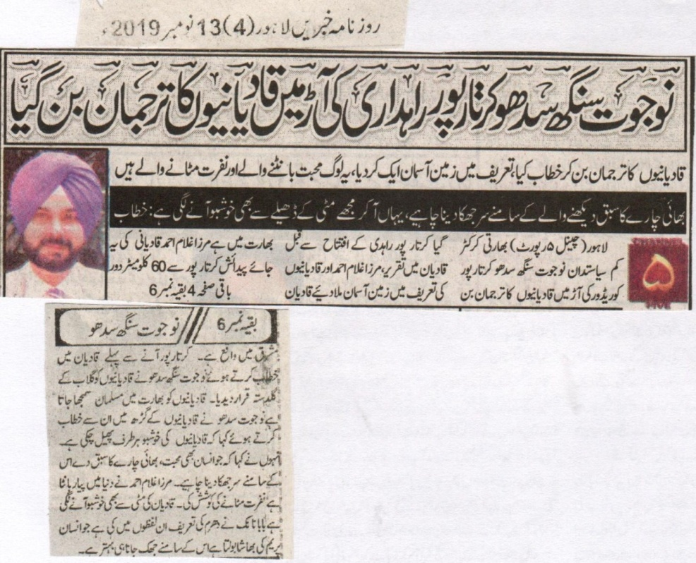
Navjot Singh Sidhu became the spokesperson of Qadianis under the cover of Kartarpur corridor.
He highly praised by saying that people here love every one and wants to remove hatred.
We must bow down for all those who preach the teachings of brotherhood. I can feel a special smell of love even from the soil.
Lahore (Channel report) Indian cricketer cum politician Navjot Singh Sidhu became the spokesperson of Qadianis under the cover of Kartarpur corridor. He delivered a speech in Qadian in which he highly praised Qadianis and Mirza Ghulam Ahmad. Qadian is in India. This birth place of Mirza Ghulam Ahmad is situated 60 km away in the east of Kartarpur. He declared Qadianis as a bunch of Roses. Qadianis are considered Muslims in India. He further said that the teachings of Qadianiyat have spread in the whole world. He said that Baba Nanak defined religion as he said that it is better to bow down before everyone who speaks about love.
(Daily Khabrain Lahore, 13th November, 2019)

