Govt asked to challenge Int’l Human Rights report
September 4, 2019
The News International
ISLAMABAD: Aalmi Majlis Tahafuz-e-Khatme Nabuwwat (SAW) and Jamaat-e-Islami (JI) have demanded of the government to challenge the report submitted by International Human Rights in the UN Council for Human Rights and declared it as a conspiracy hatched by Qadyanis and their protectors.
The Majlis leaders, Maulana Allah Wasaya and Maulana Azizur Rahman Sani, called on Jamaat-e-Islami Naib Amir Liaquat Baloch at his residence on Tuesday.
They extended invitations of 38th annual Khatme Nabuwwat Conference Chenab Nagar and Lahore Conference to the JI leader. The leaders discussed the report submitted by International Human Rights in the UN Council for Human Rights and declared it a conspiracy hatched by Qadyanis and their protectors.
The leaders urged the government to make full preparation to challenge this so-called report. The similar conspiracy was hatched in 1988 and the then government took swift action for its removal, they said.
The leaders discussed situation in Held Kashmir with concern. They condemned the world silence over human rights violation in IHK and asked the international community generally and Pakistani government specifically to take concrete step to stop Indian aggression in the held region.

https://www.thenews.com.pk/print/522037-govt-asked-to-challenge-int-l-human-rights-report

Daily Ausaf Lahore, Sunday, 1st September, 2019
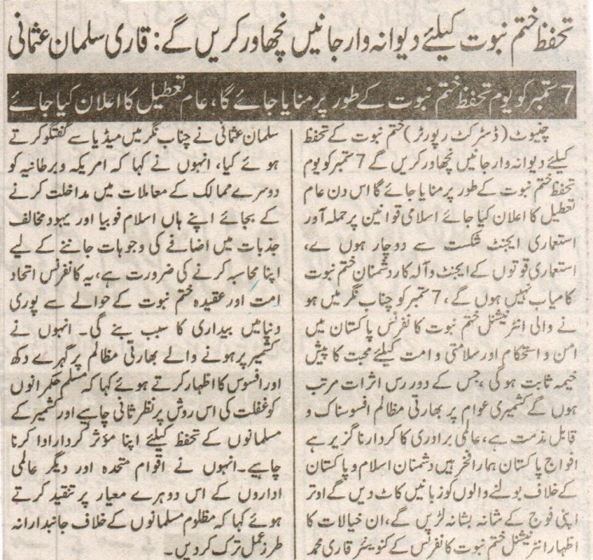
We will fervently sacrifice our lives to safeguard Khatm e Nabuwat: Qari Salman Usmani
7 September will be celebrated as Khatm e Nabuwat Day, public holiday will be announced
Chiniot (District Reporter): We will fervently sacrifice our lives to safeguard Khatm e Nabuwat. 7 September will be celebrated as Khatm e Nabuwat Day and public holiday will be announced. The agents formed [by foreign bodies] to attack Islamic constitution will face defeat and will never prevail. Khatm e Nabuwat Conference being held in Chenab Nagar on 7th September will prove to be a source of peace, stability and love for the Ummah and will have long lasting effects. Persecution of Kashmiris at the hand of Indian government is sad and condemnable. The rest of the world in not effectively playing its role. Pakistan army is our pride and we will fight side by side with them. We will render those who seek to speak against the nation and Islam speechless. These views were expressed before the media in Chenab Nagar by Qari Muhammad Salman Usmani, convener International Khatm e Nabuwat Conference. He said that instead of meddling with external affairs, America and Britian ought to solve their own Islamophobia and rising sentiments against Jews. This conference will prove to be a source of awakening for the whole world and unite the Ummah. Showing his dismay at the persecution in Kashmir, he said that Muslim rulers ought to reflect on their attitude and abstain from neglecting the issue. They must play positive role to safeguard the rights of Kashmiris. Criticizing the dual approach of the United Nations and other world organizations he added that they ought to abandon biased approach towards persecuted Muslims.
(Daily Ausaf Lahore, Sunday, 1st September, 2019)

