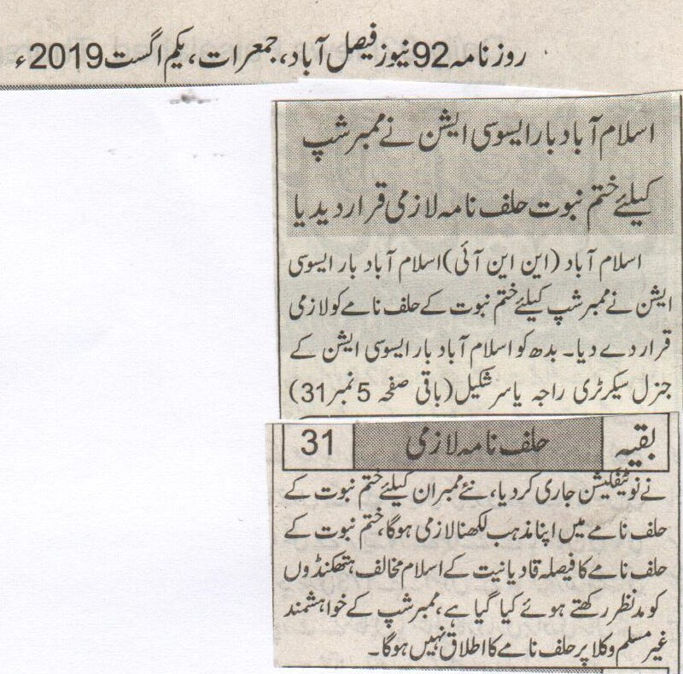
Islamabad Bar association has made the Khatm e Nabuwat declaration necessary for membership.
Islamabad (NNI) bar association has made the Khatm e Nabuwat oath compulsory for the membership. Raja Yasir Shakeel general secretary of Bar association sent a notification saying that every new member is supposed to declare his religion in the Khatm e Nabuwat oath on the form. This declaration was needed because anti Islam conspiracies of Qadianies. This declaration would not be applicable upon non-Muslim members of the association.
(Daily 92 news, Faisalabad, Thursday, 1st August, 2019)

The absence of identity

Usman Ahmad
August 01, 2019

So lost am I with where to begin that perhaps the best place to start is with this moment; me staring blankly into the screen of my desktop trying to pull together in my head all the missing parts of myself. The effect is inconclusive. Almost hypnotic. But it brings no clarity to my thoughts, only a sense of resentment at myself for scuffing my shoes as I beat the top of my feet against the floor to release all the nervous energy that rises out of my frustration.
It is a familiar ritual. This is not the first time I have found myself struggling to respond to a giant swell of hatred that strikes against the very truth of who I am. With it, a dull sort of pain thuds at the back of my head. I feel insufficient and small and inarticulate. And undone.
At times like these, I am also struck by an unnerving absence of trauma equal to the many visceral agonies that have defined the lives of so many others around me. I have not lost a child or a parent in a sectarian killing. I did not grow up being called an infidel at school. I have not had the door to my home graffitied with abuse. I have not been incarcerated for ordinary acts of everyday life. There is though a part of their experience I have shared in, that of being an Ahmadi in Pakistan, a country where we are permitted to live in, but never allowed to belong to.
Do you know what that feels like? To live in a home that is not a home, in an empty space that stretches out from the distant echoes of the past to the infertile darkness of the future. As much as one may try to overcome it, you can never get used to being cast as an outsider in a place that is supposed to be yours. There is no way to prepare for the shrinking of your reality to the point where the only things that remain part of your world are the ones that are impossible to maintain. Instead you disappear. Not completely. Traces of you are seen in the bodies of strangers. You are the hollow pause of a conversation. When you do assume the fullness of your form, it is worn by others, and then it is denied.
How am I supposed to account for all of this? I have tried and written and written and written in search for a deeper realisation or a sense of understanding of what it means for people to live with the wounds of hatred. Yet the only thing that has ever held true is that there is no nuance to the foundational reality of their existence or the texture of their suffering; no way of being seen as anything other than a transgression; just different ways of not belonging.
As I continue to drum my fingers against the keyboard, there is something missing. A central idea, or an insight, or any real point that I want to get across. For years I have sought rapprochement with the irreconcilable. Something between malice and acceptance, between the cold and the warmth, between the living and the dead. I have never found an answer. Actually no. That’s not quite true. There was much I did discover. Just nothing that lay beyond the wreckage of betrayal and heartbreak.
This is what I do know.
In the conception of what it means to be a Pakistani, the place of Ahmadis is conditional and contingent. We are marked out as different and expected to live with what that entails. Our core identity isn’t based on what we are, but what we are not. ‘Non’ is the chosen prefix to our entire existence. To be anything other than an Ahmadi is to be human and universal. We know this because we are not part of this equation. Hatred of us lies at the central formation of Pakistan. It is the moral principle by which people recognise themselves and operate together.
There is nothing that lies outside of this, but that was never what I needed to understand. The things I have always struggled to see the most are the self-evident truths that have stood as clear as day before me. Their edges are sharper than they have ever been because they no longer give way to the blur of a question mark; to things uncertain and mysterious and full of alternative potentials.
It suddenly crosses my mind that maybe even this is not important. This time the hostility that has brought me back here could just be about me. Sometimes you write just to fill a void, to allow yourself a moment of personal intimacy. It is a sort of company. A companion to bear the weight of your living. I cannot resolve the idea that the country to which I belong wants nothing to do with me or that it is well past the point from which it can be rescued from its bigotry. I am mostly speaking to myself now. There are always other ways of making sense of the world. Of being free, a little bit freer anyway. You don’t have to speak for everyone all of the time. But you do have to speak, even if what you say struggles to reach out to a deeper layer of meaning. Because of the absence of your identity. Because the privilege of silence is another thing they have taken away.
https://nation.com.pk/01-Aug-2019/the-absence-of-identity

Facebook removes profile frame targeting Ahmadiyya community
AFP | Dawn.com
July 31, 2019
The profile frame withdrawn by Facebook called for the death of the Ahmadis in Urdu and was widely shared in Pakistan. — Pixabay/File
Facebook said on Wednesday it has removed a profile frame targeting Pakistan's Ahmadiyya community as the media giant continues to grapple with the proliferation of hate speech on the social network.
Profile frames are filters Facebook users can add to their pictures that often promote a cause, celebrate a holiday, or commemorate an event or tragedy.
The frame withdrawn by Facebook called for the death of the Ahmadis in Urdu and was widely shared in Pakistan.
“We have removed the Profile Frames in question for violating our rules, and have ensured that they're unavailable for future use,” a Facebook spokesperson told AFP via email.
“We do not tolerate any content — including anything shared within Profile Frames — that incites violence, and we remove this content whenever we become aware of it.”
The frame was extensively used by Pakistani Facebook users after US President Donald Trump met with several leading members of religious groups in the White House earlier this month, including a representative from Pakistan's Ahmadiyya community.
Facebook disabled 2.19 billion accounts in the first quarter of this year, nearly double the number of accounts nixed in the prior three-month period.
The social network took down four million posts considered hate speech in the first quarter of this year and continues to invest in technology to better detect such material in various languages and regions.
However Facebook has been battered by criticism that it was more focused on growth than protecting users or thwarting deception, bullying, and harassment.
https://www.dawn.com/news/1497292/facebook-removes-profile-frame-targeting-ahmadiyya-community

