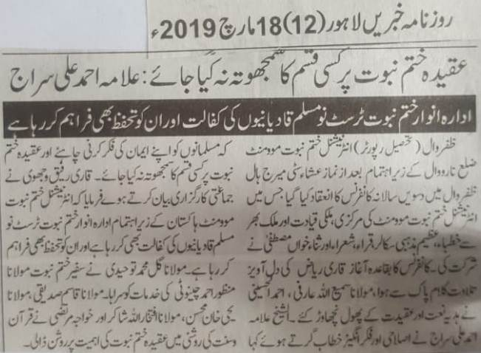
No compromise should be made on faith of Khatm e Nabuwat: Alama Ahmad Ali Siraj
Anwar e Khatm e Nabuwat institute is protecting and taking care of those people who left Qadianiat and accepted Islam.
Zafarwal (Tehsil Reporter) International Khatm e Nabuwat movement, Narowal organized 10th annual conference at city marriage hall. Various scholars and poets participated in it. Conference officially started with the recitation of Holy Quran. Sami Ulla Arfi and Ahmad ul Hussaini recited Naats. Ahmad Ali Siraj said in his address that Muslims should pay attention to their beliefs. Gull Muhammad Tauhidi praised Manzoor Chinioto for his services. Qasim Siddiqui, Yahya Khan Mohsin, Ifatkhar ulla Shakir and Khawaja Murtaza highlighted the importance of faith of khatm e nabuwat in light of Quran and Sunna.
(Daily Khabrain Lahore, 18th March, 2019)

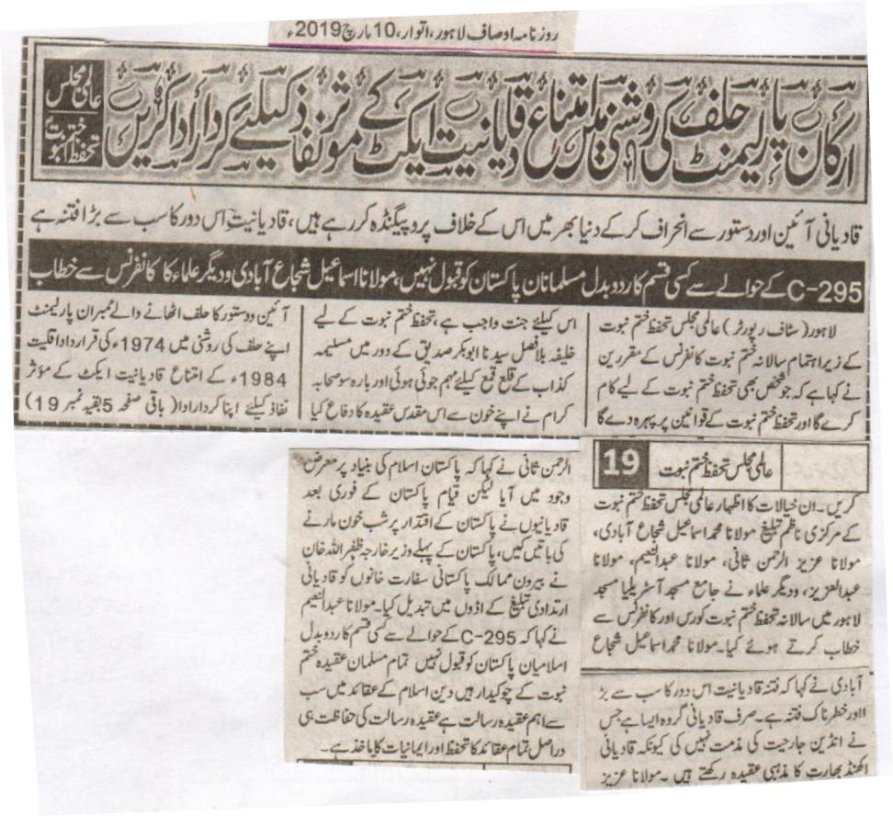
The members of the parliament in the light of their oath ought to play the role in the implementation of the anti-Qadiani act. International Majlis Tahafuz Khatm e Nabuwat
Qadianis are breaking the law and plotting propaganda all over the world against the aforementioned act.
The Muslims of Pakistan will never agree to any changes in 295-C section of the act. Maulana Ismail Shuja Abadi and various other Ulemas at a conference.
Lahore (Staff Reporter): At the international Tahafuz e Nabuwat Conference held under the arrangements of International Majlis Tahafuz Khatm e Nabwuat the speakers said that whosoever will defend the belief of the Khatm e Nabuwat and strive for this cause will for sure go to Paradise. During the reign of Hazrat Abu Bakr^{r.a} to defend the sanctity of the finality of the prophet hood a movement was started to suppress Musailma Kazzab and 1200 companions of the Holy Prophet^{sa} defended this holy cause with their blood. The members of the parliament in the light of their oath ought to play their respective roles in the implementation of the 1974 minority act and anti-Qadiani act of 1984. These views were expressed by the central Nazim of International Majlis Khatme Nabuwat, Muhammad Ismail Shuja Abadi, Maulana Aziz ur Rehman Sani, Maulana Abdul Naeem and Maulana Abdul Aziz at Jamia Masjid Australia and Lahore. Maulana Shuja Abadi stated that Qadianiat is the biggest and the most dangerous threat and sedition of the current time. Only Qadiani group has not criticized the Indian oppression because they firmly believe in a united India. Maulana Aziz ur Rehman Sani said that Pakistan came into being in the name of Islam. However, since the very beginning of its formation Qadianis tried to wreak havoc and shed blood in the region. First foreign minister of Pakistan Zafrullah Khan replaced the foreign offices of Pakistan abroad with Qadiani mission houses, aimed to spread their subversive propaganda. The Muslims of Pakistan will never agree to any changes in 295-C section of the act. All Muslims serve as the defenders of Khatm e Nabuwat. The most important teneth in Islam is that of prophet hood. To protect is how all the beliefs of Islam are safeguarded and on which the basis of faith is based.
(Daily Ausaf Lahore, Sunday, 10th March 2019)

