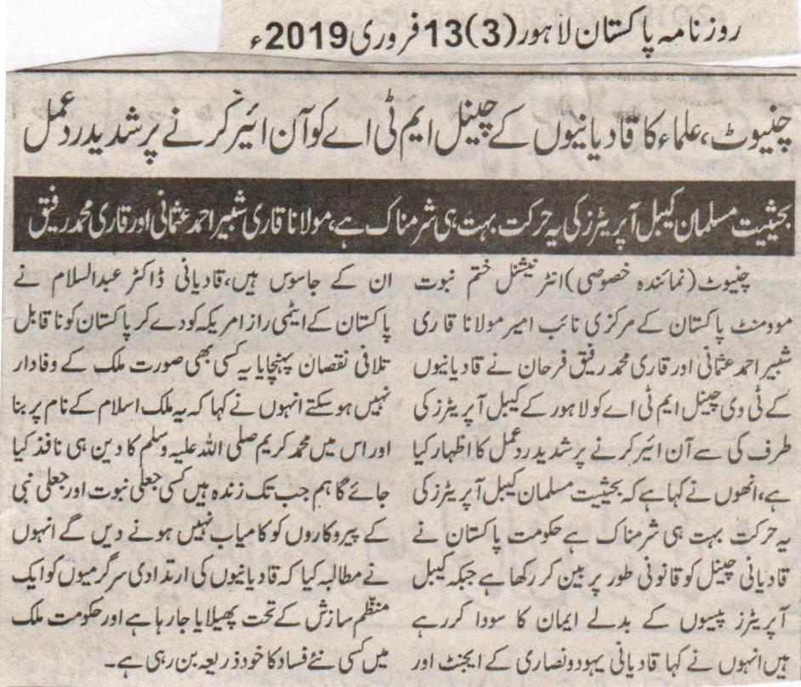
Religious persons showed strong reaction over on airing of Qadiani channel, MTA.
Being a Muslim, this act of cable operators is shameless, Shabbir Usmani and Qari Rafiq
Chiniot (Special correspondent) Central vice president of international Khatm e Nabuwat movement, Shabbir Usmani and Qari Rafiq said that government has banned TV channel of Qadianis but cable operators are selling their beliefs for the sake of money. Qadianis are agents of Jews and Christians. Qadianis, Dr Abdul Salam caused irreparable loss to the country by leaking its atomic assets. They cannot be sincere to country at any cost. This country founded on the name of Islam. That is why, only the religion of Holy Prophet (P B U H) will be implemented in it. Till the time we are alive, we will not let any fake Prophet and His followers be prevailed. Speakers said that nefarious activities of Qadianis are being promoted through special plan. Government is opening the door for violence in the country.
(Daily Pakistan Lahore, 13th February, 2019)

Qadianis cannot use the name of Muslims for the sake of religious freedom: Maulana Faiz Nazir
None of the forces can remove articles related to faith of Khatm e Nabuwat. Extremists and terrorists have damaged reputation of Islam.
Those who issue fatwas against Armed forces and rulers of the country must present proofs: Missionary of Khatm e Nabuwat movement
Chiniot (Pakistan correspondent) Missionary of Khatm e Nabuwat movement and administrator of Madrasa Faiz ul Islam, Faiz Nazir urged to end actions against religious institutes during his address to journalists. He clarified while replying to a question that God has sent Holy Prophet (PBUH) as a blessing for entire universe. His (PBUH) way of spending a life is beacon in every part of life. His (PBUH) being has caused creation of universe. Love for Holy Prophet (PBUH) is a part of our belief. Reciting Darood is only way of our redemption.
(Daily Pakistan Lahore, 12th February, 2019)

