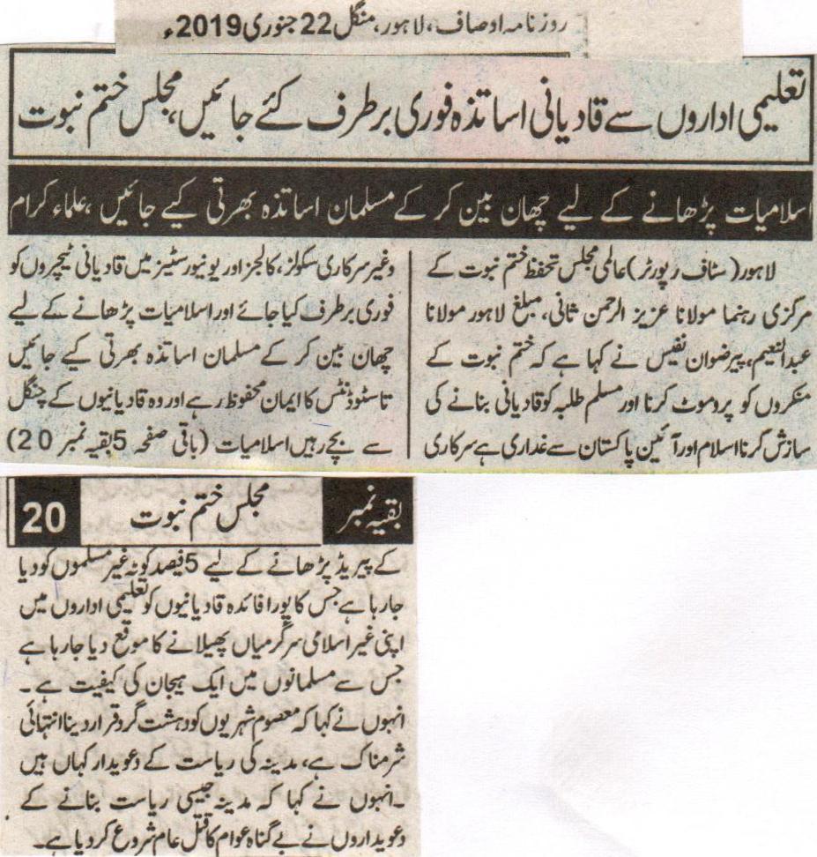
Qadiani teachers should be dismissed from the educational institutes at once, Majlis Khatm e Nabuat
Muslims Teachers should be appointed after strict scrutiny for teaching Islamiat, the Clerics
Lahore (Staff Reporter) leaders of International Majlis Tahaffuz e Khatm e Nabuat Maulana Aziz Ur Rehman Sani, Missionary of Lahore Maulana Abdul Naeem, Pir Rizwan Nafees said that the promotion of the deniers of Khatm e Nabuat and the conspiracy of converting the Muslim students to Qadiani is a rebellion against Islam and the constitution of Pakistan. The Qadiani teachers working in government and private schools, colleges and universities, and the Muslim teachers should be appointed after scrutiny for teaching Islamiat so that the faith of the students should remain safe and they should stay safe from the trap of the Qadianis. 5% quota that is being given to the non-Muslims for teaching the period of Islamiat. This is giving complete benefit to the Qadianis to promote their non-Islamic activities in the educational institutions. This is causing a huge cause of concern for the Muslims. He also said that to declare the innocent citizens as terrorist is extremely shameful, where are the ones that were the claimers of an state like Medinah. He also said that the ones who were claimers of making a state like Medinah have started the killing of the innocent people.
(Daily Ausaf, Lahore, Tuesday 22nd January 2019)

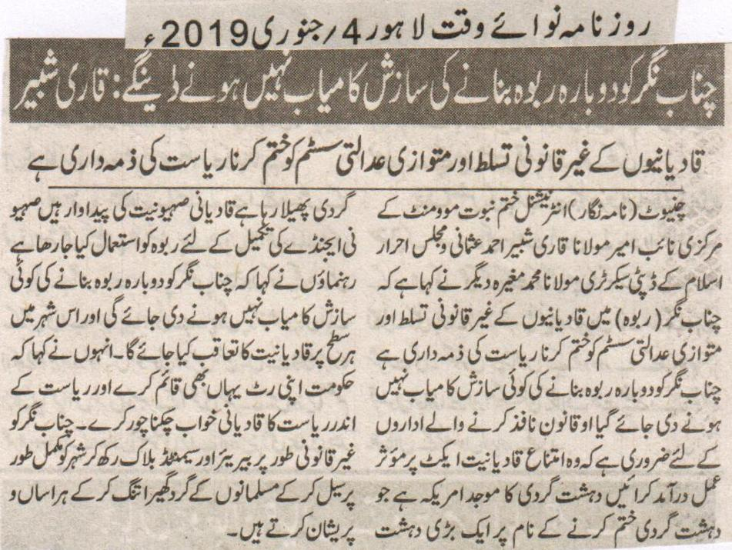
We will not let the conspiracy of converting Chenab Nagar be into Rabwah again, Qari Shabbir.
It is the responsibility of the state to abolish the biased justice system and illegal occupation.
Chiniot (Reporter) Central vice president of International Khatm e Nabuwat Maulana Qari Shabbir Ahmad Usmani and Deputy secretary of Majlis Ahrar e Islam Maulana Mohammad Mugheera said that it is necessary for the law enforcement agencies to apply the Qadianiyat act completely. Founder of terrorism is America and spreading it in the name of finishing it. Qadianis are the production of the foreign agenda, and Rabwah is used to fulfill this. They said that Qadianis will be chased in Rabwah on every level. They demanded that the government must implement its writ here and demolish the dream of Qadianis to make this city as a state within the state. Muslims are being harassed by sealing the city with illegal cemented blocks and barriers.
(Daily Nawa i Waqt Lahore, 4th January, 2019)

