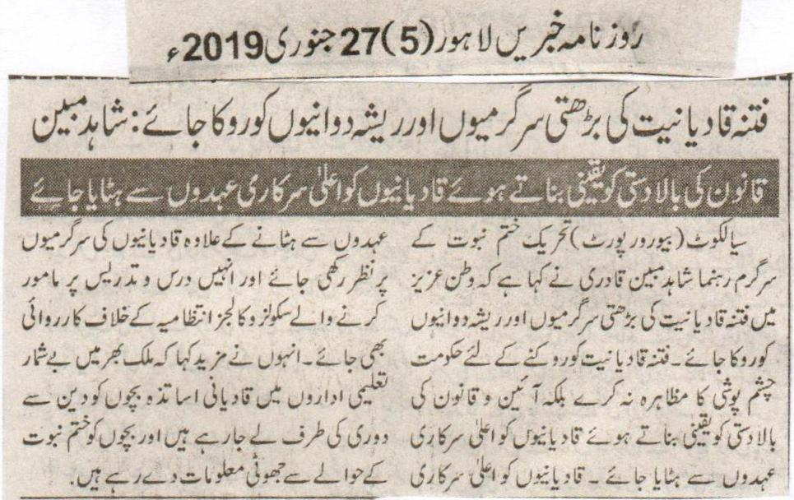
The increasing activities of the evil of Qadianiat and their foul activities should be stopped: Shahid Mubeen
While ensuring the supremacy of the law Qadianis should be removed from key government posts
Sialkot (Beauru Report) An active member of Tehreek e Khatm e Nabuat Shahid Mubeen Qadri said that the increasing activities of the evil of Qadianiat and their foul activities should be stopped in the beloved country. To stop the evil of Qadianiat the government should not overlook, but on the contrary while ensuring the supremacy of the law Qadianis should be removed from key government posts. Beside while removing Qadianis from key posts an eye should also be kept on the activities of the Qadianis. An action should also be taken against the administration for appointing teachers in colleges and schools for teaching and education. He further said that several Qadiani teachers are making the students go away from faith in the educational institutes throughout the world. They are giving the kids false information about Khatm e Nabuat.
(Daily Khabrain Lahore, 27th January, 2019)

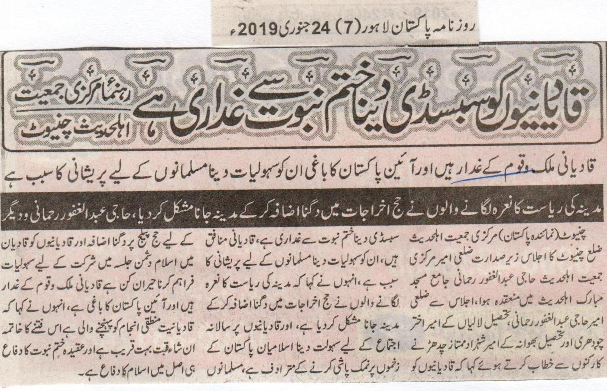
Providing subsidy to Qadianis is an act of treason with Khatm e Nabuwat: leader of Jamiat Ahl e Hadees, Chiniot
Qadinais are the traitors of country and rebels of constitution. Providing assistance to them is equivalent to troubling Muslims.
Those who chant slogan of state of Medina have made it difficult to visit it by increasing the expanses of Hajj: Abdul Ghafoor Rehmani and others
Chiniot (Pakistan Correspondent) President of Jamiat Ahl e Hadees, Abdul Ghafoor Rehmani presided over the meeting at Central Mubarak Mosque. President of Tehsil Lalian, Ameer Akhtar and president of Bhawana, Shehzad Mumtaz Chadhar along with Rehmani said in their addresses to the workers that Qadianis are hypocrites. Providing relaxation of conducting annual meeting to Qadianis is surprising and equivalent to adding insult to injury of Muslims of Pakistan. Qadianis are about to reach their logical conclusion. Protection of faith of Khatm e Nabuwat is indeed a protection of Islam.
(Daily Pakistan, Lahore, 24th January 2019)

