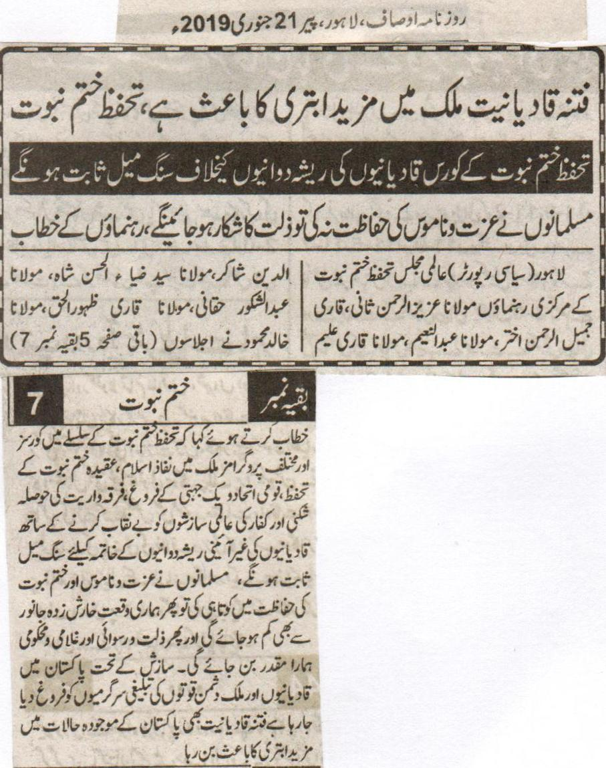
The evil of Qadianiat is making the things worse in the country, Tahaffuz e Khatm e Nabuat.
The Course of Tahaffuz e Khatm e Nabuat will prove to be a milestone against the evil activities of the Qadianis.
If the Muslims will not safeguard the honour than they will be subjected to humiliation, the address of the leaders.
Lahore (Political Reporter) Central Office Bearers of International Majlis Tahaffuz e Khatm e Nabuat Maulana Aziz Ur Rehman Sani, Qari Jameel Ur Rehman Akhtar, Maulana Abdul Naeem, Maulana Qari Aleem Uddin Shakir, Maulana Syed Zia Ul Hasan Shah, Maulana Abdul Shakoor Haqqani, Maulana Qari Zahoor Ul Haq, Maulana Khalid Mahmood while addressing the gathering said that different programs and Tahffuz e Khatm e Nabuat Courses throughout the country will prove to be a milestone in the implementation of Islam, the safeguard of the belief of Khatm e Nabuat, in the promotion of national solidarity and unity, in discouraging the sectarianism, and also to reveal the international conspiracies. Along with these it will also prove to be a milestone in ending the non-constitutional evil activities of the Qadianis. If the Muslims will be neglible while safeguarding the honour and Khatm e Nabuat than our worth will be less than an animal having the disease of itching. This will result in humiliation, sub ordination for us. According to conspiracy the anti-Pakistan activities of the enemies and the Qadianis and their preaching activities are being promoted. The evil of Qadianiat is making the things worse in the country in the current circumstances.
(Daily Ausaf, Lahore, Monday, 21st January, 2019)
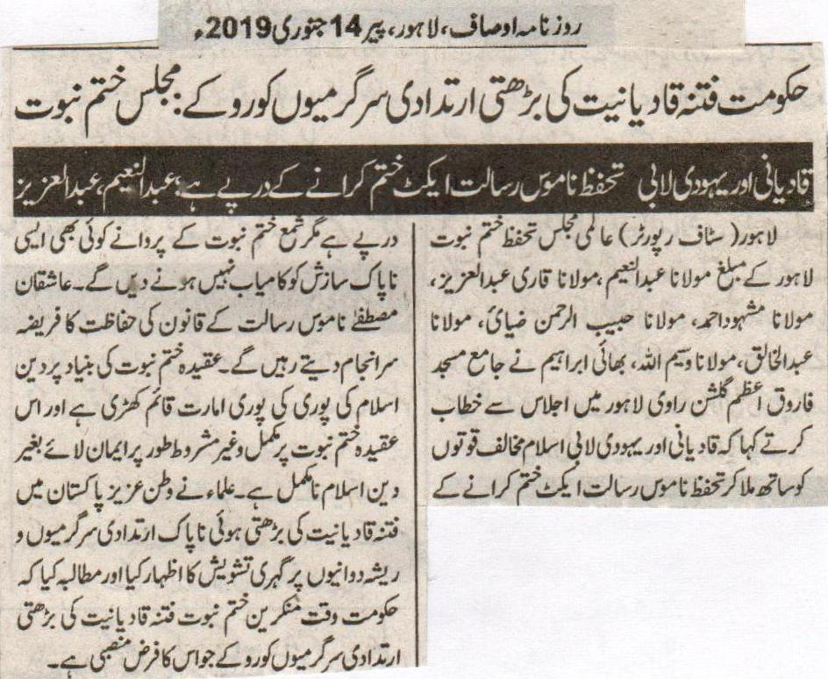
The Government should stop the ever increasing evil activities of the evil of Qadianiat: Majlis Khatm e Nabuat
The Qadiani and the Jewish Lobby are after the removal of the Safeguard of the Honour of the Prophet Act, Abdul Naeem, Abdul Aziz.
Lahore (Staff Reporter) The Missionary of International Majlis Tahaffuz e Khatm e Nabuat Lahore Maulana Abdul Naeem, Maulana Qari Abdul Aziz, Maulana Mashood Ahmad, Maulana Habib Ur Rehman Ziai, Maulana Abdul Khaliq, Maulana Waseem Ullah, Bhai Ibrahim while addressing the gathering in the Central Mosque Farooq E Azam in Gulshan Ravi Lahore said that while joining hands with the anti-Islam forces the Qadiani and the Jewish Lobby are after the removal of the Safeguard of the Honour of the Prophet Act. The lovers of Khatm e Nabuat will not any such evil conspiracy to succeed. The lovers of the Holy Prophet (P B U H) will continue to safeguard the law of the Honor of the Holy Prophet (P B U H). Upon the base of the belief of khatm e Nabuat the whole building of Islam is standing and without which complete non-conditional believe upon the belief of Khatm e Nabuat the religion of Islam is incomplete. The Clerics have expressed their deep concerns upon the ever increasing evil activities of the evil of Qadianiat in this beloved country. They have made a demand the ever increasing evil activities of the evil of Qadianiat should be stopped which is their first and foremost responsibility.
(Daily Ausaf, Lahore, Monday, 14th January, 2019)

In Review

What drives calls for giving Ahmadis a distinct identity
Ali Usman Qasmi
14th January, 2019
Composition by Marium Ali
An electoral reform law containing provisions related to the holding of elections in Pakistan became a focus of controversy immediately after its passage with bipartisan approval in 2017. It changed the wording of an oath – from “I solemnly swear” to “I declare” – which all those contesting elections must take, affirming their faith in khatm-e-nabuwwat (the finality of the prophethood). Initially, the government insisted, and rightly so, that the amendment did not alter legal provisions that require Ahmadis – who are seen as having challenged that finality – to declare themselves as non-Muslims in order to contest elections on general seats. Later, under pressure from religious groups and news media, it backtracked and called the change ‘a clerical error’. The admission did not reduce the pressure on it but rather fueled suspicions that there were some sinister motives behind the change in wording. This gave some religious groups an opportunity to launch a movement against the government in November last year.
Amidst this brouhaha, a petition was filed by Maulana Allah Wasaya – head of the Aalmi Majlis Tahaffuz Khatm-e-Nubuwwat who is also known for his extreme anti-Ahmadi views – in the Islamabad High Court. He sought an inquiry to find out those who had made changes in the oath and he wanted them punished. Among other things, he also asked the court to create a database of Ahmadis living in Pakistan, especially those holding high-ranking offices in the bureaucracy.
The honourable judge who took up the petition appointed many religious scholars and jurists as amicus curiae (friends of the court) to assist him in the case. These included Mohammad Akram Sheikh, a senior Supreme Court lawyer, Dr Hafiz Hasan Madni, a teacher at the Institute of Islamic Studies at the Punjab University in Lahore, Dr Mohsin Naqvi, a former member of the Council of Islamic Ideology, Dr Sahibzada Sajidur Rehman, a serving member of the Council of Islamic Ideology, Mufti Muhammad Hussain Khalil Khel, a Karachi-based religious preacher, Dr Aslam Khaki, a Supreme Court lawyer, and Dr Babar Awan, a former federal law minister. None of them is an Ahmadi. The court, in fact, did not summon any Ahmadis to offer their perspective on the issues raised in the petition.
The judgment in Allah Wasaya versus Federation of Pakistan (Writ Petition 3862-2017), issued after multiple hearings, was replete with various popular charges against Ahmadis that have appeared in innumerable polemical works and in many judicial verdicts as well — that they work against the interests of both the state of Pakistan and Islam. Without going into the details of the case, I am limiting myself to discussing the judge’s suggestion that a special registration system be set up for Ahmadis.
Statistics provided by the National Database and Registration Authority (NADRA) to the court during the proceedings showed that about 10,205 individuals had “converted” to Ahmadi faith in recent years. The honourable judge described their conversion as the “practice of religion-hopping which seems to have been resorted to by certain individuals to hoodwink authorities and avail the benefits of a religion they are not admittedly a part of”.
It should be noted that there is no law against apostasy in Pakistan. Similarly, there is no constitutional provision, whatsoever, that prevents Ahmadis or the member of any other religious minority from occupying ‘sensitive’ posts — such as those of federal secretaries, judges of high courts and the Supreme Court, and military commanders. Yet, the court urged the federal government to be vigilant so that no Ahmadis are appointed to these positions. For this purpose, as well as for the overall need to prevent the misuse of Muslim identity by Ahmadis, the learned judge proposed distinct names for Ahmadis so that they could be distinguished from everyone else. “Qadianis [as Ahmadis are derogatorily called] should not be allowed to conceal their identity by having similar names to those of Muslims, therefore, they should be either stopped from using name[s] of ordinary Muslims or in the alternative, Qadiani, Ghulam-e-Mirza or Mirzai must form a part of their names and be mentioned accordingly,” he noted. He also wrote that other religious minorities living in the country had “a separate identification in reference to their names and identity” except for Ahmadis who “do not hold a distinct identification due to their names and general attire, according to the Constitution”.
I will try to explain as to what kind of ‘crisis’ is generated by Ahmadis being indistinguishable. I will also look into the consequences of proposals floated and actual measures taken in the past to make Ahmadis a distinctly separate community.
Individuals can be identified as members of a certain group or community on the basis of, among many other things, the facial features they have, the clothes they wear and the religious/cultural symbols they use. In some instances, communities themselves opt for a certain outlook to mark themselves as different from others. There are traditions attributed to the Prophet of Islam (may peace be upon him) in which he is reported to have urged his followers to not follow non-Muslims in appearance and customs. When the members of early Sikh communities wanted to acquire a distinct identity, they considered it important to carry such symbols as daggers and bracelets to distinguish themselves from Muslims and Hindus.
But the same markers of distinction acquire a different significance altogether in the time of crisis and violence. In many cases, minority communities have attracted fatal attention for having distinct, identifiable features which are different from those of the majority around them. The gruesome Partition riots offer a well-known example of this. More recently, the anti-Sikh pogrom in Delhi in 1984 and the Muslim massacre in Indian Gujarat in 2002 show how external markers of identity facilitate the process of singling out targets for senseless outbursts of violence.
The case of Ahmadis, especially in Pakistan, poses an entirely different challenge. They themselves do not insist upon having their own markers of distinction even though it is true that, during the British period, they insisted on registering themselves separately from Sunni Muslims. At one stage, Mirza Bashiruddin Mahmood Ahmad, son of Ahmadi community’s founder Mirza Ghulam Ahmad, also disallowed Ahmadi women from marrying non-Ahmadi men. This, however, was hardly different from similar edicts issued by the leaders of other groups organised around sectarian identities. So, what is unique about Ahmadis?

An Ahmadi prayer hall that was attacked by a mob on the second day of Eidul Azha this year in Faisalabad’s Ghaseetpura area | Rizwan Safdar
Regardless of what the Constitution of Pakistan says about them, Ahmadis closely adhere to the Hanafi fiqh (school of religious jurisprudence). They also have names similar to those of Hanafi Sunnis and do not wear any garments that highlight their distinct religious identity. As Irfan Haider Abidi, a known Shia scholar, once rhetorically pointed out, both Ahmadis and Hanafi Sunnis have the same way of offering namaz and they also break their fasts at the same time. They, of course, have a fundamental doctrinal difference on the issue of khatm-e-nabuwwat – understood and interpreted differently by each of the two communities.
On the other hand, there are some ‘visible’ markers of identification for Shia Muslims. For instance, they offer namaz in a manner slightly different from the one followed by Sunnis and break their fasts 10 minutes after Sunnis do. Shias have other markers of identity as well. Even in the midst of sectarian violence, they make themselves visible by hoisting alams (standards) on their houses, displaying Ya Ali stickers on their cars and sporting steel bracelets. Even though these are not strictly Shia symbols and are widely used by Sunnis as well, these markers of identity have been exploited by Sunni militants to target and kill Shias in Pakistan.
Names have also been used as similar markers of sectarian identity — and often to deadly effect. In the gruesome killing that took place in Chilas in 2012, militants checked identity cards of passengers in a bus so they could distinguish between Sunni and Shia passengers. Those who had Shia sounding names were then separated and gunned down. Certain names – such as Omar and Ayesha – can similarly be indicators of a Sunni identity. In a wave of sectarian violence in Iraq that followed the American invasion of that country in the early 2000s, many Sunnis were identified on the basis of their names and killed.
It must be stated here that there is nothing scientific when it comes to identifying a person’s religious persuasion on the basis of his or her name. In the 1990s, Sunni militants gunned down one Aftab Naqvi – an apolitical, literary figure – in Lahore because his name, due to its Naqvi suffix, suggested that he could be a Shia.
‘Ali’, ‘Hasan’, ‘Hussain’ and ‘Fatima’ are some of the most obvious name choices among Shias but it is ridiculous to assume that only Shias give these names to their children. The most prominent example in this regard is that of Ali Sher Haideri who was the Sindh chief of an anti-Shia party a few years ago. As per the data collected by NADRA and cited by Islamabad-based language scholar Tariq Rehman, ‘Ali’ is the second most popular name – after ‘Muhammad’ as first name – for men in Pakistan. As is ‘Fatima’ for women.
In Jhang, the heartland of sectarian violence in Pakistan, Sunni militants seemed to be aware of this so they would ask ‘suspected’ Shias to take off their shirts to find out scars left by self-flagellation that Shias do as part of their annual mourning in the month of Muharram. Even this is not a sure sign of identification as self-flagellation is done by many non-Shias as well. I know at least one Punjabi Catholic – and there are hundreds of others like him – who would do self-flagellation using small daggers tied to chains during Muharram.
Still, the point is that there are many visible and external markers that can make Shias more identifiable than Ahmadis. The similarities in names, rituals and the use of religious symbols that exist in Pakistan between Hanafi Sunnis and Ahmadis are, indeed, unique. They do not exist between Pakistani Muslims and Pakistani Hindus or between Pakistani Muslims and Pakistani Christians to the same extent. Unlike in India where mutual borrowing in terms of names may not be an abnormal occurrence (for example, Kabir could be a Hindu name as much as a Muslim one), the same does not happen – at least at the same scale – in Pakistan. Even the use of certain religious symbols is strictly specific to certain communities in our country. If a person is wearing a cross, he/she will be a Christian or at least will be assumed to be a Christian.
Despite this relative clarity in boundaries between Muslims and non-Muslims, there was a demand from religious groups in the 1990s to include religion in identity cards. The same demand for passports had been made earlier and accepted. The argument in its favour was that the mention of religion in passports would help ensure that only Muslims travelled to Saudi Arabia for pilgrimage since Makkah and Madinah, by religious injunction, are off-limits for non-Muslims. Without religion being mentioned on passports, it was suspected that Ahmadis – constitutionally declared as non-Muslims in Pakistan – would also be able to go to Saudi Arabia for pilgrimage. Those who had made the demand were oblivious to the fact that no such information is provided in travel documents of pilgrims visiting Makkah and Madinah from most other countries. So, Ahmadis residing outside Pakistan are still able to perform umrah or hajj on passports of those other countries.
The demand for mentioning religion on identity cards was made for no such practical purposes so it was vociferously opposed both by minority Muslim sects and non-Muslim Pakistanis. It was in this context that Abidi made his speech quoted earlier. Like others opposing the demand, he feared that, in the presence of visible distinctions between Muslims and non-Muslims, the mention of religion in identity cards could well set the ground for subsequent mentioning of sectarian identities in those cards.
This is not to say that the state was not identifying Muslims by their sects already. This was happening in many cases, at least informally. For instance, information about sectarian association was being ascertained in background checks carried out for those appearing in civil service exams or those who wanted to become commissioned officers in the military. Formally, however, a decision was taken in Pakistan’s first post-independence census in 1951 to not ask people about their sects and this has stayed the same since then.
Despite some shared cultural as well as religious practices, the dissimilarities that Pakistani Sunni Muslims have vis-à-vis Shias, Christians and Hindus in the country enable the recognition of differences between them even if it is not always enforced. This is not the case with reference to Ahmadis though.
Talking about the increasing agreement on doctrinal issues between Sunnis and Shias during the 1980s, Dr Faisal Devji, a professor of Indian history at Oxford University, argued that it is sameness rather than difference between religious groups that posed a threat to communitarian boundaries. Applied to Ahmadis, this argument helps explain the Hanafi Sunni anxiety about Ahmadis hiding their faith, dissimulating their ‘real’ identity and operating secretively as Muslims. This anxiety made it important for Hanafi Sunnis to ask for legal and administrative measures – including putting down religion in identity cards – so that an Ahmadi could be ‘recognised’.
The Constitution and the law, at least initially, provided for no distinction between Pakistan’s Muslim and non-Muslim citizens. Even after the passage of the second constitutional amendment in 1974 – which declared Ahmadis as non-Muslims – there was nothing much on the statute books that identified citizens by their religion except for the constitutional provision that the president and the prime minister must be Muslims.
In such a legal environment where citizens, at least theoretically, enjoyed almost equal rights regardless of their religious identities, it was absurd to make a claim that Ahmadis, by identifying themselves as Muslims, were infringing the rights of Muslims. Since no religious community enjoyed rights specific to it, there was no question of their infringement by another community. In the famous Abdur Rehman Mubashir versus Syed Amir Ali Shah case in 1978, the gist of Justice Aftab Husain’s judgment highlighted just that — no civic rights of Muslims were infringed if Ahmadis identified themselves as Muslims.
Seen from a Hanafi Sunni perspective, this needed to change and it did with the promulgation of some Ahmadi-specific legal instruments, including Ordinance XX issued by General Ziaul Haq in 1984 which barred Ahmadis from ‘posing’ as Muslims. Under this ordinance, an Ahmadi acting or behaving as a Muslim can be punished because only a Muslim has the right to act and behave like a Muslim. Zia also added the definition of a Muslim in the Constitution and changed election rules to provide for separate electoral rolls for Ahmadis alone. Whereas all Muslim and non-Muslim voters were listed in the same rolls, Ahmadis, according to the changed rules, were to be listed separately so that they could not ‘pose’ as Muslim voters or Muslim candidates.
The problem is that no matter what the law says, Ahmadis cannot but act like Muslims. Even if their worship places are not allowed to be called mosques, what the community does inside them still looks like namaz as it is offered by Hanafi Sunnis.
This is the crisis the Islamabad High Court judge has referred to — the failure to eradicate sameness and enforce distinction between Ahmadis and Hanafi Sunnis.
Pakistan’s constitution has already declared Ahmadis as non-Muslims, an ordinance issued by a military government and upheld by the Supreme Court does not allow them to ‘pose’ as Muslims and yet there is a crisis that refuses to subside. The peculiar nature of this ‘crisis’ means that it can only be resolved by making Ahmadis distinguishable by forcing them to have distinct names — as has been suggested by the Islamabad High Court judge. He has proposed to make it compulsory for Ahmadis to add Qadiani/Mirazi/Ghulam-e-Mirza to their names so that they can be recognised. Eventually, even this will not suffice and a demand could be made to limit them to Rabwah, a town in Punjab where their religious headquarters are located.
If this does not remind us of the horrors of Nazi rule, I wonder what else would.
German Jews, though religiously different, were otherwise unrecognisable as a distinct group from other Germans. Nazi Germany had to make them distinguishable by forcing them to wear the Star of David on their sleeves. This is exactly what Ahamdis in Pakistan face. To quote philosopher and Auschwitz survivor Primo Levi: “It happened, therefore it can happen again: this is the core of what we have to say. It can happen, and it can happen everywhere.”
https://herald.dawn.com/news/1398674?ref=whatsapp

