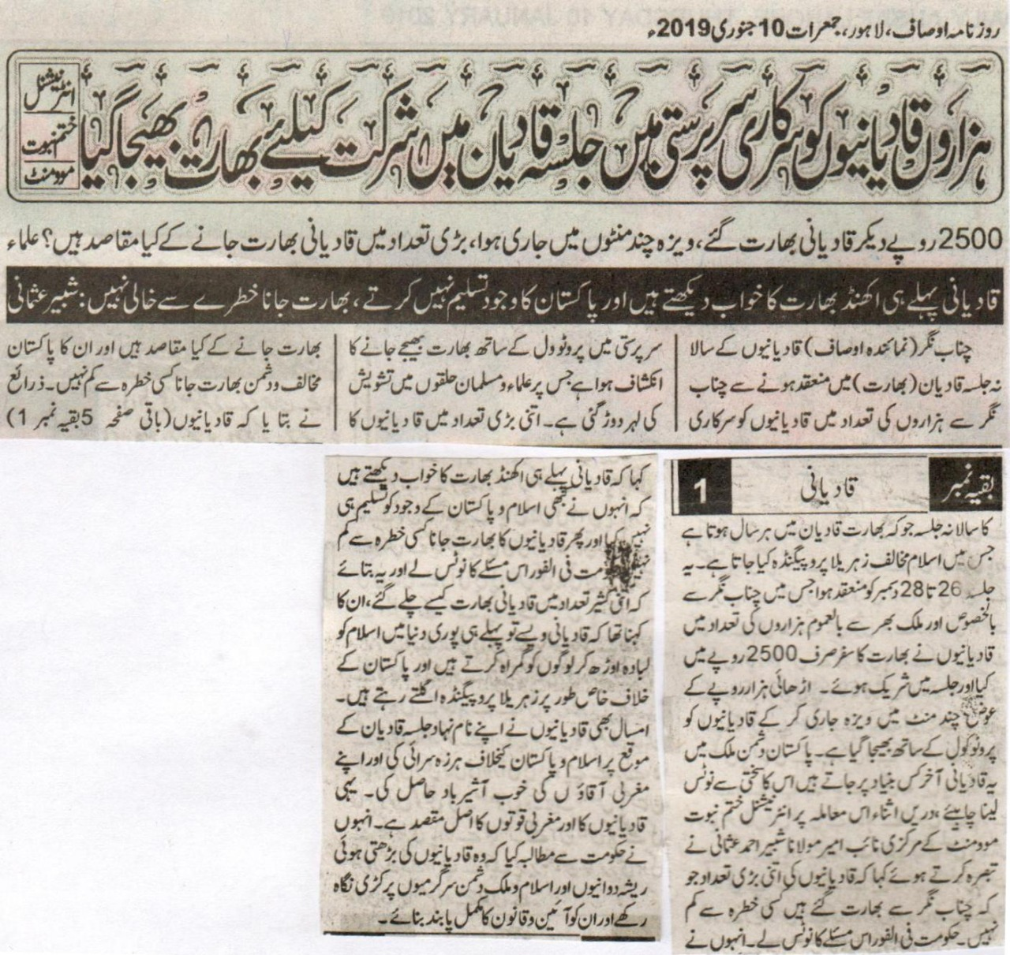
Under the supervision of government hundreds and thousands of Qadianis were sent to partake in the annual congregation held in India: Internnational Khatm e Nabuwat Movement
Qadianis travelled to India by paying the [small] amount of 2500 rupees only and the visa was issued within minutes. What is the purpose behind such a large number of people visiting Qadian, India?
Qadianis already dream of a strong and united India and do not accept Pakistan as an independent state. It is not safe [for Pakistan] to allow them to visit India.
Chenab Nagar (correspondent Ausaf): Under the supervision and protocol of government hundreds and thousands of Qadianis from Chenab Nagar were sent to partake in the annual congregation held in India. This is worried the Ulemas and the Muslims alike. What is the purpose behind such a large number of people visiting Qadian, India? It is not safe [for Pakistan] to allow them to visit India. The sources revealed that this annual congregation is held on 26 to 28 December each year and they spew hatred and conspire against Islam in [their speeches]. A huge number of people from Chenab Nagar and hundreds and thousands from the rest of the country travel to India by paying a small amount of 2500 rupees only. They were granted the visa within minutes and were sent off to Qadian with protocol. Why do these Qadianis visit a state which is the enemy of Pakistan? This issue needs to be taken seriously. The vice president of International Khatm e Nabuwat Maulana Shabeer Ahmad Usmani remarked that it is not safe [for Pakistan] to allow such a large number of Qadianis from Chenab Nagar to visit India. The government ought to take the notice immediately. Qadianis already dream of a strong and united India and refuse to accept Pakistan as an independent state. Hence, it is dangerous to send them to India. The government must take the notice immediately. It needs to disclose as to how so many people were able to travel to India. He said that Qadianis are already misleading the world by using the name of Islam and defaming Pakistan and conspiring against the state. Even on this annual gathering, they spoke against Pakistan and Islam and pleased their masters in the West. This is the true purpose of Qadianis and the West alike. He asked the government to keep an eye on their ploys and actions and make them follow the constitution.
Daily Ausaf, Lahore, Thursday, 10 January, 2019

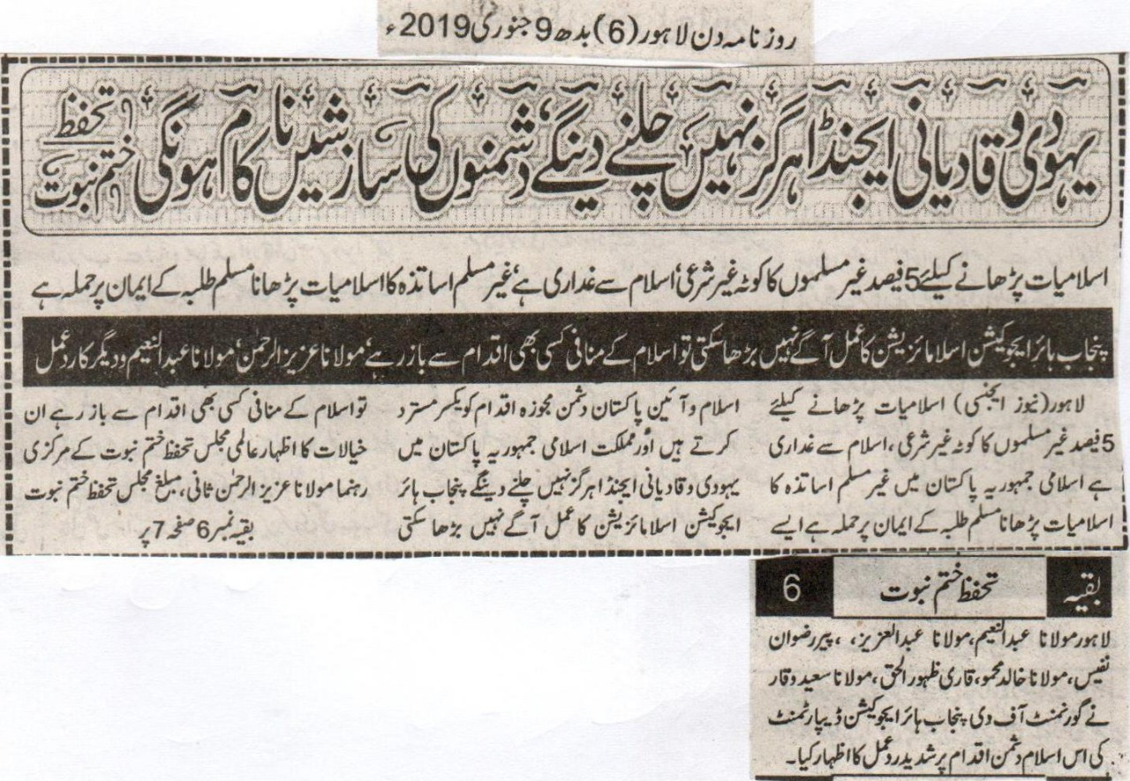
We will not let Qadiani and Jewish agendas be prevailed. We will fail all conspiracies of enemies: Khatm e Nabuwat Movement
5 % quota of non-Muslim teachers to teach Islamiat is non-religious. It is an act of treason with Islam and an attack on the faiths of Muslim students.
If Punjab higher education cannot proceed with the concept of Islamization then it must refrain itself from taking any anti-Islamic step: Aziz Ur Rehman, Abdul Naeem and others
Lahore (News Agency) Missionaries of Worldwide Khatm e Nabuwat Movement, Aziz Ur Rehman Sani, Abdul Naeem, Abdul Aziz, Pir Rizwan Nafees, Khalid Mahmood, Qari Zahoor Ul Haq and Saeed Waqar expressed severe concerns over Punjab Higher Education’s decision of assigning 5% quota to non-Muslim teachers to teach Islamiat. They rejected the reform by terming it anti-Islamic and anti-constitutional.
(Daily Din Lahore, Wednesday, 9th January, 2019)

