BLOGS, PAKISTAN

Pakistan’s left must protest against the right
Ibrahim Mahmood Batla
NOVEMBER 28, 2018
The DAILY TIMES
There are a variety of ways through which the general public can make sure that its values are adequately represented. One instrument is voting, which is certainly an incentive for the government to bend to our will. But it only happens once in five years, so then how do ensure that the government listens to us throughout the five years, and not just the election season?
One can employ several instruments to get his/her voice out there. For instance, someone who cares about the environment may lobby the relevant legislators to push for environment friendly legislation. Someone with more resources could hire a legal team to illustrate how the government has breached on the right to life by cutting trees, and if the writ petition is accepted and eventually a favorable decree is issued, the government will have its hands tied. The media is also an effective tool, and the executive government would want it on its side.
The aforementioned methods are by no means exhaustive or accessible to the common man. And it is the common man that suffers the most, as he does not have the resources to cushion himself before a severe fall. So what remedy does the common man have?
The common man has two mediums, one is fairly advanced but abstract. The other medium is tried and tested, and fairly disruptive. And even though the former medium is replacing the latter, the latter is what shapes policies and decisions in Pakistan.
If you have not guessed it already, then the former is ‘social media outrage’ and the latter is protest on the streets. The former is a medium that is today almost universally accessible, while the latter while accessible in theory is used arguably only in dire circumstances.
Social Media has obvious advantages which is why a great deal of our peers always lodge their protests on it either explicitly or implicitly. Explicitly, one may sign petitions, create long posts or share them. Whereas implicitly one may comment/like/retweet their support for a particular stance of the government. Either way, more likely than not, the not the government’s social media cell, or any other department will be gathering data in real time to see how the public has responded to a said strategy.
And ideally the government may change its stance if the people are unsatisfied, because it is supposed to be representing people in a democratic country, and a great deal of your informed citizens do voice their opinion on social media, hence making for an adequately representative sample. And we see this happening when PTI welcomed Farooq Bandial with open arms, only to expel him a few hours later after protests on social media.
However, in other times, such as after the government’s largely ‘apologetic’ stance against TLP protest, and the consequent protests on social media, the government did not change its course because of the outcry on social media. The same was the case when it came to Atif Mian, who was largely celebrated on social media, but eventually forced to resign because of the threat of protests by the right wing. A perusal of national assembly debate on the day when 295-C was promulgated shows that right wing was supported by the ostensible threat of protests outside the parliament and hence were able to coerce legislation.
Don’t get me wrong. Social media is useful. A lot of times it can be decisive as well. However, usually it is just persuasive. It is filled with information and the government knows that the millennials or alike are “cause-hunters” who will switch to another cause after a short while. The left wing does not persistently demand for structural changes but is satisfied with cosmetic changes. For instance, when it came to the Kasur case, the right remedy would be to rectify all structural inefficiencies and mishaps, but the cosmetic remedy was to speed the investigation.
As long as the left fails to recognize its right to protest, it will be ignored. Because in a country like Pakistan decisions are ignored, they need to be coerced, and when the government needs to know that for every right-wing protester, there will be someone from the left wing. And it is only this, that will lead to greater bi-partisanship and will remove the leash that the right wing seems to have on the government.
https://dailytimes.com.pk/327210/pakistans-left-must-keep-protesting-against-the-right/
The rise of Ahmadi exceptionalism
Ali Usman Qasmi November 25, 2018
THE NEWS ON SUNDAY
A historic overview of how a religious group went from being a minority to a fitna. This is the first of a two part series

The Ahmadi worship place under attack in Garhi Shah, Lahore in 2010. When Atif Mian, renowned economist from Princeton University, was nominated as a member of the Economic Advisory Council by Prime Minister Imran Khan, there were two distinct reactions from the supporters of his government. Some were ecstatic as for them it was another step towards making Pakistan a more pluralistic society. Others, more conservative sections, were indifferent initially but, as momentum gathered, voiced their discontent over the inclusion of an Ahmadi into a group that is to address the country’s economic woes.
The federal information minister sharply defended Mian’s appointment. He said the country also belongs to the minorities, and that it is the religious duty of every Muslim to protect their rights. His statement, though couched strictly in legal-constitutional terms and relying on invocation of Islamic principles of tolerance, drew the ire of firebrand political commentators.
These commentators made it clear that Ahmadis could not be treated like other minorities, i.e. like other non-Muslims. They argued that minorities have always had equal opportunity in the country, and cited the examples of Justice Alvin Cornelius and Justice Rana Bhagwandas, who became top judges of Pakistan’s highest court of law. Ahmadis, on the other hand, are not a minority, they pointed out since they refuse to accept themselves as such. Their insistence on calling themselves Muslims and the unlawful use of the ‘copyright’ to practice or represent Islam, it was said, are an affront to the sensibility of Muslims. Some commentators did not stop at denying Ahmadis minority status which ensures some degree of constitutional protection, but went a step further and called them murtads (apostates) — the punishment for which, according to many scholars in Islam, is death.
In Pakistan, the term minority is not a numerical categorisation applicable to ethnic or linguistic groups. It is a title generally bestowed upon anyone who is not a Muslim. In other words, the term minority and non-Muslim are interchangeable. What the information minister said in his carefully worded defence was that Ahmadi rights have to be protected like Christian rights or Hindu rights.
However, what is scary is not that Atif Mian was asked to step down because of his religious affiliation. It is that Ahmadis are being denied what Hannah Arendt calls “the right to have rights” — a denial written into the very language and logic of the Second Amendment of 1974 that declared them non-Muslims.
During the National Assembly’s special committee proceedings on the Ahmadi issue in 1974, Yahya Bakhtiyar, then attorney general of Pakistan, had told Mirza Nasir Ahmad, head of the Ahmadiyya community, that the Ahmadis need to be designated a minority if they want their rights to be protected. In an emotional response, Ahmad said he would prefer to live as a Muslim without rights rather than as a non-Muslim with guaranteed rights.
A few decades later we are faced with a situation which even Ahmad would not have imagined — his people can no longer be recognised as a non-Muslim minority, with any degree of guaranteed rights or civil liberties. The Second Amendment, which Zulfikar Ali Bhutto sold as “the final solution” to a “90-year-old problem” became the very legal foundation of state-sanctioned discrimination, hate and violence against Ahmadis.
When right-wing commentators insist on distinguishing Ahmadis from other non-Muslim minorities, they appear to point towards what one can call Ahmadi exceptionalism — the idea that Ahmadis are unlike any other majority or minority in Pakistan and should be treated, or mistreated, as such.
Numerous religio-political arguments were presented to justify the exclusion of Ahmadis from the fold of Islam during the month-long debate in the National Assembly in 1974. Bakhtiyar had rightfully pointed out the inherent flaw of the argument against them: he said, on the one hand, Ahmadis were being proved as inherently blasphemous in their religious views and traitors of the state in their political actions, yet on the other the assembly was promising to protect their religious and political rights as minority citizens. His objection soon drowned in the outcry, and so did any hope of the state holding its ground.

When right-wing commentators insist on distinguishing Ahmadis from other non-Muslim minorities, they appear to point towards what one can call Ahmadi exceptionalism — the idea that Ahmadis are unlike any other majority or minority in Pakistan and should be treated, or mistreated, as such.
Sects with divergent views have always existed in Islam — including in the modern period — with mutually incriminating fatwas of kufr (denial of truth) against each other. When every major or minor sect has been branded as kafir (denier of truth) by the opposing sect, what is so special about the fatwa of kufr against one group?
It can be said that fatwas against Deobandis and Barelvis mostly relate to specific statements of individual scholars. Ahmad Raza Khan Barelvi, for instance, issued fatwas of kufr against major Deobandi scholars. However, there is no consensus among subsequent Barelvi scholars on considering all Deobandis as non-Muslims. The same can be said about Deobandi fatwas of kufr against certain Barelvi beliefs and practices. This might be because disputes about the Prophet Muhammad (pbuh) being nur (light) or basher (human), the celebration of mawlid and the intercessionary powers of Sufis — though hugely significant in their own context — is not considered by a segment of Barelvi and Deobandi ulema as a deviation from the broad consensual boundaries of belief. Therefore, there is hardly a majority opinion of ulema, let alone a consensus, in favour of the fatwa of kufr against Barelvis or Deobandis.
One must also state that the opinion against Ahmadis was not always unanimous either. Till the 1890s, there were many cautious voices of restraint. Many scholars refused to append signatures on fatwas of kufr against Mirza Ghulam Ahmad without confronting him first. Others abstained out of expediency.

September 7, 1974. The Parliament of Pakistan declares Ahmadis as non-Muslims.
Early twentieth century onwards, however, religious opinion against Ahmadis became increasingly unanimous. It will be almost impossible to find a fatwa from any Sunni or Shia denomination that accepts Ahmadis within the bounds of Islam. One might find some fatwas in favour of the Lahori branch of Ahmadis (though the Second Amendment applies to them as well) that declares Mirza Ghulam Ahmad to be a mudjaddid (renewer of faith) rather than a prophet. Such unanimity of opinion over the exclusion of any other group is unparalleled.
Here, one must point out that this unanimity does not necessarily qualify Ahmadi beliefs as false and those of their opponents as true. To validate their claim of being a righteous Muslim group, Ahmadis refer to a prophetic tradition which says that the true Muslim sect will be the one which will be condemned by every other sect. They also argue that such opposition, hatred and campaign of vilification were faced by every prophet during his lifetime and by his followers afterwards.
As for violating the consensus on the finality of Prophet Muhammad’s prophethood, Ahmadis say that they too believe in Prophet Muhammad to be the last messenger of Allah. According to Ahmadi belief, Mirza Ghulam Ahmad’s prophetic status was only a reflection and shadow of Prophet Muhammad (pbuh) — a status that the founder of the Ahmadiyyah Jamat acquired through his utmost devotion and love for the prophet. As the Seal of Prophets — khatam al-nabiyyin — Prophet Muhammad (pbuh), as the owner of the seal of Prophethood, they claim, has the power to bestow this status to his most obedient and loving devotees.
However, Mirza Ghulam Ahmad’s critics argue that he not only made claims that hinted at his elevated status as a prophet, but also disrespected other prophetic figures (especially Jesus), and brought about various changes in the sharia. In addition, he claimed to be the promised messiah and, later in his life, an incarnation of the Hindu deity Krishna as well. During his lifetime, therefore, he had found detractors not only among Muslims but also among Christians and Hindus.
His followers do have a strong defence for his ‘controversial’ statements and spiritual claims. However, since the 1950s, intellectual space has been constrained to such an extent that it has become impossible for Ahmadis to present their case, even if it is in a polemical setting. In the absence of a level playing field, there is no point in listing Mirza Ghulam Ahmad’s ‘controversial’ or ‘offensive’ statements when we know that the Ahmadis would not have an equal right to participate in this debate. But one can, at least, try to make sense of the ‘nature of offence’ in the peculiar context of colonialism and impact of modernity.

Mirza Nasir Ahmad with members that represented the Ahmadiyya Jama’at in National Assembly.
It can be argued that Mirza Ghulam Ahmad’s writings received a harsh response from ulema of all religious persuasions due to the nature of his claims and the language he used to describe them. Ahmad’s critics have pointed out that similar claims of proximity with the Divine or revelations from the Divine — some of the essential attributes of prophethood — had been made by various Sufis as well. Ahmadi texts frequently refer to such claims, made by the likes of ibn Arabi and Abdul Qadir Jilani. Ibn Arabi, for instance, identifies two different types of nabuwwats (prophethoods) — one of sharia (law) and the other of wilaya (granted authority). It can be inferred from ibn Arabi’s writings that he is referring to two different kinds of nabuwwats — a sharia-based nabuwwat ended with Prophet Muhammad (pbuh) and wilaya that is continuing. When such statements were read out by Ahmadis in an inquiry commission headed by Justice Samdani in 1974, the judge dismissed them as “Sufi hyperboles”. The underlying argument was that Sufis, in a state of ecstasy, say things that cannot be read literally. While others had claimed spiritual eminence and prophetic experiences as well, they had fallen short of claiming nabuwwat. Mirza Ghulam Ahmad, on the contrary, used the title of nabuwwat to describe these spiritual experiences. Rather than indicting Sufis for ‘aberrant views’, this critique should be read as a testimony to the complexity of Islamic religious traditions in the pre-modern era and its ability to accommodate and engage with divergent views about the Divine and readings of the scripture.
Mirza Ghulam Ahmad’s case was different since he was writing in the late nineteenth century in a language that was heavily tinged with scriptural, philosophical and mystical references, profusely dense and opaquely metaphorical, for an audience that had developed modern notions of self and rationality and a general suspicion of esoteric experiences. Scholarship on reformist currents in South Asian Islam during the nineteenth century explores this redefining of religion and search for the rationale behind beliefs and rituals. The ‘new prophetology’ of the era emphasised the human aspect of Prophet Muhammad (pbuh) as an essential feature, in fact, a prerequisite for him to serve as the perfect role model for people of all times and places. Various new interpretative techniques were used to rationalise Quranic verses on miracles, or certain aspects of its commandments which could not, otherwise, have been in conformity with modern sensibilities.
As for the ulema, the very aspect of prophethood was a settled issue. While various Sunni and Shia groups have their own versions of Islamic eschatology — especially the return of Jesus and the coming of Mehdi — none was waiting for the arrival of a new prophet. The usual Ahmadi argument is that Jesus’ return would break the seal of prophethood as he is a prophet himself. The general Sunni response is that his is not a new prophethood. The Mehdi himself has been described in some traditions as holding a status only similar to that of a prophet, and that Jesus would be praying behind him. However, in an era of political turmoil in different parts of the Islamic world, the messianic prophet-like figure of the Mehdi as a reviver of past glory and supremacy had become popular. The case of Muhammad Ahmad, the nineteenth-century Sudanese religious leader who claimed to be the promised Mehdi, is well-known. In the case of Mirza Ghulam Ahmad, the claim went beyond that of Mehdihood. It posed religious as well as political challenges.
One must hasten to add that the notion of an absolute closure of prophethood in Islam developed as the early community of Islam matured and grew into a distinct group of believers. Yohanan Friedmann’s work, citing parallels from other Abrahamic traditions, traces the process whereby some ambiguities in the notion of the finality of prophethood existed during the early decades of Islamic history and eventually closed off completely in later years. Mirza Ghulam Ahmad’s claims, therefore, did offer a wholly new perspective that challenged the consensus held by ulema and believers over centuries.
During the 1974 assembly proceedings, Bakhtiyar said the notion of khatm-i-nabuwwat was essentially a liberatory concept — the need for divine guidance no longer existed and that man was now free to explore rational possibilities in the world. Mirza Ghulam Ahmad’s claim of prophethood brings back the need for direct divine guidance. Such a claim, therefore, according to Bakhtiyar, strikes at the heart of Islam as a rational and modern religion.
Politically, Ahmadis have been accused of all sorts of sins. Unlike religious controversies over actual Ahmadi texts and their interpretation, political controversies and accusations against Ahmadis have mostly been fanciful, unsubstantiated and based on wild conspiracy theories. There is no disagreement that Mirza Ghulam Ahmad was a loyal subject of the Queen and penned several tracts supporting the British empire. But there was nothing exceptional in that since all his major contemporaries wrote similarly in support of the empire and its ‘blessings’. Loyalty to the state is an act of faith for Ahmadis, regardless of whether that state is Pakistan or Israel.
I have watched various talk shows, YouTube videos and read anti-Ahmadi literature that refer to a book titled The Arrival of British Empire in India, which I have not yet been able to get my hands on. The book, according to anti-Ahmadi polemics, gives a detailed account of a group of Christian missionaries who visited India after the revolt of 1857 to figure out ways of converting Muslims to Christianity and making them loyal subjects of the British Crown. This required, according to the report submitted by these missionaries, to take the spirit of Jihad out of the hearts and minds of Muslims, and to dampen their faith, love and devotion for Prophet Muhammad (pbuh). To achieve both these ends, a false prophet had to be introduced among the Muslims. In a talk show held on September 7, 2018 to commemorate the historic Second Amendment, a former deputy attorney general and a former ad hoc judge of the Lahore High Court, cited this ‘book’, to claim that the initial ‘offer’ of prophethood was made to Sayyid Ahmad Khan who refused to accept it. Subsequently, ‘candidates’ were interviewed at the Sialkot district commissioner’s office, where Mirza Ghulam Ahmad worked, after which he was selected as the new prophet. This effectively describes the process of bureaucratisation of fitna (insurrection). Such is the scourge of modernity and governmentality that even a fitna must follow bureaucratic procedures.
Mirza Sultan Ahmad, an independent researcher based in Rabwah, corresponded with the British Library to trace the book, but their record showed that no such title existed. It is, therefore, safe to assume that no such book has ever existed.
However, a more serious case against the Ahmadis was made by Muhammad Iqbal during the early 1930s. For him, the ‘organic unity’ of Islam predicated on the twin doctrinal basis of tawhid (oneness of Allah) and nabuwwa (prophethood of Muhammad [pbuh]). By challenging the existing consensus on the finality of prophethood, said Iqbal, Ahmadis undermine the organic unity of the larger Muslim community. Bakhtiyar borrowed from Iqbal’s line of reasoning in the context of a post-1971 Pakistan where the ideational basis of Islam was the only source of strength and unity for nationhood. In Iqbal’s case, too, it should be remembered that for the major part of his life, he held Ahmadis in high esteem. Some of Iqbal’s close relatives, including his son, Aftab Iqbal, were Ahmadis or had an association with Jamat Ahmadiyyah. It was in the aftermath of Kashmir agitation during the early 1930s, when Mirza Bashir-ud-Din Mahmud gained prominence as a leader of the Muslim community and Sir Zafarullah was elevated to viceroy’s executive council on a seat reserved for Muslims, that Iqbal reconsidered his opinion about Ahmadis and their status as members of the Muslim community.

Ali Usman Qasmi is the author of The Ahmadis and the Politics of Religious Exclusion in Pakistan. He tweets @AU_Qasmi
http://tns.thenews.com.pk/rise-ahmadi-exceptionalism/#.W_zHqocza1s

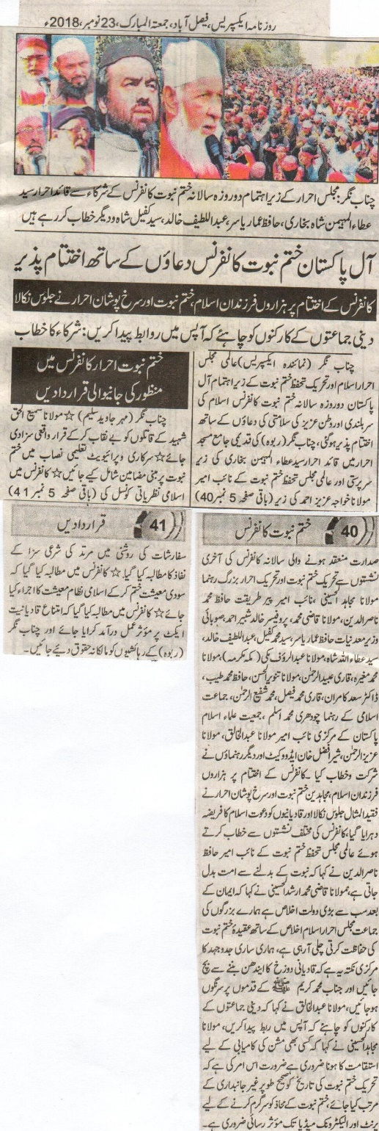

All Pakistan Khatme Nabuwat Conference ends with prayers.
At the end of the conference thousands of followers of Islam, Khatme Nabuwat and Ahrar wearing red bands started a rally.
Followers of the religious bodies ought to form a bond of mutual relationship
Chenab Nagar (Express Correspondent): Under the supervision ofInternational Majlis Ahrar Islam and Tehreek e Khatme Nabuwat an annual two-day All Pakistan Khatme Nabuwat Conference came to an end with the prayers being sought for the welfare of the country as well as for the honour of Islam. Quaid Ahrar Syed Attaul Muhaiman Bukhari and International Majlis Khatme Nabuwat’s vice president Maulana Khwaja Aziz Ahmad supervised the annual conference held at old Jamia Mosque in Chenab Nagar (Rabwah). Leaders of Tehreek e Khatme Nabuwat and Tehreek e Ahrar including Maulana Mujahid al Hussaini, vice president Pir Tareeqat Hafiz Muhammad Nasir ud Din, Maulana Qqazi Muhammad, Professor Khalid Shabir Ahmad, provincial minister for mines and minerals Hafiz Ammar Yasir, Syed Muhammad Kafeel, Abdul Lateef Khalid, Syed Attaullah Shah, Maulana Abdur Rauf Makki (Makkah), Maulana Muhammad Mugheera, Qari Ubaid ur Rehman, Maulana Tanvir ul Hassan, Hafiz Muhammad Tayyab, Doctor Saad Kamran, Qari Muhammad Faisal, MuhammadShafi ur Rrehman, leader from Jamati Islami Chaudhry Muhammad Aslam, International vice president from Jamiat ulema Islam Pakistan Ameer Maulana Abdul Khaliq, Maulana Aziz ur Rehman, Sher Afzal Khan Advocate and various others partook in the conference and addressed [the public]. At the end of the conference thousands who hailed themselves as the sons of Islam, Mujahideen Khatme Nabuwat and followers of Ahrar party wearing red bands [on their head] partook in a huge rally and invited Qadianis to folds of Islam. Talking to the conference, vice president International Majlis Khatme Nabuwat Ameer Hafiz Nasiruddin said that with the change in prophethood the ummah changes as well. Maulana Qazi Muhammad Arshad al Hussaini said that the biggest riches that faith provides is loyalty and our party formed by ancestors have been devoted to the protection of Khatme Nabuwat. Our whole mission for which we have been striving for is to ensure that Qadianis are safeguarded from the hellfire and come into the folds of [the religion] brought by the Holy Prophet^{sa}. Maulana Abdul Khaliq said that religious bodies ought to form a bond of mutual relationship. Maulana Mujahid al Hussaini added that to ensure victory of any mission consistency is the key. The need [of the time] is to remain impartial and collect the history of Tehreek Khatme Nabuwat. To have an effective front for this purpose, print and electronic media needs to be approached.
Resolutions Passed during the Conference:
Chenab Nagar (Mehar Javed Saleem)
- To unveil the identity of those involved in the murder of Maulana Sami ul Haq and punish them.
- Add essays pertaining to Khatme Nabuwat in government and private educational institutions.
- In the light of suggestion proposed by Islamic Council, the punishment for those leaving religion [Islam] ought to be implemented
- End system based on interest and introduce Islamic economic system.
- Implementation of anti-Qadiani act effectively.
- Accord proper ownership rights to the residents [Muslims] of Chenab Nagar (Rabwah)

Daily Express, Faisalabad, Friday 23 November 2018.

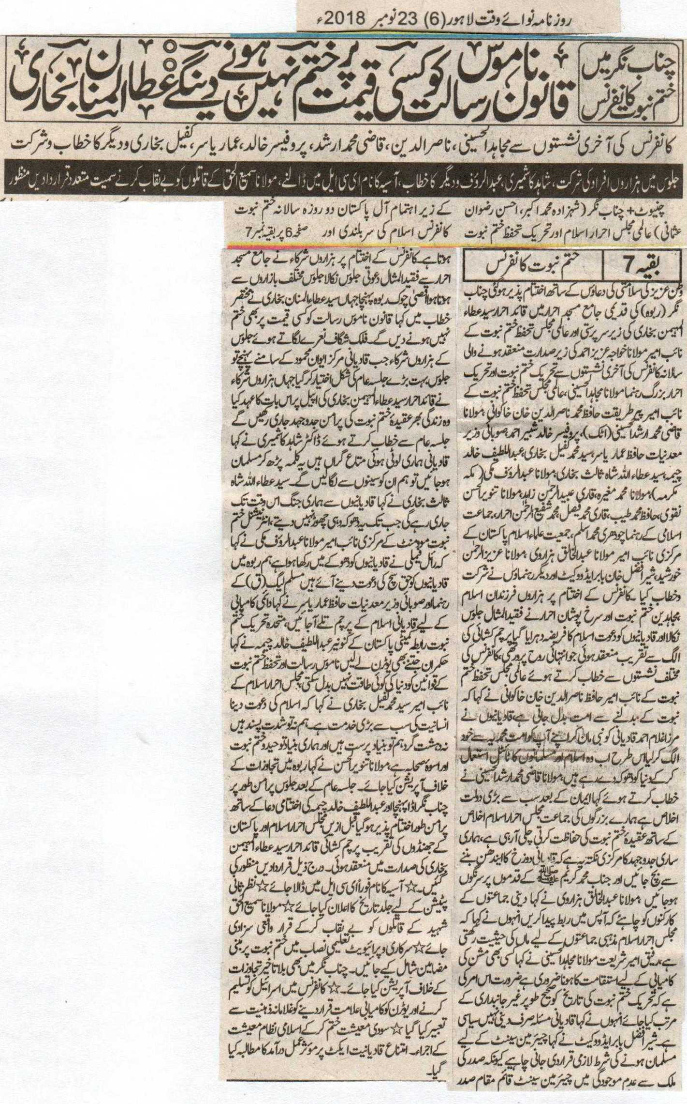
Khatm e Nabuwat conference held in Chenab Nagar. We will not let anyone omitting the law regarding honor of Holy Prophet PBUH at any cost, Ata ul Mannan Bukhari.
Mujahid al Husaini, Nasir ud Din, Qazi Mohammad Arshad, Professor Khalid, Ammar Yasir, Kafeel Bukhari and others attended and addressed the conference.
Thousands participated in the procession, Shahid Kashmiri, Abdulrauf and others addressed, various resolutions including putting the name of Asia bibi in ECL, unveiling the murderers of Maulana Samiul Haq.
Chiniot, Chenab Nagar (Shehzada Mohammad Akbar,Ehsan Rizwan Usmani) All Pakistan two days annual Khatm e Nabuwat conference was held by Almi Majlis Ehrar e Islam and Tehrik Tahafuz Khtm e Nabuwat. It was ended up with prayers for the solidarityof our country in old Jamia Masjid Ehrar of Chenab Nagar which was presided over bySyed Ata ul Maimon Bukhari. Peer Tareeqat , Hafiz Mohammad Nasir ud Din Khan Khakwani, Maulana Qazi Mohammad Arshad Alhusaini(Attock) Prof. Khalid Shabbir Ahmad, Provincial Minister for Natural sources Hafiz Ammar Yasir, Sayed Mohammad Kafeel Bukhari, Abdul Latif Khalid Cheema, Syed ata ullah Shah 3rd , Maulana Abdul Rauf Makki ( Makkah Mukarma), Maulana Mohammad Mughira, Qari Ubaid ur Rehman Zahid, Maulana Tanveer ul Hassan Naqvi, Hafiz Mohammad Tayyab, Qari Mohammad Faisal, Mohammad Shafi ur Rehman, Chaudhry Mohammad Aslam representative of Jamaat Islami, central leader of Jameet Ulma e Islam Pakistan Maulana Abdul Khaliq Hzarvi, Maulana Aziz ur Rehman Khursheed, Sher Afzal Khan Babar advocate and others addressed conference. A worth mentioning procession was held afterwards by thousands of Muslims, Mujahideen of Khatm e Nabuwat, and red dressed ehrars. They fulfill their religious obligation by calling Qadianis towards Islam. A separate soulful flag hoisting ceremony was held, Hafiz Kaqwani said in his address that the whole ummat changes with the change of prophethood.Qadianis have separated themselves by following Mirza Ghulam Ahmad Qadiani. Now they are deceiving the world by using the titles of Islam and Muslims. Maulana Qazi Arshad said that the best wealth after Eman is sincerity and this jamaat of our ancestors Majlis Ehrar Islam is performing its duty with complete devotion. Our main focus is to prevent Qadinis to fall in Hell and accept the teachings of Holy Prophet PBUH. Maulana Hzarvi suggested that all religious groups must interact. He further said that Majlis Ehrar is like a mother to all religious groups. Maulana Mujahid Alhusaini said that success to any mission is consistency, so dates of terik Khatm e Nabuwat must be contrived unbiased. Qadiani issue is religious and political simultaneously. Sher Afzal said that as chairman Senete becomes the head of the state in the absence of the president that is why the term and condition for the candidate as chairman Senete must be a Muslim. Maulana Bukhari addressed at Aqsa Chowk. Thousands of participants were raising slogans and marching as they arrive at aiwan e Mehmood it had already turned into a huge jalsa gathering. Here all participants promised to continue a peaceful effort for faith of Khatm e Nabuwat throughout their lives. Dr Kaashmiri said that Qadianis are just like our lost property. We will embrace them as soon as they read the Kalma. Syed Atatullah Bukhari said that our war with Qadianis will continue until they leave hypocracy. Mulana Abdul Rauf said that the royal family has kept the Qadianis in deceive. We all are here in Rabwah to invite them towards Islam. Hafiz Ammar said that Qadianis must come under the flag of Islam for eternal success. Convener Cheema said thatno power in this world can change the rules regarding Khatm e Nabuwat despite of the U-turns of government. Syed Bukhari said that calling towards Islam is the biggest service of humanity. We are neither extremists nor terrorists. Our faith is on Tauheed, Prophethood and actions of the companions of Holy Prophet PBUH. Maulana Tanveer ul Hassan demanded an operation against the illegal passages. It ended up on a silent prayer held by Abdul Latif Khalid Cheema at Chenab Nagar bus stop. Following resolutions were passed:
- Aasia`s name must be kept I n ECL immediately
- A date must be announced for Review petitions
- Murderers of Maulana Sami ul Haq must be arrested and punished
- Essays about Khatm e Nabuwat must become the part of syllabus of government and private schools
- Accepting Israel and declaring U-turn a success symbol were taken as a mind of slave

- Islamic economic system must take over the interest system
- An exemplary proceedings are demanded on the Prevention of Qadianiyat act.
    - Daily Nawai Waqt Lahore, 23rd November, 2018.

