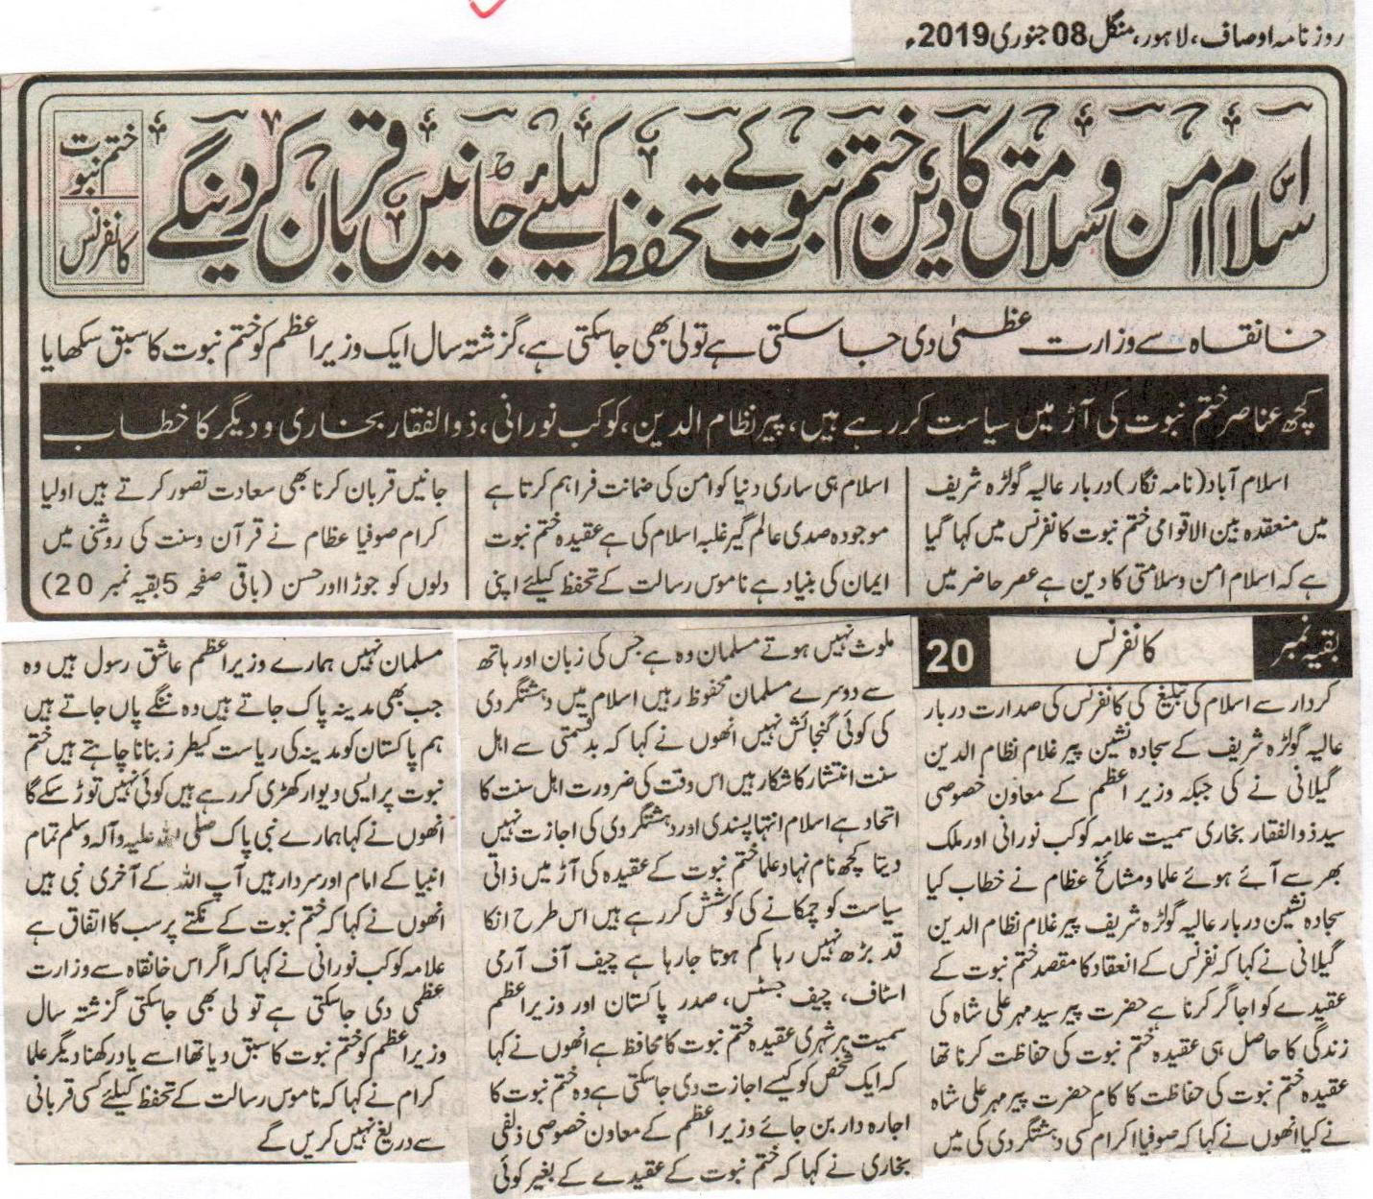
Islam is a religion of peace and security, will sacrifice our lives for the safeguard of Khatm e Nabuat: Khatm e Nabuat Conference.
If Prime Minister ship from high above, than it can also be taken back, last year a Prime Minister was taught a lesson regarding Khatm e Nabuat.
Some sources are doing politics in the name of Khatm e Nabuat, address of Pir Nizam Uddin, Kaukab Norani, Zulfiqar Bukhari and others.
Islamabad (Correspondent) It was said in International Khatm e Nabuat Conference held in Darbar e Aaliya Golra Sharif that Islam is a religion of peace and security. In the current age only Islam can provide the guarantee of peace throughout the world. The current century is the century of the Islamic revolution. The belief of Khatm e Nabuat is the base of faith. We consider it a privilege to sacrifice our lives for the safeguard of the honour of the Holy Prophet. The godly people and the saints preached the message of Islam in the light of the Holy Quran and Sunnah while joining the hearts of the public and through their good conduct. This conference was presided by the Sajjad Nasheen of Golra Shareef Pir Ghulam Nizam Uddin Gilani. Special advisor to the Prime Minister Syed Zulfiqar Bukhari, Allama Kaukab Norani and other clerics from around the world delivered their speeches. Sajjada Nasheen of Darbar e Aaliya Golra Shareef Pir Ghulam Nizam Uddin said in his speech that the objective of this conference was to highlight the belief of Khatm e Nabuat. The real objective of the life of Hadhrat Pir Syed Mehar Ali Shah was the safeguard of the belief of Khatm e Nabuat. Hadhrat Pir Mehar Ali Shah performed the task of safeguarding the belief of Khatm e Nabuat. He also said that the saints are not involved in any kind of terrorism. A Muslim is one from whose hand and tongue the other Muslims are safe. There is no room for terrorism in Islam. He also said that unfortunately the Ahl e Sunnat are not on a same page. At this point of time the unity of Ahl e Sunnat is the need of time and Islam does not allow extremism and terrorism. Some so-called clerics are doing personal politics in the name of the belief of Khatm e Nabuat. This is not increasing their status on the contrary it is decreasing it. The Chief of Army Staff, Chief Justice, The President, The Prime Minister and every citizen is a protector of the belief of Khatm e Nabuat. He also said that how can a single person be allowed to become responsible for the belief of Khatm e Nabuat. Special advisor to the Prime Minister Syed Zulfiqar Bukhari said that no one can be a Muslim without the belief of Khatm e Nabuat, the Prime Minister is a lover of the Holy Prophet (P B U H). Whenever he goes to Medinah he goes bare footed. We want Pakistan a state similar to the state of Medinah. We are preparing such a wall on Khatm e Nabuat which will be unbreakable. He also said that our Prophet Muhammad (P B U H) is the leader and head of all the Prophets. He is the final Prophet of Allah. He also said that with relevance to the belief of Khatm e Nabuat everyone is on the same page. Allama Kaukab Norani said that if the Prime Ministership can be given given from here it can also be taken back. Last year a Prime Minister was taught a lesson regarding Khatm e Nabuat you should remember that. Other clerics also said that we will not hesitate from any kind of sacrifice for the safeguard of the Honour of the Prophet.
(DailyAusaf Lahore, Tuesday, 09th January, 2019)

We will compete against those who plan to conspire against Qadianiat prevention act: Worldwide Khatm e Nabuwat Movement
Protection of faith of Khatm e Nabuwat is a way to obtain intercession of Holy Prophet (PBUH). MujahadeenKhatm e Nabuwat defeated Qadianis at every forum: Aziz Ur Rehman
Qadianis do not waste any opportunity to destabilize the country: Abdul Naeem and QariJameel Ur Rehman
Lahore (Staff Reporter) Leaders of Worldwide Khatm e Nabuwat Movement, Aziz Ur Rehman, Abdul Naeem, Jameel Ur Rehman Akhtar, Abdul Aziz and Aleem Uddin Shakir said in their addresses to the gathering that Muslim community never let any false claimant of prophet hood successful. They said that Muslims will keep on protecting law of blasphemy and Qadianiat prevention act. They will not step back from scarifying anything for the faith of Khatm e Nabuwat. Qadianis always use nefarious tactics with an aid of their foreign masters to ruin the image of the country. It is evident for every Muslim to protect himself from the deceits of Qadianis. Programs of Khatm e Nabuwat conferences and courses are being finalized.
(Daily Ausaf, Lahore, Monday, 7th January, 2019)

