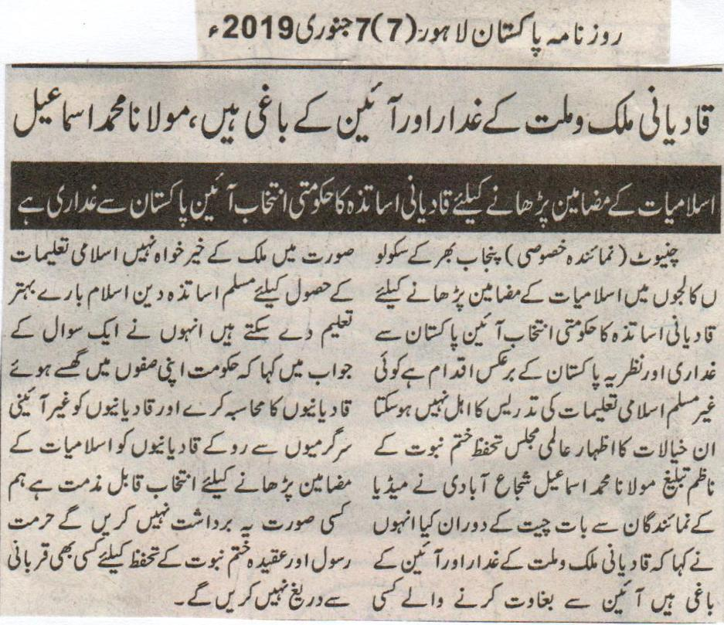
Qadianis are the traitors of the country and the nation, and are rebellion against the constitution, Maulana Muhammad Ismael
The selection of Qadiani teachers for teaching the subject of Islamiat by the government is rebellion against the constitution of Pakistan.
Chiniot (Special Representative) The appointment of Qadiani teachers to teach the subject of Islamiat in schools and colleges throughout Punjab by the government is a step of rebellion against the constitution of Pakistan and against the ideology of Pakistan. A Non-Muslim cannot be eligible to teach Islamic teachings. These thoughts were by the Preacher of International Majlis Tahaffuz e Khatm e Nabuat Maulana Muhamamad Ismael Shujabadi while talking to the media representatives. He also said that Qadianis are the traitors of the country and the nation, and are rebellion against the constitution. And the ones responsible for rebellion can never be faithful to the country. The Muslim teachers can teach Islamic teachings in a better manner. While answering a question he said that the government should hold the Qadianis present in their circles accountable, and should stop the Qadianis in their non-constitutional activities. The selection of the Qadiani to teach Islamic subjects is indeed condemnable, we will not tolerate it. We will not hesitate from any kind of sacrifice for the honor of the Holy Prophet and the belief of Khatm e Nabuat.
(Daily Pakistan Lahore, 7th January, 2019)

No one can include Qadianis among Muslims: Khatm e Nabuwat Movement
Constitutionally, Qadianis are non-muslim minority. We will not let conspiracies pertaining to Qadianiat, Khatm e Nabuwat and removal of related articles of constitution be prevailed.
Khatm e Nabuwat Movement always protected faiths of Khatm e Nabuwat, protection of honor of Holy Prophet (PBUH) and laws pertaining to Qadianis at every forum. We will follow this suit in future as well: Ismail Shuja Abadi
Lahore (Staff Reporter) Leader of Worldwide Khatm e Nabuwat Movement, Ismail Shuja Abadi and missionary Maulana Abdul Naeem said in their addresses to the gathering of students and scholars at Jamia Ahya Ul Aloom and Maftoha Lil Muslimat that Muslim community has separated Qadianis from Islam and Muslims due to their false faith. We will not let any Qadiani join the sect of Muslim. We will not let anyone make Qadianiat Prevention Act ineffective at any cost. They urged to remove Qadianis from prominent posts. Abdul Naeem said that faith of Khatm e Nauwat is a primary faith of Islam and entire building of Islam is based on it. Without believing Khatm e Nabuwat unconditionally, faith of Islam is incomplete. Protection of Khatm e Nabuwat and honor of Holy Prophet (PBUH) is a religious duty. Scholars expressed severe concerns over the rising conspiracies of Qadianis in Pakistan and asked government to perform its duty of stopping them from nefarious activities.
(Daily Ausaf, Lahore, Wednesday, 2nd January, 2019)

Every Muslim is obliged to protect Islam from Mirza Qadiani and evil of Qadianiat: Majlis Ahrar
We are slave to none except ALLAH. Ahrar always talked about truth whether it has to sacrifice everything.
Qadianiat is progressing due to its wealth. Its future will be dark while its conclusion will be horrific: Kufail Bukhari
Chenab Nagar (Ausaf Correspondent) Vice president of Majlis Ahrar Islam Pakistan, Kufail Bukhari said that anti-Islam forces used to protect traitors such as Qadianis but Islam will last forever. Muslims protected Islam with their blood during all the periods. Even today, every Muslim with self-respect is ready to sacrifice to protect his religion and every word of Holy Prophet (PBUH). Liar, Mirza Ghulam Qadiani initiated tradition of apostasy and paganism, but he failed. Now, his followers are concerned with the selling of his old tonic vine in new bottle. We will counterblast to every conspiracy of Qadianis. Qadianis are free to develop as many conspiracies as they wish, but Ahrarians will not depress. Those days are not far away when flag of Khatm e Nabuwat will be raised in every street whereas Qadianiat will be demolished all over the globe. Muslims can tolerate anything except the circumstances where slave to Britishers targeted crown of Holy Prophet (PBUH).
(Daily Ausaf, Lahore, Tuesday, 18th December, 2018)

American dream of controlling religious matters of Pakistan can never be achieved: Zahid Qasmi
Which minority does America want to give religious freedom? Parliamentarians having non-Islamic point of views are the barriers in converting Pakistan into a similar state like Madina.
Faisalabad (Special correspondent) Chairman of central Ulama council, Zahid Mehmood said in his address to the gathering at central Goal Mosque that none of the religious sects provides same rights to minorities that Islam provides them. Rejection of alcohol-bill by national assembly is negating Pakistan’s claim of converting Pakistan into the state like Madina. It is clearly a non-Islamic reform. American blame of violating religious freedom is an attempt to convince Pakistan to accept its do-more formula. Minorities have all basic rights in accordance with the law and constitution of Pakistan. Today, America is talking about the sect that never accepted Pakistan and its constitution. In fact, America is depriving minorities of basic rights in its state. Nation knows about the sect that America wants to provide with religious freedom under the cover of its blame of violating religious freedom. Parliament of Pakistan declared every person who was convicted of treason, non-Muslim. Zahid Mehmood praised Member of Parliament, Ramesh Kumar for presenting a bill pertaining to imposing ban on alcohol. On the other hand, he condemned all members who opposed that bill in the parliament. He said if government of Pakistan is sincere with its plan of converting Pakistan into Islamic state like Medina then it must take steps to have this bill passed by national assembly.
(Daily Nawa I Waqt Lahore, 15th December, 2018)

