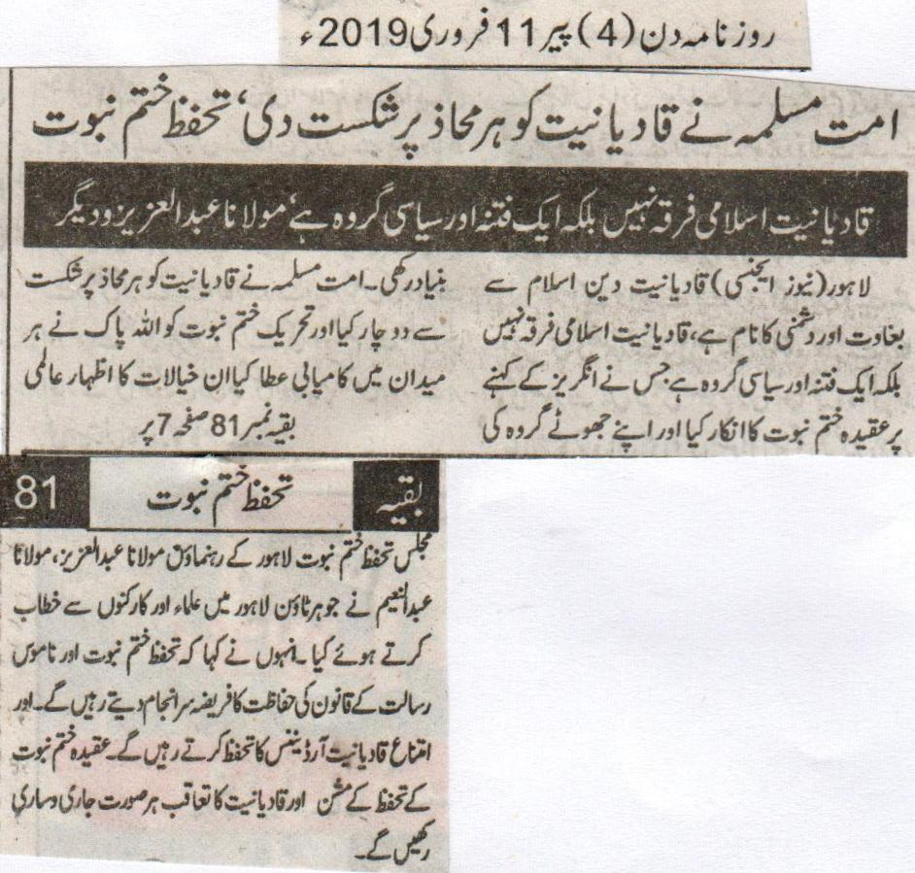
Muslim community defeated Qadianiat at every forum: Khatm e Nabuwat Movement
Qadianiat is not an Islamic sect but an evil and political group: Abdul Aziz and others
Lahore (news agency) Leaders of Khatm e Nabuwat Movement, Abdul Aziz and Abdul Naeem said in their addresses to the workers at Johar town that Qadianiat is a name of treason and enmity with the religion of Islam. It is a sect that denied faith of Khatm e Nabuwat as per the instructions of British and founded its liar group. God blessed Khatm e Nabuwat movement with the success at every forum. Speakers pledged to keep on performing the duty of protecting law of Khatm e Nabuwat. They also pledged to track down Qadianiat at any cost.
(Daily Din, Monday, 11th February, 2019)

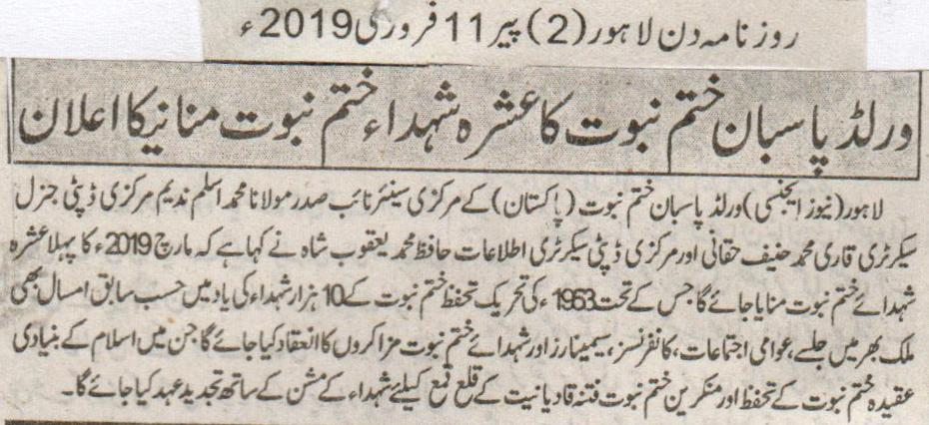
World Pasban e Khatm e Nabuwat announced to celebrate Ashra for martyrs of Khatm e Nabuwat.
Lahore (News Agency) Central vice president of world Pasban e Khatm e Nabuwat Maulana Mohammad Aslam Nadeem central Deputy general secretary Qari Mohammad Hanif Haqani and central Deputy secretary for information Hafiz Mohammad Yaqoob Shah said that first ten days of March 2019 will be observed in the name of the ten thousand martyrs of Khatm e Nabuwat of 1963 for which seminars, congregations, public gatherings, conferences will be held. A promise will be done with the mission of the martyrs to demolish the apostasy of Qadianiyat and protection of the basic faith of Khatm e Nabuwat.
(Daily Din Lahore, Monday, 11th February, 2019)

