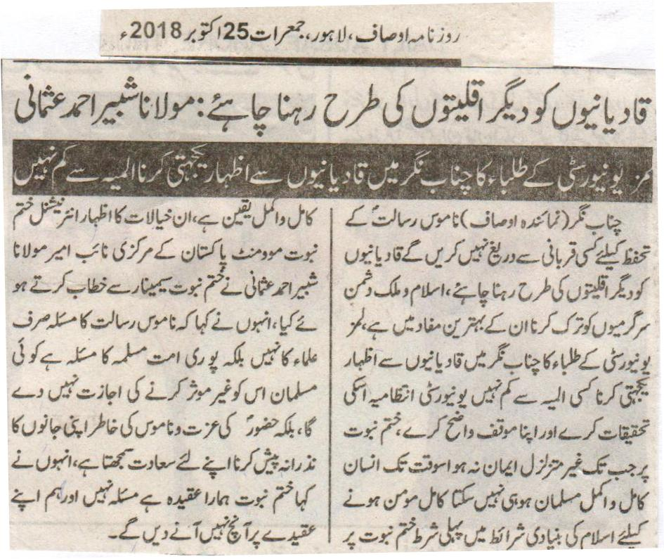
Qadainis should live like other minorities: Maulana Shabbir Ahmad Usmani
The visit of the students of LUMS University to Chenab Nagar to express sympathy with the Qadianis is nothing less than a calamity.
Chenab Nagar (Represenative Ausaf) Won’t hesitate from any kind of sacrifice for the safeguard of the Honor of the Holy Prophet (P B U H), Qadianis should live like other minorities. To refrain from anti Islam and anti-Pakistan activities is good for them. The visit of the students of LUMS University to Chenab Nagar to express sympathy with the Qadianis is nothing less than a calamity. The University administration should investigate this matter and should express their clear opinion about this. Till the time you have undoubted faith on Khatm e Nabuat a human cannot be a complete Muslim. In order to be a complete faithful (Momin) the first condition of the basic conditions provided by Islam is a complete and undoubted faith on Khatm e Nabuat. These thoughts were expressed by the Central Deputy Ameer of International Khatm e Nabuat Movement Pakistan Maulana Shabbir Ahmad Usmani while addressing a Khatm e Nabuat Seminar. He also said that the issue of the Honour of the Prophet Muhammad is not the issue of the clerics only, but it is the issue of the whole Muslim Ummah. No Muslim will give the permission to neutralize it, but on the contrary will consider it a blessing to sacrifice his life for the honor of the Prophet Muhammad (P B U H). He also said that Khatm e Nabuat is our belief not an issue and we will not let anything happen to our belief.
Daily Ausaf Lahore, Thursday, 25th October, 2018.
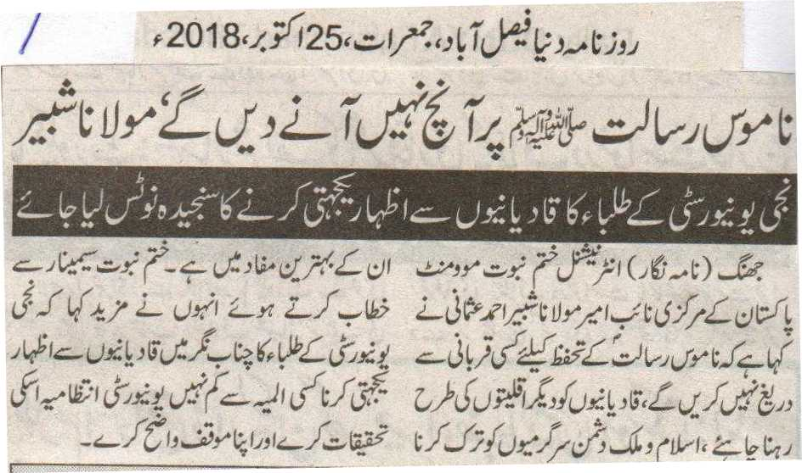
Won’t let anything happen to the Honour of the Prophet Muhammad (P B U H), Maulana Shabbir
The act of showing sympathy with the Qadianis by the students of the private University should be taken notice of in a serious manner
Jhang (Correspondent) Central Deputy Ameer of International Khatm e Nabuat Movement Pakistan Maulana Shabbir Ahmad Usmani said that we will not hesitate from any kind of sacrifice for the safeguard of the honour of the Prophet Muhammad (P B U H). Qadianis should live like other minorities. To refrain from anti Islam and anti-Pakistan activities is good for them. While addressing the Seminar he further said that the visit of the students of Private University to Chenab Nagar to express sympathy with the Qadianis is nothing less than a calamity. The University administration should investigate this matter and should express their clear opinion about this.
Daily Duniya Faisalabad, Thursday, 25th October, 2018.

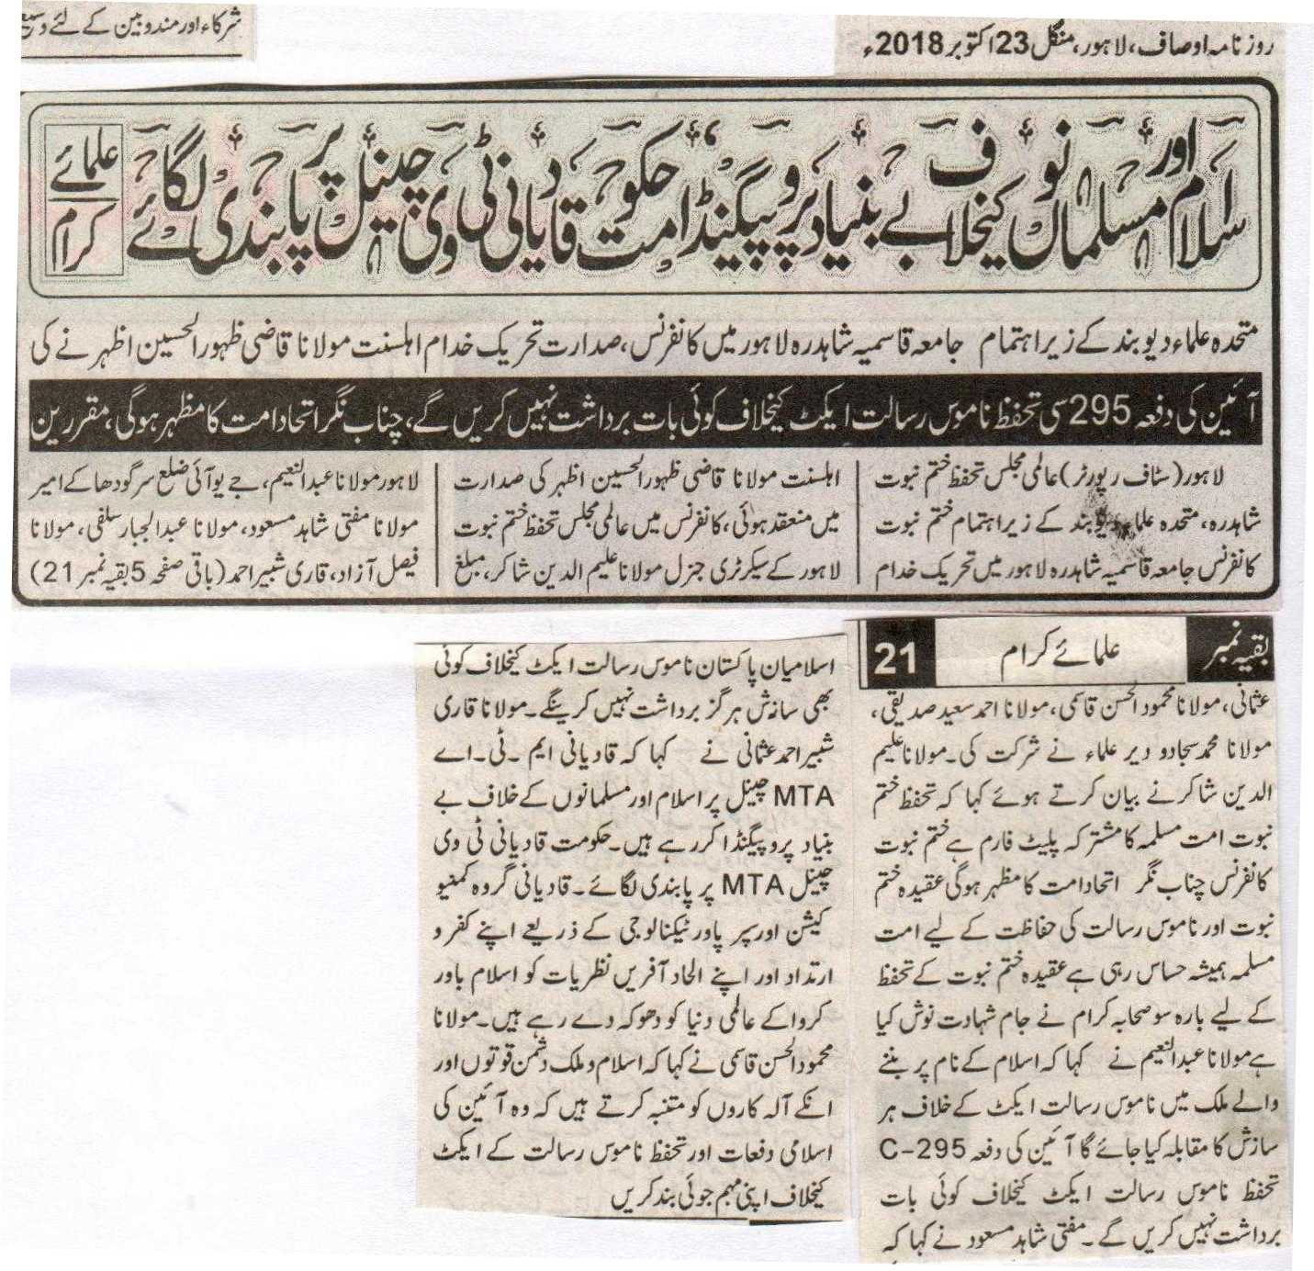
Due to the baseless propaganda against Islam and Pakistan, the Government should impose ban on the Qadiani TV Channel: The Clerics.
A conference held in Jamia Qasmia Shadhra Lahore under the sponsorship Mutahhida Ulema Deoband, was presided by Maulana Qazi Zahoor Ul Hasan of Tehreek e Khuddam e Ahl e Sunat.
Will not listen to anything against section 295-C the Blasphemy Act of the Constitution, Chenab Nagar will be a reflection of the unity of the Ummah, Speakers.
Lahore (Staff Reporter) Under the sponsorship of International Majlis Tahaffuz e Khatm e Nabuat Shadra, and the Deoband Clerics a Khatm e Nabuat Conference was held in Jamia Qasmia Shadra Lahore which was presided by Maulana Qari Zahoor Ul Hasan Azhar of Tehreek e Khuddam e Ahle Sunnat. General Secretary of International Majlis Tahaffuz e Khatm e Nabuat Lahore General Maulana Aleem Uddin Shakir, Missionary Lahore Maulana Abdul Naeem, Ameer of JUI District Sargodha Maulana Mufti Shahid Masood, Maulana Abdul Jabbar Salfi, Maulana Faisal Azad, Qari Shabbir Ahmad Usmani, Maulana Mahmood Ul Hasan Qasmi, Maulana Ahmad Saeed Siddiqui, Maulana Muhammad Sajjad and other Clerics attended this conference. Maulana Aleem Uddin Shakir while addressing said that the Safeguard of Khatm e Nabuat is a combine platform of the Muslim Ummah. The Khatm e Nabuat conference in Chenab Nagar will be a sign of unity of Ummah. The Muslim Ummah has always been sensitive about the belief of khatm e Nabuat and the safeguard of the Honor of the Prophet Muhammad (P B U H). 1200 Companions got martyrdom while trying to safeguard the belief of Khatm e Nabuat. Maulana Abdul Naeem said that every conspiracy against the act of Blasphemy Act in a country which was acquired in the name of Islam. Will not listen to anything against section 295-C the Blasphemy Act of the Constitution. Mufti Shahid Masood said that the Islamians of Pakistan will not tolerate any conspiracy against Blasphemy Law Act. Maulana Qari Shabbir Ahmad Usmani said that Qadianis are busy in baseless and false propaganda on MTA channel against Islam and Pakistan. The government should impose ban on the Qadiani TV channel MTA. The Qadiani group through communication and super power technology through their apostasy and evils are destroying the Islamic ideologies and are misleading the International world. Maulana Mahmood UI Hasan Qasmi said that we warn the anti-Islam and Pakistan forces and their supporters to stop their campaigns against the Islamic clauses in the constitution and the Blasphemy Act.
Daily Ausaf Lahore, Tuesday, 23rd October, 2018.

After Beaconhouse, extremists threaten LUMS ‘of consequences’
BY STAFF REPORT ,
OCTOBER 21, 2018)
PAKSITAN TODAY
LAHORE: After the Beaconhouse School System, the Lahore University of Management Sciences (LUMS) has also come under threat from the extremist elements.
A message, circulating on social media and SMS, warns the management of LUMS that a campaign will be launched against the varsity for its supposed ‘anti-Islam’ activities.
The warning message, which is making the rounds in social media, mentions a recent extracurricular visit by students of LUMS to the city of Rabwah, the headquarters of the Ahmadiyya community, as the reason for the threat.
According to the details, LUMS Assistant Professor of Political Science Taimur Rehman took one of his classes to Rabwah and to interact with the Ahmadiyya community in a bid to know the persecuted community better.
“In an environment where religious groups are spreading hate against the persecuted Ahmadiyya community, me and my students decided to go to Rabwah to express solidarity with the community” explained Prof Rehman in response to the criticism on social media.
The trip involved students interacting with the residents of Rabwah and trying to get to know and understand the community, their beliefs and problems.
However, after the local news agency of the town ‘Rabwah Times’ reported the incident, a great hue and cry was made with a number of people saying that the visit was a conspiracy meant to mainstream the Ahmadiyya movement.
This was followed by the circulation of threats against Prof Rehman, his students, and the LUMS administration.
Messages like “What is the LUMS teaching its students? Is this not the anti-Islam agenda of this university?” and “If LUMS does not respond, we will launch a campaign against them just like we launched a campaign against Beacon House” were circulated on various social networking platforms.
Earlier, Beaconhouse School System had also come under fire in a campaign led by self-proclaimed defence analyst Zaid Hamid, who had attacked the school for printing a question paper, asking the reasons behind the Pakistan Army’s loss in the 1971 war.
https://www.pakistantoday.com.pk/2018/10/21/after-beaconhouse-extremists-threaten-lums-of-consequences/

The Bigots of Politics
By Ali Arqam | Cover Story |
Newsline Magazine
Pakistan has a long history of politicians playing the faith or religion card to woo the voter, or to settle scores against political opponents. Apart from the religio-political parties who rely heavily on such arguments, members of mainstream political parties have often used religious references to pursue their political goals. Some have resorted to religious notions to attack and discredit their political rivals.
Captain (Retd) Safdar
Among all the members of mainstream political parties who have expressed bigoted views about the faith of political opponents or religious minorities, Nawaz Sharif’s son-in-law, Captain Safdar, tops the list. From paying homage to Mumtaz Qadri’s ‘bravery’ and extolling the virtues of vigilantism against alleged blasphemers, to venting outrage against Ahmadis in parliament, he has never shied from flaunting his bigoted views.
These views have invited the ire of people who term his narrative dangerous, and call on the government to charge him for glorifying terrorism, an act punishable under the law.
Rana Sanaullah
Former Law Minister Punjab and a prominent member of Pakistan Muslim League-Nawaz (PML-N), Rana Sanaullah, are among the most controversial figures in this regard. He is known for his close ties with proscribed religious outfits, including the Ahle Sunnat Wal Jamaat (ASWJ). In 2010, Barelvi religious clerics demanded his resignation from the PML-N and criticised him for not taking action against the murderers of Maulana Sarfaraz Naeemi, who was killed in a suicide attack, for which the Tehreek-e-Taliban Pakistan (TTP) claimed responsibility. The PML-N supported him, as he was instrumental in forging electoral alliances and seat adjustments with the ASWJ in the by-elections, as well as the 2013 general elections.
When the PML-N provincial government had differences with then Governor Punjab, Salmaan Taseer, he resorted to personal attacks and released pictures of Taseer’s family gatherings to the press, accusing him of conducting un-Islamic activities in the Governor’s House.
Taseer was later killed by his guard, a policeman, after religious clerics declared him a blasphemer for his efforts to help Asia Bibi, a poor Christian woman accused of blasphemy. The witch-hunt against Taseer and his family, led by Rana Sanaullah, was termed a “politically incited murder” by a PPP woman lawmaker.
Six months after the assassination of Salmaan Taseer, in a war of words with then PPP leader and cabinet member, Babar Awan, Sanaullah declared Babar Awan Wajib ul Qatal (one liable to be murdered). The remarks caused a stir and the upper house of parliament adopted a resolution against his remarks, demanding that the PML-N government remove Sanaullah from the post. In spite of the uproar, he remained unscathed.
However, last year, his surprising comments about the lack of religious freedom for minorities, especially Ahmadis, brought him at odds with conservative religious circles. The Barelvi radical group, Tehreek-e-Labbaik Pakistan (TLP), asked him to clarify his position on Ahmadis before a body of religious clerics. This was one of the demands in their negotiations with the Punjab government to end their April sit-in.
Sanaullah continues to spark controversy. In May, in a bid to demean the Pakistan Tehreek-e-Insaf (PTI)’s show of strength in Lahore, he passed some extremely misogynistic remarks against the women participants of the jalsa. Subsequently, Shahbaz Sharif, the party head, had to apologise for his remarks through a tweet.
Babar Awan
Babar Awan, former Senator and member of the Pakistan People’s Party (PPP) for almost two decades, parted ways with the PPP and joined the PTI last year. Awan, a prominent lawyer, has a tainted past due to his association with the military dictator, General Zia-ul-Haq. After joining the PPP, he became close to then party chairperson Benazir Bhutto and Asif Zardari and defended the cases against them in court.
Awan resorted to bigoted remarks against the Ahmadis when he was accused of taking 35 million rupees allegedly to bribe judges, from Sheikh Afzal, the owner of Haris Steel Mills, whose cases were pending in the courts. To defend himself, Awan termed the charges against him as a conspiracy by the Ahmadi lobby.
Babar Awan parted ways with the PPP last year and joined the PTI. He was appointed adviser to the Prime Minister on Parliamentary Affairs by Imran Khan, but had to resign from the post in the wake of corruption reference filed against him by the National Accountability Bureau (NAB) for allegedly causing delays in the Nandipur Power Project.
Syeda Shehla Raza
PPP leader and former deputy speaker Sindh Assembly, Shehla Reza is one of the most active women parliamentarians, but has a history of passing bigoted remarks against Ahmadis. She extolled the 1974 law that declared them non-Muslims. In early September this year, she mocked the PTI government’s decision of appointing Dr Atif R Mian as a member of the Economic Advisory Council, saying he was the great-grandson of Mirza Ghulam Ahmed Qadiani, founder of the Ahmadi faith.
She faced criticism for her tweet from within the party as well as from journalists and activists. She had to retract her remarks and delete the tweet. Later, she clarified that her social media team had tweeted the remark and it was not her opinion. In a surprising move, a few representatives of non-governmental organisations came to her defence through a press conference, terming the criticism against her a smear campaign.
Fayaz-ul-Hasan Chohan
A spokesman of the PTI provincial government in Punjab, the Minister for Information and Culture is termed the PTI equivalent of the PML-N’s Rana Sanaullah, for using derogatory language and bringing the religious beliefs of opponents into politics. Chohan recently caused outrage by his misogynistic remarks against Pakistani film and theatre’s female actors. He defended himself on TV by abusing a news anchor, and later apologised for it. Earlier, in 2015, he called Pervaiz Rashid, then federal Information Minister, an Ahmadi and termed his religious views as being heretical.
Recently, a video of Chohan reciting a naat on a visit to Mumtaz Qadri’s grave, appeared on social media. The family of Salmaan Taseer criticised the act of paying homage to a proclaimed offender, who was sentenced to death for committing murder.
The PTI, though, has played the Khatm-e-Nabuwwat card at the party level throughout its election campaign, to gain an edge over the PML-N, so the presence of politicians such as Chohan and the infamous Sheikh Rashid in their fold should not come as a surprise. In October 2017, a federal minister had made an amendment in the Khatm-e-Nabuwwat clause of the Elections Act 2017, which deals with the finality of the prophethood of Muhammad (PBUH). In the rewording of the clause (which was reversed after the backlash that followed), “solemnly swear” was replaced with “believe.” It resulted in weeks-long protests organised by the TLP at the Faizabad Interchange in Islamabad, in November. The PML-N government and the military finally caved in to the demands of the Khadim Hussain Rizvi-led TLP and the dharna came to an end. To gain political leverage over his opponents during the 2018 election campaign, Imran Khan repeatedly referred to the PML-N government’s attempt to amend the clause.
https://newslinemagazine.com/magazine/the-bigots-of-politics/

