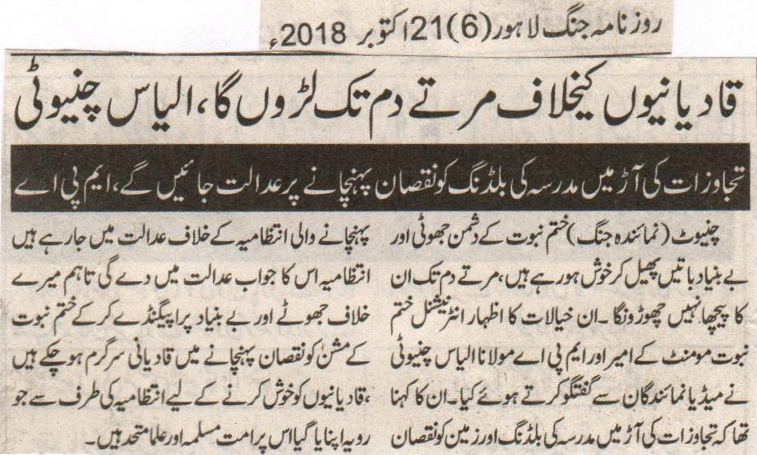
Will fight the Qadianis till my last breath, Ilyas Chinioti
Will go to the court on the damage cause to the Madrassa building, while making an excuse of operation against the encroachments, MPA.
Chiniot (Representative Jang) The enemies of Khatm e Nabuat are being while spreading false and baseless talks, will not leave them till my last breath. These thoughts were expressed by the Ameer of International Khatm e Nabuat Movement and MPA Mualana Ilyas Chinioti while talking to the media. He was also saying that we are going to the court for the damage cause to the building and the land while making an excuse of the operation against the encroachments. The administration will answer it in the court, but the Qadianis are busy in a false and baseless propaganda against me while causing damage to the Khatm e Nabuat issue. The Muslim Ummah and the Clerics are united against the attitude chosen by the administration to please the Qadianis.
(Daily Jang Lahore, 21st October, 2018).
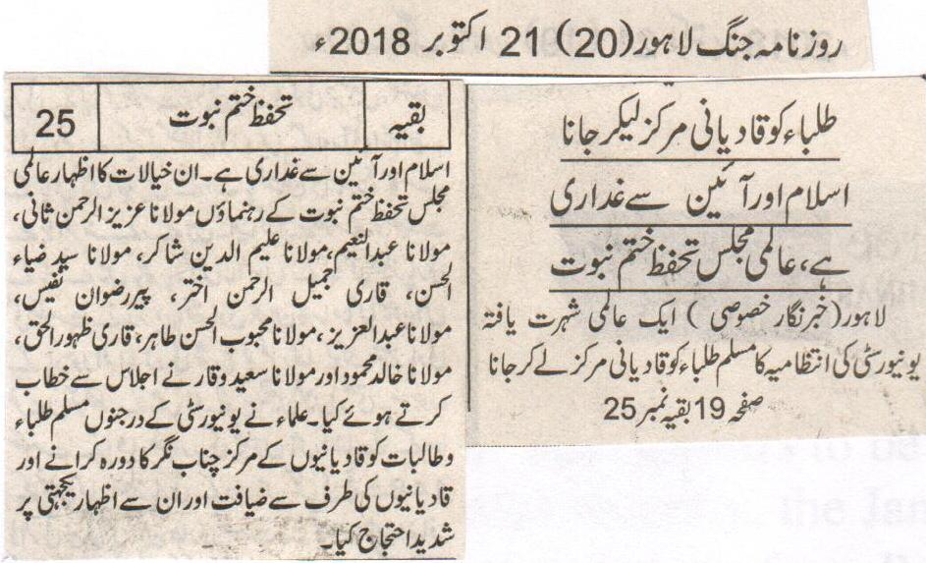
To take the students to the centre of the Qadianis is a rebellion against Islam and the constitution, international Majlis Tahaffuz e Khatm e Nabuat.
Lahore (Special Correspondent) To take the Muslim students of an Internationally renowned university to the centre of the Qadianis is a rebellion against Islam and Constitution. These thoughts were expressed by the leaders of International Majlis Tahaffuze Khatm e Nabuat Maulana Aziz Ur Rehman Sani, Maulana Abdul Naeem, Maulana Aleem Uddin Shakir, Maulana Syed Zia Ul Hasan, Qari Jameel Ur Rehman Akhtar, Peer Rizwan Nafees, Maulana Abdul Aziz, Maulana Mehboob Ul Hasan Tahir, Qari Zahoor Ul Haq, Maulana Khalid Mehmood and Maulana Saeed Waqar while addressing a sitting. The Clerics recorded a large protest on the visit of the number of male and female students to the center of the Qadianis in Chenab Nagar, and eating with them and showing sympathy with them.
(Daily Jang Lahore, 21st October, 2018).
EDITORIAL

‘Islamic revolution’

Daily Times
OCTOBER 21, 2018
Siraj-ul-Haq is a man who appears to be hitting back. For while addressing a youth convention in Peshawar recently, the Jamaat-e-Islami (JI) chief spoke of the need for an Islamic revolution to transform Pakistan into a truly ideological nation. And although he refrained from talking in terms of bully-boy tactics by stressing how the journey must start with the self — the message could not have been clearer. At least when seen through the eyes of the Ahmadiyya.
After all, Haq was not best pleased with a group of LUMS students. Their crime being to visit Rabwah in central Punjab; the country’s only Ahmadi-majority city. The purpose of the trip was to demonstrate solidarity with this most beleaguered group as part of a university community project aimed at promoting peace, tolerance and acceptance of Pakistan’s religious minorities.
This was sufficient to prompt Haq to take rhetorical aim at the Ahmadis. He accused the latter of conspiring against the country by spreading their influence in education institutes. Not only does this rob the students from one of Pakistan’s most prestigious universities of any kind of agency — it conveniently casts the Ahmadiyya in the role of aggressor.
It is regrettable that in the present climate, which has seen a resurgence of the religious right, such basic acts of good will negatively impact communities long under siege. This is not to suggest an interruption of such informal initiatives. Rather, it is to call on the mainstream political leadership to come together to stand with this group.
After all, it is the absence of collective action on this front that risks the security of all: religious minorities, human right defenders and even politicians themselves. Meaning that the only winners are the hardliners. And if this continues, Pakistan will never realise the dream of pluralism. Thus the Imran Khan government must take the lead over the next five years to right the wrongs of the immediate past. From not supporting the then PMLN government over the standoff with the Tehreek-e-Labbaik (TLP) over a clerical error that was deemed to afford the Ahmadis undue relief from institutionalised persecution. To a sitting MPA from that very regime denouncing this minority group on the floor of the National Assembly unchallenged. To a High Court judge essentially calling for their religious profiling.
If this does not happen, Pakistan will have suffered yet another non-inclusive set-up at the helm. *
Published in Daily Times, October 21st 2018.
https://dailytimes.com.pk/312650/islamic-revolution/

Perspective

The early champions of anti-Ahmadi cause
Manan Ahmed Asif
Updated 2 days ago

Illustration by Soonhal Khan
What we often report is that it was Zulfikar Ali Bhutto who passed a constitutional amendment on September 7, 1974 to declare Ahmadis non-Muslims. What we frequently state is that it was his nemesis Ziaul Haq who promulgated Ordinance XX which prohibits those already declared as non-Muslims from practising Islam. We trot out these constitutional and legal provisions sometimes to explain and at other times to justify – even condone – the unending physical and psychological violence inflicted upon the Ahmadi community in Pakistan. Such as when a mob burned down Ahmadi houses and historical sites in Sialkot on May 23, 2018. Such as when Atif R Mian, an economist at the Princeton University, had to resign on September 7, 2018 from the newly elected government’s Economic Advisory Council.
Those who support the exclusion of Ahmadis from public life in Pakistan argue that this exclusion is well-deserved because the Ahmadi community violates the Constitution of the Islamic Republic by insisting on being Muslim. (They conveniently ignore the fact that all citizens do not have to agree with all the provisions of a constitution all the time. Otherwise, any demand for a constitutional amendment would be illegitimate.) Even those who support civic liberties for Ahmadis do so only after qualifying their statements with Ahmadi-specific legal and constitutional provisions.
That the problems we have with Ahmadis all stem from the law and the Constitution is a soft-bellied lie of our prejudiced present and fallacious history. The current status of Ahmadis does not have its origin in 1974.
We seldom pause to remember how anti-Ahmadi laws came about and how the movement against them originated. We assume that these things happened as a logical next step after the creation of Pakistan as a Muslim state, making it an imperative to define and determine who was a Muslim – and, thus, a legitimate citizen of the new state – and who was not.
We need to remind ourselves that the discrimination that Muslims display towards Ahmadis did not suddenly develop after the creation of Pakistan. In fact, Majlis-e-Ahrarul Islam – one of the earliest instigators of an anti-Ahmadi movement – originated in British-ruled India. As early as 1935, it made a call for Ahmadis to be excommunicated from Islam and expelled from government offices. One key target of its ire was Chaudhry Zafarullah Khan, a leading Ahmadi jurist at the time.
We also need to remind ourselves that there have been many fierce champions of an anti-Ahmadi cause much before Tehreek-e-Labbaik Pakistan’s chief Khadim Hussain Rizvi came to promote it last year. One of the most prominent among them was one Agha Shorish Kashmiri, a poet, reporter, author and publisher. He did much, perhaps the most, to turn Pakistan’s Urdu-reading middle class – mainly in Lahore and Karachi – against Ahmadis.
Born in Amritsar in 1917, Kashmiri joined the Majlis-e-Ahrarul Islam in the mid-1930s and spent more than five years in jail under the Defence of India Act in the late 1930s and the early 1940s for his anti-Ahmadi activities. In 1944, Kashmiri moved to Lahore and began his career as a journalist. On January 1, 1949, he launched a colour weekly from the same city. It was called Chatan (‘rock’ in English).
Kashmiri imagined the magazine as one dedicated to the cause of Islam. It deployed Allama Muhammad Iqbal’s poetry and Islamic history as twin poles to emphasise the finality of the Prophet of Islam (may peace be upon him) as the last messenger of God. It had a couplet from a poem by Iqbal as its motto (which was printed on the cover of its every issue): Agarche buth hain jamaat ki aasteenon main/mujhe hai hukm-e-azaan la ilah-a-illallah (though idols are hidden in the sleeves of those standing for prayer/I am commanded to proclaim there is no God but Allah).
Inspired by Zamindar, a Lahore-based Urdu newspaper that had played a major role in mobilising Punjabi Muslims along religious lines before 1947, Chatan was priced low so as to maximise its outreach. For the first few years, an issue cost a couple of annas (12 paisas); by 1965, it cost 37 paisas; by 1980, its price rose to three rupees.
Chatan argued that, instead of being a religious group, Ahmadis were a political community that had conspired to create Pakistan out of India in order to have its own independent state which, it claimed, was going to be set up in Kashmir. This claim was the reason why Kashmiri raised his voice against Chaudhry Zafarullah Khan’s appointment as Pakistan’s foreign minister, arguing that, being an Ahmadi, he would misuse the post to help his own community achieve its political objectives.
Chatan also published reports that claimed Ahmadis were poisoning the Pakistani Army and the civil bureaucracy with their propaganda. Soon, the magazine started organising public meetings to demand Chaudhry Zafarullah Khan’s ouster from the government. These meetings featured speeches and writings from religious figures as Maulana Abul A’la Maududi, the founder of Jamaat-e-Islami, and Maulana Abu’l Hasan Nadwi, an eminent scholar.
Thus originated the earliest political movement in Pakistan — with the objective to demonise, expel and even discard the Ahmadi community. It is a movement that has been with us since 1947 – since the Kashmir issue began – and Jinnah appointed Zafarullah Khan as Pakistan’s foreign minister.
Maududi and Nadwi subsequently published two pamphlets, Qadiani Masla (The Qadiani Problem) and Qadianiat: Islam aur Nabuwwat-e-Muhammadi kay khilaf aik baghawat (Qadiani Movement: A rebellion against Islam and Prophet Muhammad), respectively. The pamphlets were published in March 1953.
Chatan, in the meanwhile, was aggressively mobilising public opinion against Ahmadis, labelling the agitation against them as Tehreek-e-Raast Iqdaam (Righteous Step Movement). Yet the agitation was seen by many in the country merely as an “Ahrar-Ahmadi Controversy”— at least this is how Justice Muhammad Munir framed it in his inquiry report on the anti-Ahmadi pogroms of 1953.
Kashmiri made a fresh bid at fanning anti-Ahmadi hatred in the mid-1960s. He began to argue that the Ahmadis were, in fact, Zionists. By using terms such as Mirza’il (an amalgamation of Israel and Mirza, the title of the Ahmadi community’s founding leader Mirza Ghulam Ahmad) and Ajami Israel (Eastern Israel), Kashmiri relied heavily on anti-Semitic and anti-Jewish notions to associate Ahmadis with a Zionist conspiracy to dominate the whole world. Chatan’s earlier insistence on Ahmadis being a political community was now smeared with an anti-Semitic internationalism.
The stories published in Chatan included lists of Ahmadi civil servants, bureaucrats and businessmen — ‘secretive’, ‘conspiratorial’ Ahmadis who were planning to bring about the demise of Pakistan. Ayub Khan’s dictatorial regime, that was generally soft towards the magazine, started censoring its contents in 1967. Kashmiri published the censorship order on his magazine’s cover on August 1, 1967. He was also jailed during this period for inciting violence.
After 1971, Chatan blamed the creation of Bangladesh on Ahmadi ‘conspiracies’. It portrayed Mirza Muzaffar Ahmad, President Yahya Khan’s economic advisor, as the source of grievances that East Pakistanis had developed against West Pakistan. On October 18, 1972, the magazine published a cover story that ‘exposed’ India’s plans to divide Pakistan into many states. Along with Bangladesh, these included Sindhudesh, Khalistan and an Ahmadi state in Balochistan.
During these years, Chatan turned to lobbying Zulfikar Ali Bhutto who had taken over power from Yahya Khan and who had already received a glowing profile in the magazine’s December 4, 1967 issue for publicly declaring that Ahmadi were non-Muslims. Though the government briefly jailed Kashmiri in August 1972 for provoking anti-Ahmadi violence, his agenda was clearly ascendant. By then the title of Mujahid-e-Khatm-e Nabuwwat (the soldier of the finality of prophethood) was conferred upon him by his supporters.
Kashmiri died in 1975 but Chatan did not stop its anti-Ahmadi campaign. It published cover story after cover story ‘exposing’ the presence of Ahmadi spies in the government as well as an Ahmadi ‘conspiracy’ to control the whole world in collaboration with Jews. Its July 12, 1982 issue carried a cover photo of Zia along with a self-explanatory caption: “Qadiani Activities and the Role of the President”. Inside the magazine was the coverage of an International Khatm-e Nabuwwat Conference in London and an article ‘exposing’ an Ahmadi ‘conspiracy’ against Pakistan’s nuclear weapons programme. The article included a quote from Dr Abdul Qadeer Khan, who is credited with being the founder of that programme, to substantiate its claims.
Chatan, however, is just one of the many streams that contribute to the river of hatred that separates Ahmadis from Muslims in today’s Pakistan. The magazine’s long run – that ended in 1989 when it ceased publication – helps us see the role of popular media in creating a public opinion in which Ahmadis have been reduced to nothing but conspirators, sub-citizens and even sub-humans.
These are the foundations of our hatred and communal discrimination that undergird our contemporary perceptions of the Ahmadi community — not any law or a constitutional amendment.

In an earlier version of this article, we wrote that Chatan held public meetings that featured religious figures such as Maulana Abul A'la Maududi and Maulana Abu'l Hasan Nadwi. We would like to specify that these meetings featured speeches and writings from the aforementioned religious figures. We also wrote that Maududi and Nadwi went on to publish two books in March 1953. They were actually pamphlets. We apologise for the errors.

The writer is a historian at Columbia University in New York.

This article was published in the Herald's October 2018 issue. To read more subscribe to the Herald in print.
https://herald.dawn.com/news/1398687/who-were-the-fierce-champions-of-an-anti-ahmadi-cause
- Home
- Today
- Opinion

A never-ending ordeal
Rabia Mehmood
October 16, 2018
International The News
As the world awaits the Supreme Court’s verdict on Aasia Bibi’s unjust conviction and death sentence in a blasphemy case, hardliners have started agitating both online and offline, increasing pressure on the authorities to uphold the sentence. A not-so-cryptic tweet by Rizvi Media of Tehreek-e-Labbaik (TLYR) reads: “Think carefully before making any decision.”
The fate of those unjustly accused of blasphemy hinges on this emblematic case, which has created an environment of fear and hostility for Pakistanis especially those who adhere to religions other than Sunni Islam.
Since Punjab Governor Salmaan Taseer’s killing in 2010, I have interviewed and spoken to hundreds of Pakistani minorities. The impact of Taseer’s death, for taking a stand against Aasia Bibi’s arrest on blasphemy charges, came up a lot in the conversations. Many spoke about how unsafe minorities felt in Pakistan. If a governor could not be protected, then what of religious minorities, who are at a higher risk?
Eight years on, the situation seems to be getting worse. Prosecutions on blasphemy charges have expanded to the internet and people have been accused even for social media posts.
In February this year, a video of an injured young man, Sajid Masih, went viral on social media. Sajid alleged that he was tortured by an officer belonging to the Federal Investigation Agency who ordered him to have sex with his cousin, Patras. Unable to bear the humiliation, Sajid jumped off from the fourth floor of the FIA building.
Patras Indreyas Masih, Sajid’s cousin, was charged with committing blasphemy – taken into police custody on February 19 after being accused of posting a blasphemous message on Facebook. The case, which was filed by a TLYR supporter, went to trial on April 30.
Patras Masih’s lawyer and family insist that he was a minor at the time of the alleged offence. However, the authorities have prosecuted and tried Patras as an adult. His family says that, despite allegations in the media that his National ID card showed he was 21, his age on his CNIC was changed for him to be able to get a job and provide for his low-income family.
His birth certificate clearly shows he was born in 2001, proving he was 17 at the time of the post. Pakistan is party to the Convention on the Rights of the Child, according to which each child has the rights to freedom of religion and expression.
Accusing and prosecuting children for blasphemy is not new to Pakistan. Many other minors who were arrested on blasphemy charges include Salamat Masih (11) of Gujranwala, Rimsha Masih (13) of Islamabad, Nabil Chohan (16) of Kasur, Ryan Stenton (16) of Karachi and Aqib Saleem (15), an Ahmadi of Gujranwala. Nabil Chohan has been in jail for two years without access to a lawyer of his choice.
In addition to minors, the list of Pakistanis condemned under blasphemy charges include women, older people, persons with mental disabilities, teachers, school and university students and many others. In 2009, a blasphemy case against a Muslim woman living with schizophrenia, Zaibunnisa, was quashed by the Lahore High Court after she had spent nine years in jail and five in a mental health facility.
Even the faintest suspicion of a blasphemy allegation is enough to put the accused and, in case of religious minorities, their entire community in danger. In 2012, I had reported on an Ahmadi man who was acquitted in a blasphemy case after spending years in prison sharing a barrack with militants. Despite being proven innocent, he ended up living in hiding, unable to step out the town his family was living in. He eventually had to flee Pakistan for a safer place for him and his family.
Christians and Ahmadis have been displaced within Pakistan and others have had to either flee the country or seek asylum elsewhere due to the lack of protections and the constant threat of blasphemy laws pending over them.
The impunity and free pass given to those who use blasphemy laws to threaten and attack minorities is not a mystery. So far, there has been no accountability for those who have justified and advocated hatred and discrimination against the most marginalised sectors of society.
Despite decades of activism by civil-society organisations, journalists and legislators to amend the blasphemy laws to protect the rights to freedom of religion and expression for all, Pakistani authorities seem reluctant to bring laws in line with international law and have preferred to stay in the past. In the meantime, the list of victims who fall prey to blasphemy allegations keeps growing.
The question is: will Naya Pakistan take a stand against the religious discrimination that has hounded minorities for decades in Purana Pakistan?
Today, Patras Masih’s parents remain displaced from their home due to threats they have received since their son was accused. It is time for the justice system to ensure that blasphemy allegations are no longer used to silence and violate the human rights of any Pakistani.
The writer is a South Asia Researcher at Amnesty International.
https://www.thenews.com.pk/print/381374-a-never-ending-ordeal

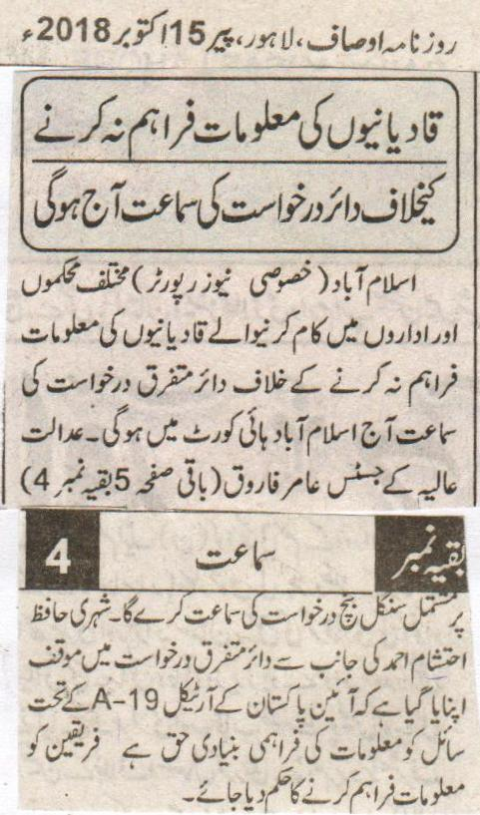
The hearing of the application submitted against not providing information of the Qadianis will be held today
Islamabad (Special News Reporter) The hearing on several applications submitted for not providing the information of the Qadianis working in different departments and institutions will be held today in Islamabad High Court. A single bench consisting of Justice Amir Farooqi of Supreme Court will hear this case. Hafiz Ehtisham Ahmad a citizen is of the view in different applications that according to Article A-19 of the constitution of Pakistan it is necessary to provide the questioner with the basic information. The parties should be instructed to provide the information.
(Daily Ausaf Lahore, Monday, 15th October, 2018).

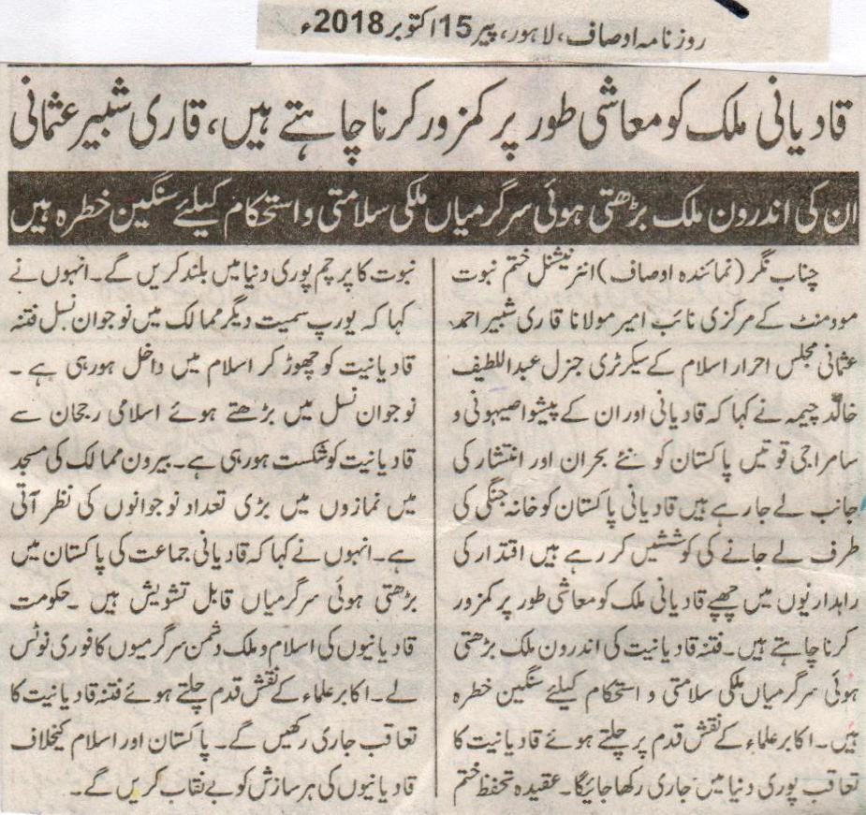

Qadianis want to make Pakistan weak financially, Qari Shabbir Usmani.
Their ever increasing activities inside the country are a severe concern for the security and integrity of Pakistan
Chenab Nagar (Representative Ausaf) Central Deputy Ameer of International Khatm e Nabuat Movement Maulana Qari Shabbir Ahmed Usmani, General Secretary of Majlis e Ahrar Islam General Abdul Latif Khalid Cheema said that Qadianis and their leaders the Satanic and the Jewish forces are taking Pakistan towards new crises and a state of disturbance. Qadianis are taking Pakistan towards the civil war. The Qadianis hiding in the circles of leadership want to financially weaken up the country. The ever increasing activities of the Qadianis inside the country are a severe concern to the security and integrity of the country. While following the footsteps of the clerics from the ancestors we will continue to pursue the Qadianis throughout the world. We will raise the flag of the belief of safeguard Khatm e Nabuat throughout the world. He also said that the younger generation is leaving the evil of Qadianiat and accepting Islam in countries throughout the world including Europe. The ever increasing interest of the younger generation towards is causing damage to Qadianiat. There are large number of persons from the younger generation that are seen in mosques in the foreign countries. He also said that the ever increasing activities of the Qadianis is a cause of concern. The government should take immediate notice of the anti Islam and Pakistan activities of the Qadianis. Will continue to persuade the Qadianis while following the footsteps of the clerics from the ancestors. Will reveal every conspiracy of the Qadianis against Islam and Pakistan.
Daily Ausaf Lahore, Monday, 15th October, 2018.

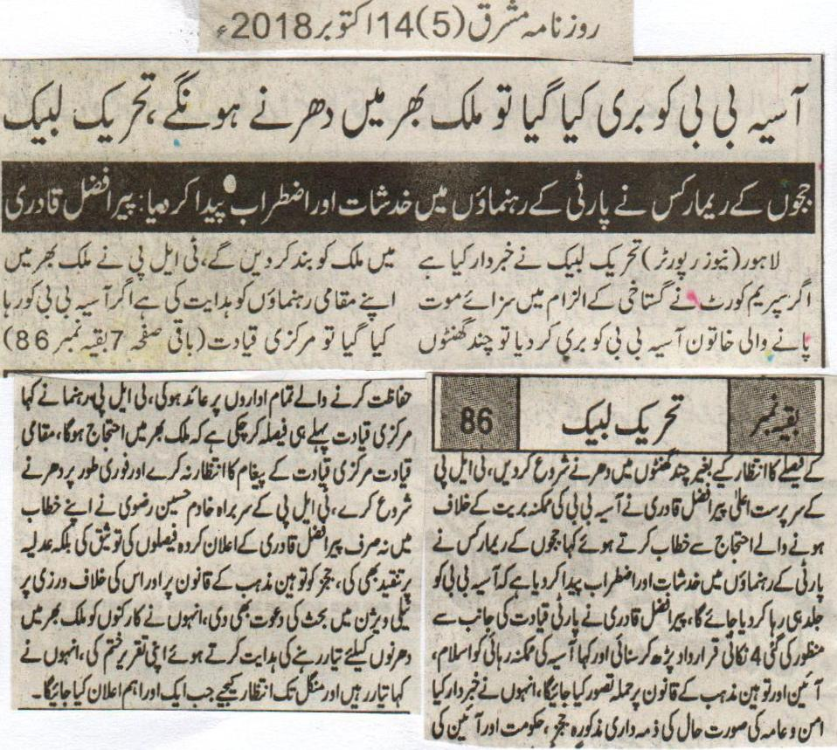
There will be countrywide protests if Asia Bibi is released, Tehreek e Labbaik
The remarks of the judge have created a concern and doubts among the party leaders. Peer Afzal Qadri.
Lahore (News Reporter) Tehreek e Labbaik has issued a warning that if Asia Bibi who is facing death penalty because of being accused of Blasphemy is released by the Supreme Court than we will shutdown the country within few hours. TLP has issued orders to their leaders throughout the country that if Asia Bibi is released, than to start the sit-ins within few hours without waiting for the decision from the Central Command. The caretaker of TLP while talking to the protest on the possible release of Asia Bibi said that the remarks of the judges have created doubts and concerns among the party leaders that Asia Bibi will be released soon. Peer Afzal Qadri read the 4 point resolution approved from the Party leadership and said that the probable release of Asia will be considered as an attack on Islam, constitution and the law of Blasphemy. He also said that it is the responsibility of the above mentioned judges, the government and the institutions protecting the constitution to maintain the law and order situation. The TLP leader also said that the central leadership has already decided that there will be countrywide protests. The Regional Leadership should not wait for the order of the Central Leadership and should start the sit-ins. The Head of TLP Khadim Hussain Rizvi not only backed the announced decision of Peer Afzal Qadri, but also criticized the Court. He also called on the law of Blasphemy and its violation and also invited him for a discussion on TV. He also ordered the workers throughout the country to be ready for sit-in and on this note he finished his speech. He said that be ready and wait till Tuesday when we will make another important announcement.
Daily Mashriq, 14th October, 2018.

