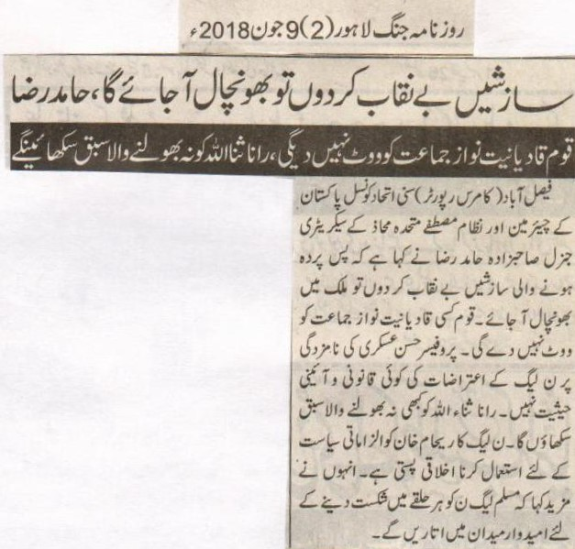
If I uncover the schemes chaos will come, Hamid Raza.
Nation will not vote Qadiyaniat supporting party, will teach unforgettable lesson to Rana Sana Ullah.
Faisalabad (commerce reporter) Hamid Raza, Chairman Sunni Unity Council Pakistan and Secretary General of Nizaam e Mustafa Mutahidda Mahaaz, said that if i uncover the schemes behind the curtain there will be chaos. Nation will note vote any Qadiyaniat supporting party. There is no legislative and constitutionalist value of N League's allegations against the nomination of Prof Hasan Askari. I will teach unforgettable lesson to Rana Sana Ullah. N League's use of Rehaam Khan to play blame politics is a moral degradation. He further said that we will put candidates in every sector so as to defeat PMLN in each sector.
Daily Jang Lahore (2)9th June, 2018

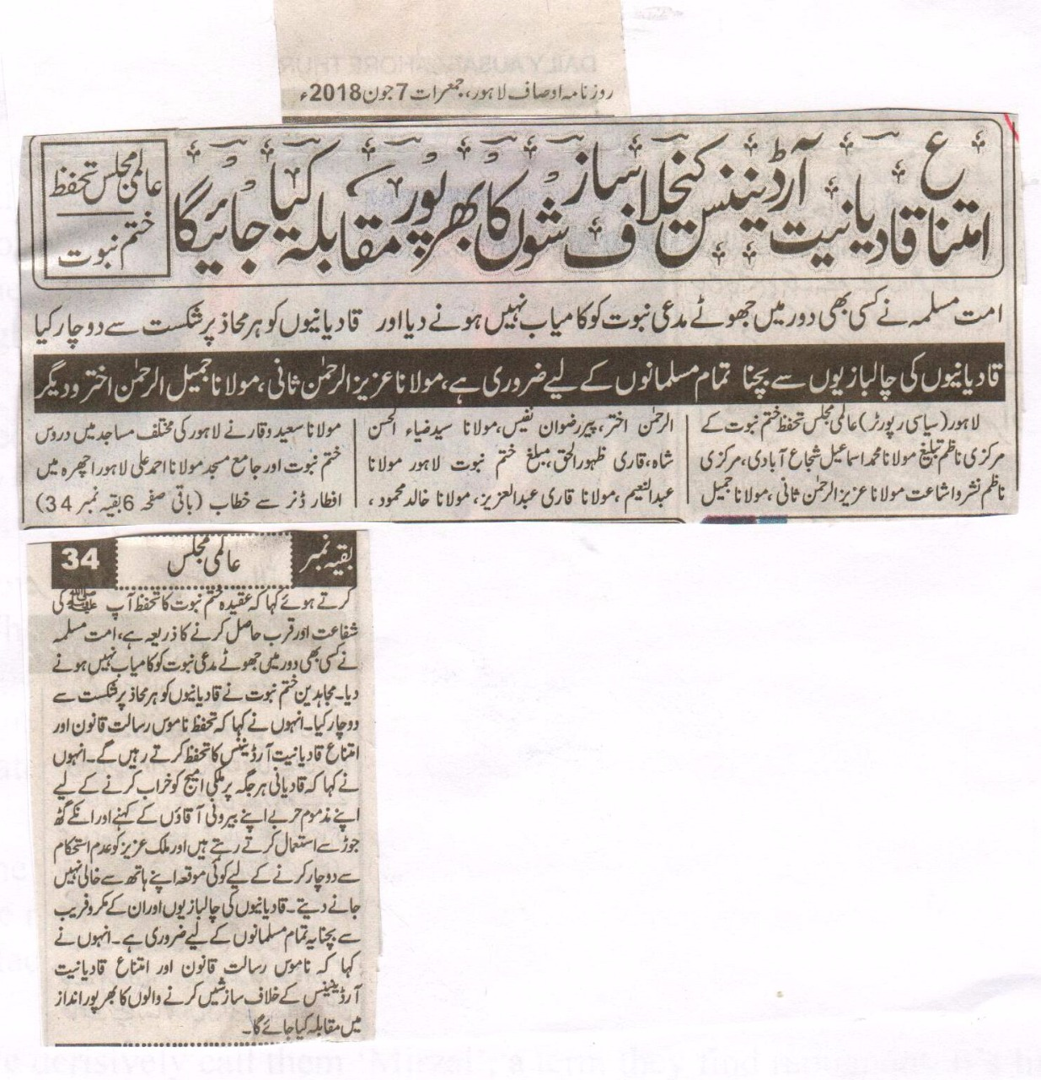
All the Conspiracies against Anti Qadianiat law would be fought against. International MajlisTahaffuzKhatm e Nabuwat.
The Muslim Nation has never let a false prophet succeed; they have on every front against Qadianies.
It is important for all the Muslims to protect themselves from the conspiracies of Qadianies. Maulana Aziz ur Rehman Sani, Maulana Jameelur Rehman Akhtar and others.
Lahore (Political Reporter) Maulana Mohammad Ismaeel Shujabadi central inchargetableegh (preaching) International Majlis Tahaffuz Khatm e Nabuwat, central Nazim Nashr o Isha’at Maulana Aziz ur Rehman Sani, Maulana Jameelur Rehman Akhtar, Pir Rizwan Nafees, Maulana Syed Zia Ul Hasan Shah, Qari Zahoor Ul Haq, Muballigh (Preacher) Khatm e Nabuwat Lahore Maulana Abdul Naeem, Maulana Qari Abdul Aziz, Maulana Khalid Mahmood, Maulana Saeed waqar spoke form different mosques all over Lahore and in his speech at Central Mosque Maulana Ahmad Ali Lahore Ichhra form Aftar Dinner said that the Belief in the Finality of the prophet hood SAW (Khatm e Nabuwat) is the way to achieve intercession of the holy prophet SAW and his nearness on the day of judgment. The Muslim Ummah (Nation) has never in any era let the false prophets succeed. The devotees of the Khatm e Nabuwat have defeated them on every front. They further said that we would defend the Anti Qadianiat Ordinance. He also said that Qadianiestry to destabilize the country and defaming it in front of western powers and they also become instrument of their plots against the homeland. Those who are conspiring against the anti Qadianiat ordinance would be dealt with iron hand.
(Daily Ausaf Lahore. Thursday, 7 June, 2018)

Enforced disappearance: Why a whole community is going missing
Haniya Javed
Updated Jun 06, 2018 02:47pm

Usama Munir thought the end was nigh. He was standing in the basement of an Ahmadi prayer hall inside Lahore’s Model Town area on May 28, 2010 wondering what might hit him — a bullet or a bomb. As visions of an imminent death circulated in his head, he saw someone falling into the basement from the floor above. The man landed in front of Munir, struck by a bullet in the back.
An unknown number of attackers had entered the ground floor of the prayer hall a few minutes earlier. They first hurled a grenade to create space for themselves. Then they stood in the middle of that space and started shooting indiscriminately. Many worshippers, hit by shrapnel and bullets, ran downstairs to the basement for cover. “A man had a bullet injury in his abdomen. He came downstairs, lay down and breathed his last,” recalls Munir, sitting in his house in Lahore in December 2017.
The mayhem continued for about half an hour. It ended only when the police, a bomb disposal squad and ambulances rushed in to clear the prayer hall off the attackers as well as the wounded and the dead.
Munir tried calling his father Munir Ahmad Sheikh while he was still in the basement. A retired judge of the Supreme Court of Pakistan, Sheikh was also the amir of Lahore’s Ahmadi community at the time. He was offering his prayer at another prayer hall in Garhi Shahu, around 12 kilometres to the northeast of Model Town.
The call did not connect. Sheikh would later call his wife to tell her that the Garhi Shahu prayer hall was also under a terrorist attack and that he had been hit by a bullet in the leg.
Three hours later, Munir and other members of his family were sitting inside their house in Garden Town, glued to the television and desperately seeking updates on the Garhi Shahu attack. Calls were being made to those outside the prayer hall there but no information was coming through. After an agonising wait, someone got the latest news and it was bad. Sheikh had not survived.
Around 98 people, including Nasir Ahmed Chaudhry, a 90-year-old retired major general of the Pakistan Army, also lost their lives in the twin attacks.
“Threats were there,” says Munir. His father was getting letters from Tehreek-e-Taliban Pakistan that they would attack Ahmadis in Lahore. One of the letters arrived right when Munir’s younger brother was getting married in December 2009. Those who sent the letter knew about the wedding and threatened to attack it. “My father deployed extra security at the periphery of the wedding’s venue,” Munir says.
He and his younger brother shifted to Rabwah shortly after the attacks.
They happened to be visiting Lahore in December 2017 for a family event when they faced something unusual. “My wife went to a grocery store to buy a toothbrush. A couple of people sitting inside the shop looked at each other and told her that they did not have toothbrushes even when she could see them on a shelf,” he says.
They knew she was an Ahmadi and would not sell anything to her.
Malala Yousafzai, a 15-year-old girl from Swat, was being treated at Queen Elizabeth Hospital Birmingham on October 27, 2012 when 22-year-old Ummad Farooq was flown into the same hospital from Karachi. Both Malala and Ummad Farooq were shot in the head. Both were targeted by religious extremism back home in Pakistan.
Three days earlier, Ummad Farooq was returning home in Karachi’s Baldia Town after attending a Friday congregation. He was riding a car along with his father Farooq Ahmed Kahloon and his brother Saad Farooq’s father-in-law Nusrat Chaudhry. Saad Farooq was escorting them on a motorcycle. Before they could realise that they were being followed, two men riding a motorcycle approached Saad Farooq and shot him dead. Next, they fired several bullets at the car, injuring all three of its occupants. One of the bullets entered Ummad Farooq’s forehead and got lodged in his skull.
Saad Farooq, 26, had gotten married only three days earlier. Flowers still hung from his wedding marquee in a part of his family home. “Look at these pictures of his wedding,” says his mother Kausar Farooq as she opens a grey photo album resting on a coffee table in her Connecticut house in the winter of 2016. Snow from the previous week still lines the roads leading to her residence in the village of South Glastonbury in the United States. She has been living here along with her family since 2013.
At the time of the shooting in Karachi, Kahloon was working as the head of the Ahmadi community in Baldia Town. He was under pressure to either relinquish his post or leave the area. Threatening messages laced with hatred would often appear on the gate or the boundary wall of his house. His community had engaged private guards for him yet Saad Farooq would insist on being with his father all the time. “Saad would always be the first one to get suspicious if someone was following his father,” Kausar says with her eyes shining brightly as if in pride over her son’s courage.
About five weeks before Saad’s assassination, police constable Muhammad Nawaz left his house in Karachi’s Orangi Town area to go to work. A few minutes later, his 17-year-old son Saqib Nawaz was rushing to the spot where his father lay dead in a pool of blood. The body was so disfigured that Saqib Nawaz could identify it only from the feet.

A sticker that reads “Qadianis are not allowed to enter” at a shopping centre in Lahore| M Arif, White Star
Nawaz was one of the 13 Ahmadis killed in various parts of Orangi Town within a few months that year. All these killings were part of a long-running campaign of violence against Ahmadis in Pakistan. The data collected by Jamaat-e-Ahmadiyya, an organisation that, among other things, watches the religious, economic and political interests of Ahmadis in Pakistan, shows that 260 of its members were killed in the country between 1984 and 2017.
According to Nawaz’s widow, his was a planned murder. A day after her husband was killed, two people from the neighbourhood knocked at her door and asked her if she was an Ahmadi. When she confirmed she was, they told her how they had overheard several men talking about the murder of an Ahmadi. The neighbours heard one of those men asking another if he had killed the right person. The other confirmed that he had followed the victim since his departure from his house and was certain about his identity.
For many days after Nawaz’s murder, his wife would gather all her five children in one corner of her house to avoid bullets being fired from outside. The local grocery store refused to sell them food, some unknown people cut their electricity connection and their regular electrician refused to fix it.
Eventually, they had to leave their home to stay safe. As did 83 other Ahmadi families living in Orangi Town, says Chaudhry Munir Ahmad, an Ahmadi activist in Karachi. He, too, was shot at in 2016 by two men riding a motorcycle but was lucky to have survived the attack.
Dr Abdul Khaleeq was not that lucky.
A member of Karachi’s Ahmadi community, he broke his fast on a day in June 2016 along with his family at his house in the Gulzar-e-Hijri neighbourhood near University of Karachi and left for his clinic located about five kilometres away in Sikandar Goth. A little later, some people barged into the clinic where two patients were waiting for their medical examination. The intruders shot Khaleeq, told the patients to go away, pulled the shutters down and left.
Someone who ran a pharmacy opposite the clinic immediately informed Khaleeq’s family about the shooting. The doctor’s son wasted no time in reaching the clinic. He put his father in a car and rushed to a nearby hospital. Khaleeq was already dead when they reached the hospital.
The very next day, his widow, Bushra Khaleeq, heard about some suspicious looking men doing rounds of the streets where she lived with her children. Her brother brought them all to his own house in Azizabad area to ensure their safety. “It seems some people wanted [Gulzar-e-Hijri] cleared of Ahmadis just as they have in Baldia and Orangi towns,” he says in December 2017.
Work started in a routine fashion on Friday, November 20, 2015, at a chipboard manufacturing factory owned by Jamaat-e-Ahmadiyya in Jhelum. The process of burning waste paper started as early as 6:00 am. It was all done by 8:00 am, allowing the workers to perform other tasks.
At around 3:30 pm, when work resumed after a prayer break, some workers came to Qamar Tahir who was in charge of waste disposal that day. They told him about reports doing the rounds in the factory that papers burnt earlier in the day included pages of the Quran. He went to the part of the factory where some people were discussing the issue. They showed him a partially burnt copy of the Quran and told him that they had found it when they were taking out the ash.
The copy was burnt around the edges but there was no damage visible to the area where verses were written, Tahir says in an interview in December 2017. This did not make sense to him. “Temperature inside the site where the paper was burnt could be anywhere between 900 and 1,000 degrees centigrade. It would be impossible for any paper to remain undamaged or partially damaged once it was thrown into that space that had only a 10-feet diameter,” he says.
In less than an hour, the police arrived and arrested him. “They tortured me and kept me in a lockup in Jhelum,” he says. Later that evening, a mob torched the building, the machinery and the raw material at the factory that remains closed even today.
Tahir was then taken to a jail in Gujrat city where he spent two months before he was shifted to Adiala Jail in Rawalpindi. A court later sentenced him to imprisonment for 25 years for ordering the desecration of the Quran. He appealed to the Lahore High Court against his sentence and the judges ordered his release on August 30, 2017 saying there was no evidence against him.
Tahir is among 516 Pakistani Ahmadis alleged to have committed blasphemy since 1987; nine of them have been killed by lynch mobs or in targeted attacks. According to the data compiled by Peter Jacob of the Lahore-based research and advocacy group, Centre for Social Justice, Ahmadis constitute about one-third of all those who have faced allegations of blasphemy in Pakistan in the last 30 or so years.
Tahir insists the blasphemy allegation against him was motivated by something other than his religion. The whole episode, he claims, had its origin in an agitation by some workers who wanted to unionise. He also alleges these workers were being egged on by some real estate developers in the area who were eyeing the factory’s land to set up a housing scheme. “The management did not want to sell it.”
Close to two and a half years after that fateful day, Tahir is still not sure if he could go back to Jhelum and be safe there. “I want to spend another year away from my hometown so that the incident gets erased from people’s minds,” he says.
Until then, he will be biding his time in Rabwah.

The interior of an Ahmadi prayer hall in Lahore after a terrorist attack in 2010 | M Arif, White Star
Rabwah is almost midway on the highway that connects Sargodha in the west with Faisalabad in the east. Located just opposite Chiniot city, it is spread over 1,500 acres of land lined with low brown hills on the southwest and the river Chenab on the east.
A large cemetery called Behishti Maqbara, or heavenly graveyard, can be seen on the right where a narrow road diverges from the highway to go to Chenab Nagar. Secured by barbed wire with just one heavily guarded entrance, this burial place is reserved for Ahmadis who donate a certain portion of their income to their Jamaat. The space is allocated on the basis of who has given how much to their community both in cash and kind.
Paths within the cemetery look smooth and well maintained. The graves, covered in pebbles, all have tombstones. In one of them is buried Pakistan’s most known physicist, Dr Abdus Salam. “In 1979, [he] became the first Nobel laureate for his work in Physics,” reads his tombstone in Urdu. In September 2014, someone erased the word ‘Muslim’ between ‘first’ and ‘Nobel’, making the epitaph inaccurate.
One Maulana Zulfiqar Ali Khan Gauhar is buried on a raised platform to the right of Salam’s grave. He was the elder brother of Maulana Shaukat Ali and Muhammad Ali Jauhar, the famous Ali Brothers, who led a movement of Indian Muslims for the protection of the Turkish Muslim Caliphate in the late 1910s.
A separate enclosure is dedicated to the successors of Mirza Ghulam Ahmad, the founder of the Ahmadi faith, their wives and other prominent members of Jamaat-e-Ahmadiyya. The tombs are bigger in this section, the epitaphs are more descriptive and the graves are given more space. It is here that Pakistan’s first foreign minister Sir Zafarullah Khan lies buried.
The road that leads in to the residential part of Rabwah is lined by small shops and tea stalls. Autorickshaws and motorcycle-driven autotongas wait for passengers outside a large hospital just at the start of the town. This medical facility is run by Jamaat-e-Ahmadiyya and caters to a large number of patients every day. Many of them are non-Ahmadis living in nearby towns and villages.
Rabwah is home to about 70,000 Ahmadis. It offers them a safe haven if and when they feel unsafe elsewhere in Pakistan. “[It] is a temporary refuge and a shelter,” says Amir Mahmood, spokesperson of Jamaat-e-Ahmadiyya in Rabwah. “People find a sense of security in this town because the Ahmadi community lives here together.”
Except that Rabwah is not always safe.
An Ahmadi heart surgeon, Dr Mehdi Ali Qamar, was murdered in 2014 as he was leaving the graveyard just outside the town. A 26-year-old Ahmadi, Bilal Ahmed, was gunned down on a street inside Rabwah in 2016 while he was on his way home from his shop.
Rabwah was set up as Jamaat-e-Ahmadiyya’s headquarters in 1948 on land purchased from the government. “The city was to serve as a centre or a foundation for the Ahmadiyya movement,” says Mahmood.
Mujeebur Rahman, an 83-year-old lawyer in Rawalpindi, remembers the day when the foundation stone for the town was laid. “It was barren land … Samples of the soil were sent to the University of Agriculture, Faisalabad, and it was found to be completely infertile,” he says.
Vegetation is still rare in Rabwah. A big meeting ground, which has not been used for years, is grassy but sprinklers work regularly to keep it so. A number of trees can be seen around the Jamaat’s secretariat, its guest house and the residences of its main leaders. The roads leading to these buildings are also smooth and clean. Deeper inside the town, the streets are sandier, narrower and bumpier. Patches of greenery there are also small and tree cover is thin.
The road leading to the town’s main prayer centre, Baitul Mehdi, is heavily barricaded. Policemen and young volunteers stand guard outside the centre as the Friday sermon is being delivered inside. Twenty minutes later, worshippers leave in twos and threes. They do not exit en masse to avoid becoming targets of a mass attack.
Muslim religious leaders never liked the idea of Ahmadis living in a town of their own. They first made the government allot some land to Muslims on the periphery of Rabwah. Then they created additional pressure to force the government to change the name of the place in order to erase its Ahmadi identity. The Punjab Assembly consequently changed Rabwah’s name to Chenab Nagar on February 4, 1999 against the wishes of 95 per cent of its residents who happen to be Ahmadis.
They also do not have any representation in the local government, which is run entirely by the representatives of the remaining five per cent. As a result, government-provided amenities remain scarce in Rabwah. “Development work here is done cursorily. [The town] is not the government’s primary concern,” says Mehmood. Why would an exclusively non-Ahmadi government care about a much-hated community’s welfare, he asks, especially when “they do not get any votes from here”.
And that is one of the main reasons why Ahmadis are not represented in the local government. They stopped taking part in the polling process four decades ago as a protest against voter registration and public representation laws that are discriminatory towards them (since they require a mandatory declaration of faith by all Ahmadi voters as well as Ahmadi contestants). “We want to vote but we will not as long as were are being discriminated against for our faith,” says Mehmood.
Parliament tried to do away with some of this discrimination when it passed the Elections Reforms Amendment Act 2017 in October last year. The act changed, among other things, a phrase from an oath about the finality of prophethood that all election candidates must take while filing their nomination papers — from “I solemnly swear” to “I declare”. The new law also rescinded Sections 7-B and 7-C of the Conduct of General Elections Order, 2002. The first of these sections reiterated the constitutional status of Ahmadis as non-Muslims and the second provided for the deletion of a candidate’s name from a joint electorate if he or she failed to sign a declaration on the finality of prophethood.
Within five days, the government backtracked and reversed the changes.

A portrait of Dr Abdus Salam at the primary school he attended in Jhang | M Arif, White Star
Mirza Ghulam Ahmad, born in 1835, is recognised both as a messiah and a prophet by his followers who are known as Ahmadis — or derogatively as Qadianis and Mirzais. Since Muslims believe that no prophet will follow the Prophet of Islam (may peace be upon him), most of them see Ahmadis as apostates.
The emergence of the Ahmadi community in the second half of the 19th century was also seen as part of a colonial conspiracy to keep Indian Muslims divided and, thus, subservient to the British.
The Muslim antagonism towards them soon made it to courts.
Ali Usman Qasmi, a teacher at the Lahore University of Management Sciences, cites in his book, The Ahmadis and the Politics of Religious Exclusion in Pakistan, the case of a woman from Bahawalpur who filed for divorce from her husband in 1926 on the ground that he had become an apostate by converting to Ahmadiyyat. The chief court of Bahawalpur initially rejected her petition but she filed a review petition at the Supreme Judicial Council that sent the case to a trial court. A lengthy trial followed in which religious arguments for and against Ahmadis were presented in detail. A final verdict, issued in 1935, decreed that Ahmadis were non-Muslims and converting from Islam to Ahmadiyyat was an act of apostasy.
Yet, in the political sphere, Jamaat-e-Ahmadiyya worked in tandem with other Muslim political organisations such as the All India Muslim League. Ahmadis supported the movement for Pakistan (whereas most ulema-led religious parties opposed it). Sir Zafarullah Khan, a prominent Ahmadi lawyer, in fact, became one of the main leaders of the movement. He was also chosen as the Muslim League’s representative in the commission that drew the boundary between the Indian and Pakistani parts of Punjab. He would soon be criticised for letting India have the Gurdaspur tehsil of Sialkot district even though it was a Muslim-majority area. The reason why Gurdaspur is so central to the anti-Ahmadi narrative is that it is here in the village of Qadian that Mirza Ghulam Ahmad was born.
After Pakistan came into being, Sir Zafarullah Khan became a close aide of Muhammad Ali Jinnah besides being the foreign minister. But when Jinnah died in 1948, he would not offer his funeral prayer, providing more grist to the propaganda mills that alleged that his act of not participating in the funeral prayer was occasioned by his belief that the Father of the Nation – like all non-Ahmadis – was a non-Muslim.
Jamaat-e-Ahmadiyya spokesperson Mehmood says the reason why Sir Zafarullah Khan did not offer the funeral prayer was because “it was led by Maulana Shabbir Ahmed Usmani who believed Ahmadis to be apostates”. Sir Zafarullah Khan did not think it right to offer the prayer behind someone who considered his community as non-Muslim, Mehmood adds.
Coming as it did immediately after Gurdaspur going to India, this generated a massive amount of public anger against Sir Zafarullah Khan in particular and Ahmadis in general. Demands for his sacking from the government grew louder with each passing day.
These demands pushed the government into a bind. Pakistan was facing a severe wheat shortage at the time and his services were needed to reach out to the United States and other western countries for help. This made it impossible for the government to sack him.
The animosity between Ahmadis and non-Ahmadis, in the meanwhile, was becoming so intense that the two sides deployed whatever means and resources they could muster against each other — including popular media such as newspapers and magazines. Sensing the threat to law and order caused by these incendiary publications, the government banned several journals and newspapers brought out by various religious parties as well as by Jamaat-e-Ahmadiyya.
This stoked public anger further rather than quashing it. People came out on to the streets across Punjab in February 1953 and large scale anti-Ahmadi agitation started throughout the province, leading to the murder of hundreds of Ahmadis. The government imposed Section 144 that bans public gatherings but this, too, did not work.
Qasmi describes how rumours about mass killings of protesters at the hands of the administration helped the agitation to maintain its momentum.
On March 4, 1953, a police official was lynched to death near Wazir Khan Mosque in Lahore after someone alleged that he had desecrated a book of religious verses while dispersing a crowd of protesters. In subsequent riots and the police attempts to suppress them, 24 people were killed and as many as 100 others were injured. When the situation became too difficult for the civilian administration to handle, the government imposed martial law in Lahore and deployed the army in various parts of the city to restore public order.
The martial law authorities acted quickly and arrested a large number of protest leaders, including Abdul Sattar Niazi, a firebrand mullah from Mianwali, and Abul A’la Maududi, the founding head of Jamaat-e-Islami. Both were given the death sentence in May that year for inciting hatred against Ahmadis.
The government also set up a court of inquiry comprising then chief justice of Pakistan, Mohammad Munir, and a Lahore High Court judge, Rustam Kayani. It was directed to look into the events that had resulted in the deadly violence. After detailed hearings, the two judges compiled their findings in a report that stated that various political leaders and government representatives were largely to be blamed for letting politics take precedence over law and order and thereby allowing the situation to worsen under their watch.
During the hearings, the judges also sought explanations from Jamaat-e-Ahmadiyya on its statements that referred to non-Ahmadis as kaffirs (apostates). They also asked ulema and religious leaders to define what a Muslim is so that this definition could be used to determine the religious status of Ahmadis.
No unanimous definition emerged at the end of the day. “On the basis of the ‘definition’ given by the ulema, the Munir-Kiyani report made its best-known statement,” notes Qasmi. This statement stated: “If we attempt our own definition as each learned divine has done and that definition differs from that given by all others, we unanimously go out of the fold of Islam. And if we adopt the definition given by any one of the ulama, we remain Muslim according to the view of that alim but kafirs according to the definition of every one else.”

Civil society members hold a peace vigil for the Ahmadi community outside an Ahmadi prayer hall attacked in Lahore in 2010 | M Arif, White Star
The infamous ‘Rabwah incident’ started in an unlikely manner. A train stopped at Rabwah railway station on May 29, 1974. Some members of the local Ahmadi community got into it and started distributing their religious literature — as they would do in all trains passing through the town. That day a number of students from Nishtar Medical College, Multan, were riding the train. They took umbrage to the distribution of Ahmadi literature and were beaten up by some Ahmadi residents of Rabwah.
The incident resulted in violent protests and mob attacks on the Ahmadi community and its properties and businesses across Punjab. Ahmadi men were abducted and tortured; in several cases, whole Ahmadi communities were expelled from where they had been living for generations. The violence continued sporadically for more than three months and resulted in the killing of at least 18 Ahmadis, mostly in central Punjab.
The government appeared utterly helpless in quelling the unrest that was often instigated by the ulema and led by religious activists. The failure to restore law and order put the federal administration of Zulfikar Ali Bhutto under severe pressure to resolve what at the time was called the ‘Qadiani Question’. Religious groups, indeed, accused Bhutto of having a soft corner for Ahmadis because they had supported his Pakistan Peoples Party in the 1970 general elections.
As a first step to address the problem, the government set up an inquiry tribunal headed by a Lahore High Court judge, K M A Samdani. It was mandated to look into the ‘Rabwah incident’ and apportion blame for it. The tribunal completed its report in August 1974 and handed it over to the Punjab government that never made it public.
Sadia Saeed, an assistant professor at the University of San Francisco, has included an interview with Samdani in her book, *P**olitics of Desecularization: Law and the Minority Question in Pakistan.* The judge told her on January 30, 2008 that the tribunal had nothing to do with the religious difference between Ahmadis and Muslims that, according to him, was “at one level … a matter of opinion” and a matter of faith at another.
Samdani also told Sadia that initial reports about the level of violence perpetrated by Ahmadis were wildly exaggerated. His inquiry did establish that Ahmadis had beaten Nishtar Medical College students but the beatings had been provoked by a May 22 altercation instigated by the students of the same college.
After setting up the inquiry tribunal rather involuntarily, the government was then forced to take another step.
Even before the Samdani-led tribunal had submitted its report, writes Ali Usman Qasmi, a “resolution was also moved by 37 members of the [National Assembly]”. The resolution described “Mirza Ghulam Ahmed as a false prophet and condemned the adulterations he had allegedly made in the teaching of Islam … [and] suggested converting the [National Assembly] into a special committee” to resolve the Ahmadi issue once for all. Bhutto was left with no option but to say that he would follow Parliament’s decision.
The National Assembly “held 21 in-camera sessions” between August 5 and September 7, 1974 and Jamaat-e-Ahmadiyya actively participated in its proceedings. As Qasmi points out, the Jamaat presented the findings of the Munir-Kiyani report in its favour to stress that various Muslim figures had been declared apostates by their sectarian rivals at different points in Muslim history. “The religious parties put forward what they deemed as controversial statement by Mirza Ghulam Ahmad about Prophethood and [about] excluding non-Ahmadis from Islam among others.”
In an eerie similarity to a recent ruling by the Islamabad High Court, the then attorney general (AG) raised many questions on how one person falsely claiming to be the member of a religious community infringed the fundamental rights of that entire community. Qasmi has recorded a dialogue between the AG and Nasir Ahmad, the most senior representative of Jamaat-e-Ahmadiyya at the time, to highlight this controversy.
“AG: Do you agree that if a person makes a false declaration or any kind of declaration, somebody else has an authority to examine it, enquire into it, question it, about his religion? If I fill in a form …
Nasir Ahmad: Not about his religion, but about his declaration.
AG: Yes, in the declaration, a falsehood lies in the fact that he is not a Muslim and he says that he is a Muslim.
Nasir Ahmad: The authority is concerned with the declaration, not with his faith.
AG: No, the authority is concerned that no Non-Muslim should get in there.
Nasir Ahmad: The authority is concerned with the man who submits the false declaration.”
Nasir Ahmad then followed it up with this statement: “A declaration that I am a Muslim, if I make it in good faith, then it should be accepted. If I make it in bad faith, that means that I am not honest to God.”

Abdul Shakoor’s shop in Rabwah | Haniya Javed
Towards the end of the hearings, the AG raised another question: can a non-Ahmadi be a Muslim. Qasmi quotes Nasir Ahmad as responding that “according to his faith no non-Ahmadi in the Muslim community could be of this standard”.
Muslim religious leaders immediately picked this statement to assert that Ahmadis considered all non-Ahmadis as non-Muslims. Another statement by a Jamaat-e-Ahmadiyya representative that the window of prophethood was still open also came in handy for these religious leaders.
On September 7, 1974, the National Assembly voted in favour of emending a part of Article 260 of the constitution to declare that “non-Muslim means a ‘person who is not a Muslim and includes a person belonging to the Christian, Hindu, Sikh, Buddhist or Parsi community, a person of the Quadiani Group or the Lahori Group (who call themselves ‘Ahmadis’ or by any other name), or a Bahai, and a person belonging to any of the scheduled castes”.
Abdul Shakoor, 83, owns a shop in Rabwah that sells assorted items ranging from religious books to spectacles to scents to table clocks.
The space above the shop’s shelves is lined with Shakoor’s photos. In one of them, he can be seen in police custody. The photo was taken on September 27, 1986. His crime: a sticker carrying the kalima (the Muslim vow of faith) was found in his shop in Sargodha.
The then government of Ziaul Haq had only recently added two new clauses, 298-B and 298-C, to the Pakistan Penal Code, prohibiting Ahmadis from doing or saying anything that could help them pass off as Muslims. This included a ban on them referring to their places of worship as masjid or mosque, reciting or displaying the kalima and Quranic verses in their shops and other public places belonging to them, and referring to their prayers as namaz, like Muslims do.
Shakoor was booked under Section 298-C but was released three months later. He was booked again under the same law on June 21, 1989 for displaying the kalima and Quranic verses in his shop. The trial court sentenced him to two years of imprisonment and imposed a fine of 1,000 rupees on him. A district and sessions judge, however, ordered his release on December 9, 1989.
Three months later, he was facing the court again — this time for wearing a ring that had the word Allah written on top of it. A magistrate in Sargodha sent him to jail for three years but a district and sessions judge allowed his release on January 21, 1992.
Shakoor’s most recent arrest was on December 2, 2015. The charge against him this time was that he was selling copies of the Quran. Shakoor’s nephew, who runs the shop in his uncle’s absence, says a man came to the shop that day, asking for a copy of the Quran that also had translation and tafseer (exegesis).
The customer then wanted to get behind the counter where Shakoor was sitting but his nephew “told him to stay outside and wait”. While the nephew was looking for a copy, the man made a call to someone and sat across from Shakoor. Soon a car came to the front of the shop. The people who got out of it arrested Shakoor and told his nephew to leave the shop.
The latest charges against the old man include clauses of an antiterrorism law as well, prompting an antiterrorism court to award him five years in prison. He received an additional three years in jail for violating Section 298-C. Shakoor has appealed against his sentence at the Lahore High Court where a decision is still pending.
He remains behind bars in the meanwhile.
Kanwal* vaguely remembers her childhood in the mid-1970s. Her father worked in the population planning department at the time and was travelling when his wife and children had to leave their home in Sargodha and move to Rabwah for safety in 1974. Enraged mobs were torching Ahmadi houses and businesses and their lives were under imminent threat.
It was in this atmosphere that her father returned home unaware of the anti-Ahmadi frenzy. As he approached his residence, he realised a big mob was following him. “My father went to the rooftop to save his life,” she says.
A friend of his rushed to his house and told him that he would not be able to escape through the roof. “The friend led my father out from the back door, wrapped him in a blanket and made him lie in the back seat of his car. When the crowd followed the car, the friend chanted anti-Ahmadi slogans along with them. That is how my father was rescued.”
Kanwal also remembers how difficult it was to live under the constant threat of violence while she was studying in a college in Sargodha a few years later. “Whenever my brothers stepped out of our house, boys and men would threaten to kill them,” she recalls. “Stones were often thrown at our gate.”
She moved to the United States in 1989 but had migrated from Pakistan to Canada earlier. “When people here talk about Donald Trump and his hateful campaign against Muslims, we find it funny. We grew up with this hatred.”
It is a Sunday and roads in Long Island, a suburb in New York, are almost deserted. Around 50 women of different ages have gathered inside Baitul Huda, a prayer hall in the neighbourhood. Its building looks more like a house than a place of worship.
The women, all Ahmadis, sit facing another woman talking to them from a podium in a basement. Most of them have migrated to the United States from Pakistan. Some of them are originally from India and Bangladesh.
Sadia*, who is a housewife in New York, is one of them. Before moving to the United States, she lived in Rabwah and does not have fond memories of her life there. She recalls how she and other women in her community always stood out — if not for their religion then for their dress.
“Back in Pakistan, our burqas would give us away,” she says, explaining how an Ahmadi burqa is distinct due to the way its scarf is stitched. “I was 12 years old when I went with my family to Faisalabad from Rabwah for shopping. On our way back, our car broke down so my father decided to put the women and girls in a bus but no bus would stop for us. The drivers would look at our burqas, shake their heads and continue driving,” she says at her New York home.

A children’s playground inside Rabwah | Haniya Javed
Muneera*, 52, another participant of the Long Island congregation, has a similarly harrowing experience of living in Swat as an Ahmadi woman. “If Mashal Khan was not spared and if Zainab’s case can become what it became, how can I ever be safe in Pakistan?” she says when asked as to why her family left Pakistan.
Mashal Khan was murdered last year by a lynch mob, at a university in Mardan where he was studying, over allegations of blasphemy and Zainab’s father rejected a government-appointed investigation team into her rape and murder in Kasur early this year because the probe was headed by an Ahmadi police officer.
Sadia, Muneera and some other women move to a community centre next to the prayer hall after the sermon is over. It is lined with tables and chairs and a buffet of lentils, rice and chicken curry.
“Each family gets to host a lunch at the end of our Sunday gathering. It is a time to meet each other,” says Sadia as she puts a spoonful from each dish into paper plates for others who are all chatting and laughing.
Ahmadi immigrants had started making their way to the United States as early as the 1930s. A larger influx of them took place between the 1950s and the 1970s. On the whole, about 100,000 Ahmadis live in North America. Sixty per cent of these are of Pakistani origin, according to Ahmadiyya Muslim Community, USA.
Gatherings such as the one at Baitul Huda are common for Ahmadi communities living in various parts of the United States. According to Professor Hussein Rashid of the department of religion at Columbia University, they are more a manifestation of a shared insecurity than of anything else. “Staying together does not tell anything about the community except the fact that they are a minority, and a besieged minority,” he says. “This is often the case with immigrant groups and those who are persecuted in their home countries that they tend to stay within themselves.”
About 457,103 Ahmadis still live in Pakistan, as per the 2017 census. Saleemuddin, a spokesperson of Jamaat-e-Ahmadiyya in Karachi, says the community has never considered the option of mass migration. “We are among the makers of this country,” he says.
Those who have migrated also continue to face threats and harassment.
Tanveer Ahmed, a taxi driver from Bradford, England, stabbed an Ahmadi shopkeeper, Asad Shah, to death outside his shop in the same city. The following year, a ‘Final Prophet Conference’ was held in Springfield, Virginia, where, according to a tweet by one of the participants, most speakers were of Pakistani origin. They urged Muslims to use all their energy to stop Ahmadis from spreading within the United States. Funds to spread awareness about Ahmadis were also elicited at the conference, according to the tweet.
Zeeshan*, a Pakistani stand-up comedian popular on social media, recalls his experience from the time when he used to wait tables. He says how an uncle of his refused to have a Shezan cold drink because it is reportedly manufactured by an Ahmadi-owned company but he really enjoyed his Pepsi made by a company owned by white Christians. The Lahore Bar Association, a forum of lawyers, once famously barred the sale of Shezan products on the premises of Lahore’s district courts.
Shezan International Limited complains in a written statement that religious discrimination against its products is rampant in markets across Pakistan. “We have observed in different areas that [a] number of groups consisting of four to five people … go shop to shop to convince and threaten [Muslim retailers that they should not] continue their business with Shezan …”
Even in schools and colleges, discrimination against Ahmadis is rampant.
For Salman*, who spent his early days in Rawalpindi and migrated to Germany in 2013, his faith became a sticking point when he was seeking admission to a school of his choice. He was a student of class seven at a school run by the Pakistan Air Force in the 2000s and wanted to join a cadet college in Rawalpindi. During his admission interview, he was asked to fill a form about his faith. “I was shocked. That is when it started to hit me that we are different from others,” he says.
Salman has an active social media presence. He took to twitter recently to disclose his faith. It was scary and mentally exhausting, growing up as an Ahmadi in Pakistan, he said in a tweet. He decided to declare his faith in the wake of a sit-in protest just outside Islamabad by Muslim religious activists against a change in election nomination forms that was perceived as diluting, if not entirely obliterating, the difference between Ahmadis and non-Ahmadis in Pakistan. “I thought people should know what exactly happens to people of the Ahmadi community. Getting their sympathies was not the point.”
Back home in Pakistan, Ahmadi students have far worse to deal with. In 2011, as per media reports, 10 Ahmadi students were expelled from two schools in a village in Faisalabad district. They had to move to another district to re-enroll. In a similar incident in the summer of 2008, the Punjab Medical College, Faisalabad, first expelled 23 Ahmadi students but later suspended them for two weeks on charges of preaching their faith on campus.
Stories of discrimination against Ahmadis are ubiquitous but lately they have been more pervasive than before in the national documentation of citizens.
When Aisha* applied for her National Identity Card for Overseas Pakistanis (Nicop) in 2015, she received an email from the National Database and Registration Authority (NADRA) telling her to submit a copy of her foreign/Pakistani passport as well as that of her mother. After she sent the copies, NADRA officials asked her to clarify as to why her mother’s religion was given as Ahmadiyyat on her passport but her own was recorded as Islam.
She did not receive any reply from NADRA afterwards. When she pestered the officials through repeated emails, they told her that her religion needed to be changed to Ahmadi on her Nicop that she finally received two years later.
Aisha wonders what would have happened to her if she was in Pakistan. She could have been accused of either having hidden her real religious identity, which is a crime for Ahmadis in Pakistan – or, worse still, could have faced the allegations of apostasy – for changing her religion from Islam to Ahmadiyyat. “[Someone] would probably have hauled me to a court for changing my religion,” she says.
In February 2018, the Islamabad High Court did something similar. It ordered NADRA to submit a comprehensive report about more than 10,000 Ahmadis who have changed their religious status from Muslim to Ahmadi while applying for the renewal of their Computerised National Identity Cards in the last decade or so. When the court was told that more than 6,000 of them have already left Pakistan, the judge directed the federal government to show their travel history to him.
A month later, the same judge made it mandatory for all Pakistani citizens to declare their faith in oath before joining the armed forces, civil services and the judiciary. This could well be motivated by rumours that often circulate about people being given high-profile jobs — that they are Ahmadis. The most recent object of these rumours has been Qamar Javed Bajwa, the Chief of Army Staff. In the past, former chief minister of Punjab Manzoor Wattoo has faced the same allegation.
According to Peter Jacob of the Centre of Social Justice, religious minorities in Pakistan rightly feel that enhancing the scope of religion in national documentation, as has been ordered by the high court in Islamabad, “will expose them to more religious discrimination”. He, however, points out that the judge’s ruling is not unprecedented. “A Pakistan Muslim League-Nawaz (PMLN) government in 1992 had tried to introduce a column for religion in the National Identity Cards, a move that was thwarted by a nationwide protest by religious minorities and the civil society,” he says. “What is striking this time round is that [the directive for emphasis on religion in identity-related documents] is coming from the bench [that] is supposed to [ensure the implementation] of the constitution in the light of fundamental human rights.”
The Human Rights Commission of Pakistan, therefore, has called on the government to seek a reversal of the ruling through an appeal at the Supreme Court. “Forums for justice … should play their due role in safeguarding the fundamental rights of the most vulnerable sections of society. It is therefore unfortunate that Pakistan‘s religious minorities should feel more unsafe as a result of a ruling by the honourable court,” the commission said in a recent statement.
Officials at the state’s own National Commission for Human Rights (NCHR) have a similar point of view. They say they are asking the federal government to challenge the ruling. “This decision [has been made] on a petition by a single judge,” says Chaudhry Muhammad Shafique, an NCHR member. “Human rights of citizens cannot be left at the mercy of one individual,” he says. “Such sensitive legal or constitutional issues should be raised and decided in a full court setting of [the] Supreme Court [working] as a constitutional court to settle [such] constitutional issues.”
*Names have been changed to protect identities.
https://herald.dawn.com/news/1398500

‘Mirzai’ — the biggest enemy
How painfully helpless would one feel when one cannot even defend oneself? When one’s so-called ‘protectors’ are complicit in the crime being committed
Hassaan Khan Niazi

JUNE 6, 2018
As the world watches the drama unfold in Jerusalem, Al-Aqsa mosque is once again the centre of our attention. Israel’s right-wing government plans to demolish the mosque in the next stage of takeover of the holy city. Even the thought of it is painful; how agonizing it will be seeing the holy edifice being torn down? I wonder how the local Muslims living in Jerusalem will deal with the loss. My question to all the thaikaidars of Islam in Pakistan is, what will you do when ultra-right Jews replace Al-Aqsa with a Synagogue.
Recently, I woke up to the news of an Ahmadi place of worship being demolished by religious fanatics in Sialkot.
How painfully helpless would one feel when one cannot even defend oneself? When one’s so-called “protectors” are complicit in the crime being committed, and especially when someone is not in a position to put up a defense because that someone belongs to a minority in Pakistan. Apparently, the police of Sialkot was watching it all happen and didn’t move a muscle.
The wound inflicted at Babari Masjid still feels awfully painful but in reality we are no different from Modi, whose BJP demolished our mosque. How can you attack a holy site? For me it is still hard to comprehend.
We derisively call them ‘Mirzai’, a term they find repugnant. It’s like referring to inanimate objects that do not breathe, or feel anything. Only in the past couple of years I found out that a few of my school friends belonged to the Ahmadi faith. They had chosen to hide that aspect of their lives because they were scared of rejection, or being ostracized. It made me wonder how I would feel if the proverbial shoe was on the other foot, and if I had, in some parallel universe, traded places with them. I can only relate this feeling with the Palestinians living in Jerusalem right now.
Another stray thought came rushing in: why is it that I have yet to come across a single Ahmadi who is not humble and who can actually pose a credible threat to the society? They are normally better educated and better behaved than their counterparts in other faiths. I have definitely found them better human beings than Aamir Liaquat, Khadim Rizvi and Maulana Fazlur Rehman.
One can understand the intolerance that is being exhibited by the Hindu majority in India on its minorities. Manusimriti is a part of their creed and their caste ridden system is built on intolerance and hatred for those they perceive to be lower than them. But Islam was different, it is different. It preaches tolerance. The Quran says that the murder of one man is the murder of all of humanity. When did we descend from such high ideals?
What creed or version of Islam makes us intolerant? How come invoking the name of the greatest human being that ever lived, and whom Allah refers to as Rehmatul–Alamein (may Allah’s blessings and peace shower on him endlessly), we commit the most barbaric of acts? How can a lover of Madina be so abusive and dangerous for the people who are weak?
Unfortunately, our current system promotes the radical elements who are out in the open, no longer lurking in the shadows. It was less than a week back that I interacted with an FIA official, and was left speechless. From disrespectful comments to derogatory slurs, his words were punctuated by incomprehensible hate. It will not surprise me at all if he was found amongst the hooligans that demolished the Ahmadi place of worship in Sialkot. This is supposedly an educated man, sworn to uphold the law and protect all Pakistanis regardless of their ethnicity and creed.
What can one expect from dregs of the society then, whom we have left behind in our mad rush for material gains, who are brainwashed by the so-called Mullahs, to riot at their behest, when and wherever it pleases them? They are the foot soldiers of the fanatics. The Dalit in India see a similar fate.
I came to see this official in Lahore, to discuss a human rights case regarding a widow and mother of two minor daughters, against whom the FIA had registered an unreasonable case.
I was trying to convince the official that the FIR under S-420 could be fatal for her and the two minor children, when suddenly, in a room full of nearly 10 men, instead of discussing the matter he was supposed to discuss, he threw a jibe at me by telling me not to be a hero and act like a professional lawyer. To which I responded that I do want to be a “hero” if it meant that I was defending the rights of my clients. His frustration increased and he said, “jao jaker mirzaiyon ko defend kero” (go defend “Ahmadis”). I felt that this was his way to shut me up. My rebellious nature took over and I instantly said. “I will.”
He laughed sarcastically followed by an awkward silence that left me flabbergasted at his obnoxious, unethical and very unprofessional behaviour. Is this how an officer of law should behave? What are we doing to ourselves? Shivers run through my body when I recall those 10 faces in the room. Anyone could have done anything in the name of Islam.
It took me a day to digest the whole incident and I thought I should just forget what happened there.
But then, seeing many people across the vast spectrum of social media condemn the attack on the Ahmadi place of worship, I got the courage to share my experience with the public at large. When should people like this official run the affairs of state in this manner, what will our future look like?
Most certainly, this is not Islam! I am more conservative than many Muslims around and definitely more than any of the hooligans who attacked the Ahmadi house of worship in Sialkot the other day. It is my belief that hellfire awaits anyone who thinks people they hate are not human and they are free to inflict pain as they please.
I love Mujahideen like Burhan Wani, but I have zero respect for the thugs who bully and terrorize the weak.
Lastly, if an Ahmadi place of worship hurts and bothers someone so much, then they must seek relief through a court of law with standing. No one has the right to take anyone’s life or obstruct their lawful activities, as equal citizens of this nation, including worship.
Human rights are for every human being in the world — not just Muslims!
We need to be different from the Zionist and hardcore extremist Hindus in India. If you want to participate in jihad then go raise a voice for the pitiful Palestinians and Kashmiris.
It is high time we start loving the minorities.
The writer is Barrister and Lahore based Human Rights and Criminal Law Lawyer and Director Law Clinic Blackstone College of Law. Twitter: @HniaziISF Facebook: Has-saan Khan Niazi email: hkniazi@hotmail.com
Published in Daily Times, June 6th 2018.
https://dailytimes.com.pk/249452/mirzai-the-biggest-enemy/

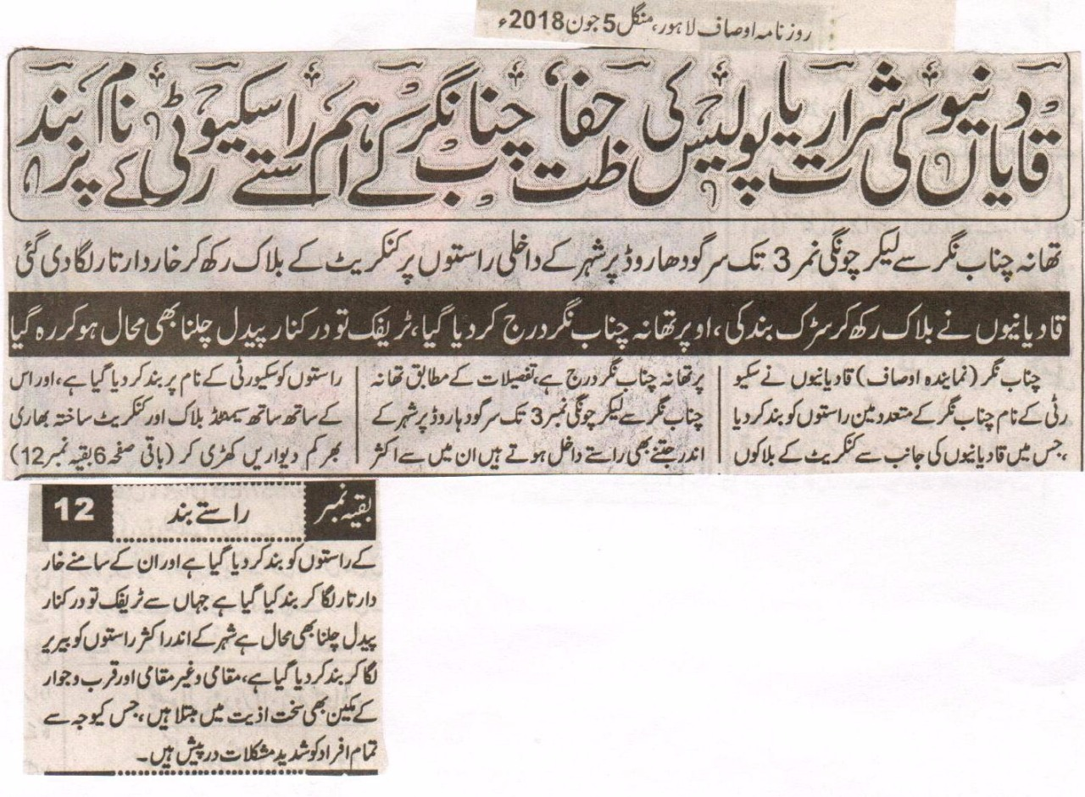

Qadiani shenanigans or the Police security important routes of Chenab Nagar barred.
From Police Station to toll#3 (chongi) all the entrances on the Sargodha road were barricaded by putting up concrete blocks and barbed wire.
Qadianies have closed the roads by putting up blocks and “Police Station Chenab Nagar” has been painted on it, even walking is difficult on these roads let alone traffic.
Chenab Nagar (Representative Ausaf) In the name of security Qadianies have closed several roads by concrete blocks emblazoned with “Police Station Chenab Nagar”, according to details on Sargodha road from Police Station till toll#3 (Chongi) all the entrances have been blocked in the name of security, and cemented blocks and heavy concrete walls have been built along the barriers to close the entrances, moreover barbed wires are there so even walking pass them is difficult and traffic is also disrupted, there are barriers on a lot internal ways which is making the life of locals and people from skirts very difficult because of which people are facing severe problems.
(Daily Ausaf Lahore, Tuesday, 5 June, 2018)

