Will take rest after making the conpiracies of the Qadianis go fail, Abdul Latif.
Our lives and death for the safeguard of Khatm e Nabuat, Address of General Secretary, Majlis e Ahrar in Masjid Muavia.
Toba Tek Singh (Correspondent) General Secretary of Majils e Ahrar Pakistan Abdul Latif Khalid Cheema said that many Clerics including Syed Atta Ullah Shah Bukhari played a crucial role in making the conspiracies of the Qadianis go fail. While giving address in Jamia Masjid Muavia he said that our living and our death is for the safeguard of khatm e Nabuat. He said that even today Mirzai’s are making conspiracies against Islam and Pakistan. We will only take rest after making their conspiracies go fail.
Daily 92 News, Tuesday, 10th April, 2018.

Government should solve the problems of the Paksitanis residing in Thailand:Ilyas Chinioti.
Chenab Nagar (Representative Nawa I Waqt) The belief of khatm e Nabuat is the base of the faith. Apart from the safeguard of the rights of the Paksitanis residing in the foreign countries, there should be more propogation of conferences on the topics of life of the Holy Prophet (P B U H) and Khatm e Nabuat in the Pakistani embassies. The vast and the guaranteed arrangements should be made for the release of the Pakistanis being kept in the jails of Thailand, apart from providing all possible facilities including pocket money. There should be orders issued in providing oppurtunities to meet them, in order to hear the problems of the Pakistanis residing in Thailand, and find their solution. Their should be programs arranged on the topic of Khatm e Nabuat. Thai Clerics and the students studying in Madrassa, should make a strong resolve keeping in mind the safeguard of the belief of Khatm e Nabuat and the Honor of the Holy Prophet (P B U H), to further strengthen the beleifs and faith of the Muslims. These thoughts were expressed by the Ameer of the International Khatm e Nabuat Movement Maulana Muhammed llyas Chinioti, while coming back from a trip of Bangock, Thailand and speaking to the journalists in Muslims Colony yesterday.
Daily Nawa I Waqt Lahore, 9th April, 2018.

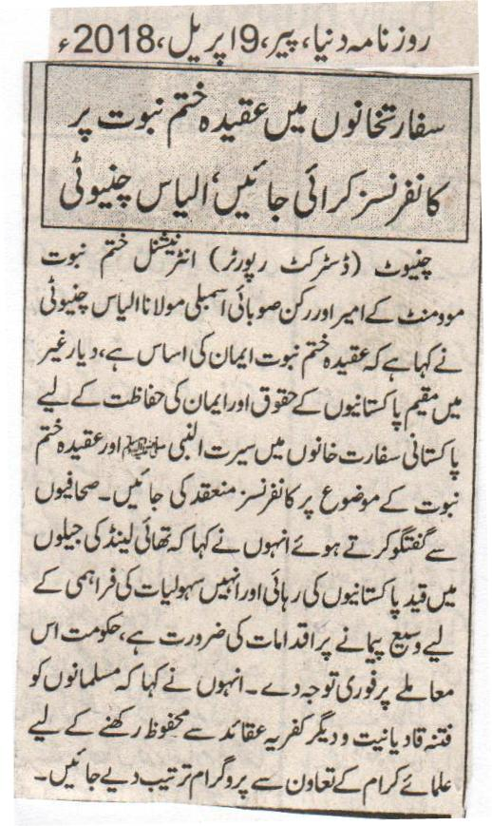
There should be Conferences on the belief of Khatm e Nabuat in the embassies, Ilyas Chinioti.
Chiniot (District Reporter) Ameer of International Khatm e Nabuat Movement and member of Provincial Assembly Maulana Ilyas Chinioti said that the belief of Khatm e Nabuat is the base of the faith. There should be Conferences conducted in embassies on the topic of the life of the Holy Prophet (P B U H), and the belief of Khatm e Nabuat, for the safeguard of the rights of the Pakistanis, and their faith of the Pakistanis residing in the foreign countries. While speaking to the journalists he said that for the release of the Pakistanis kept in the jails of Thailand, and for providing them facilities there is a need for the arrangemnets to be made on a vast level. The goverenment should pay immediate attention to it. He said that in order to protect Muslims from the evil of Qadianiat,and other beleifs of infidelity, programs will be finalised with the co-operation of the Clerics.
Daily Duniya, Monday, 9th April, 2018.

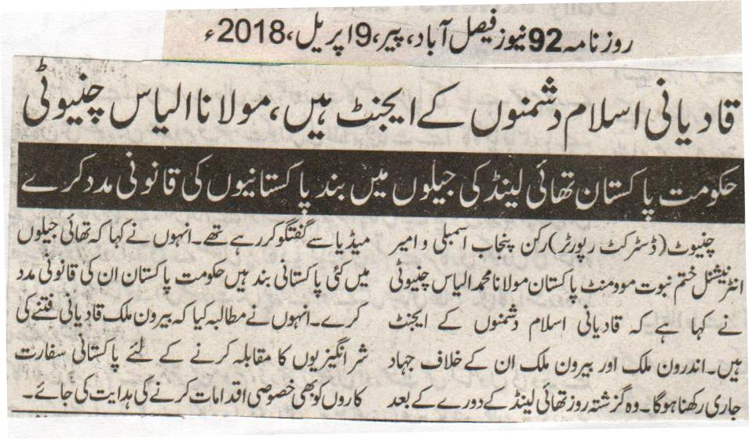
Qadianis are the agents of the enemies of Islam, Maulana Ilyas Chinioti.
The government of Pakistan should provide legal help to the Pakistanis kept in the jails of Thailand.
Chiniot (District Reporter) Member of Punjab Assembly and Ameer of International Khatm e Nabuat Pakistan Maulana Muhammed Ilyas Chinioti said that the Qadianis are the agents of the enemies of Islam. Jihad will have to be continued inside and outside the country. He was talking to media after returning from a trip of Thailand yesterday. He also said that there are several Pakistanis kept in the jails of Thailand, the government of Pakistan should provide legal assistance to them. He also made a demand that in order to fight the evil of Qadianiat, instructions should be given to the Pakistani diplomats to take special steps.
Daily 92 News Faisalabad, Monday, 9th April, 2018.

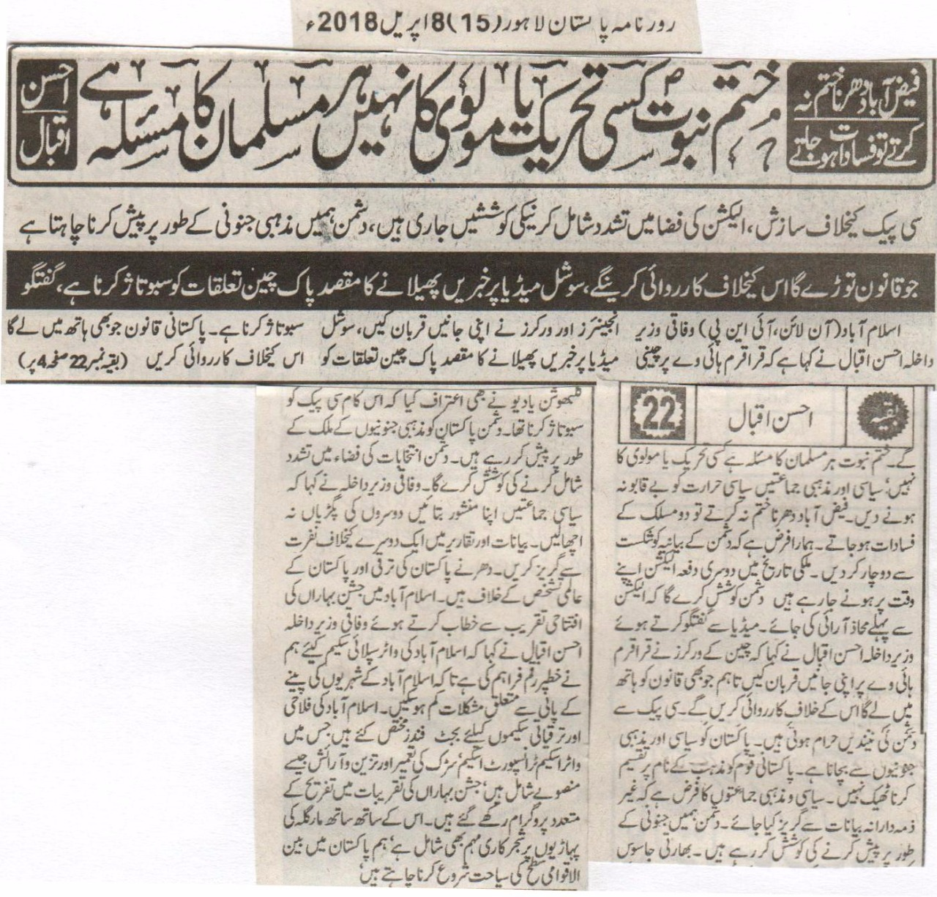
If we did not finish Faizabad Sit-In, than there would be riots: Khatm e Nabuat is not the matter of any movement and Cleric, it is the matter of every Muslim: Ahsan Iqbal.
Conspiracies against CPEC, there is an attempt made of including violence in the environment of the Election, our enemy wants to show us a religious fanatic.
There will be action taken against those who attempt to go against the law, the purpose of spreading news on Social Media is to sabotage Pak-China relationship, Discussion.
Islamabad (Online, INP) Federal Interior Minister Ahsan Iqbal said that for the construction of Karakoram Highway Chinese engineers and workers have sacrificed their life, the real purpose of spreading news on social media is to sabotage Pak-China friendship. Whomsoever will try to lay their hands on the Pakistani laws, there will be action taken against them. The matter of Khatm e Nabuat is the matter of every Muslim, not any movement or Cleric, the religious and the political leaders should not allow religious temperature to get out of control. If we did not finish the Faizabad Sit-In, than there could have been riots between two sects. It is our responsibility to defeat the narrative of our enemies. This is the second time that the elections are going to be held on time, there will be an attempt made by the enemy that there could be a situation of disturbance. While speaking to media Interior Minister Ahsan Iqbal said that the Chinese workers have donated their lives for Karakoram Highway, but whosoever will try to take the law in his own hands there will be action taken against him. Enemies sleep has taken a setback due to CPEC. We have to save Pakistan from fanaticism of politics and religion. It is not right to divide the Pakistani nation in the name of religion. It is the responsibility of our religious and political parties to refrain from giving any irrelevant statements. The enemy is trying to present as fanatics. Kulbushan Yadhav also made a confession that his basic purpose was to sabotage the CPEC. The enemies of Pakistan want to present Pakistan as a country of religious fanaticism. The enemy will try to include violence in the environment of the Election. The Federal Interior Minister said that the political parties should announce their charter, instead of degrading each other. They should refrain from promoting hate against each other in speeches. Sit-In’s are against the progress of Pakistan, and its international identity. While speaking on the occasion of inauguration of the spring festival in Islamabad the Federal Interior Minister said that we have devoted a handsome amount of money for the water supply in Islamabad, so that the reservations of the residents of Islamabad regarding the drinking water should be minimized. We have devoted budget funds for the welfare and development schemes of Islamabad, which include water schemes, transport schemes, construction of roads, and maintenance projects. There were several programs held for the entertainment on the occasion of spring festival. Apart from this it also includes plantation movement on Margalla Hills. We as Pakistanis want to promote tourism on international level.
Daily Pakistan Lahore, 8th April, 2018.

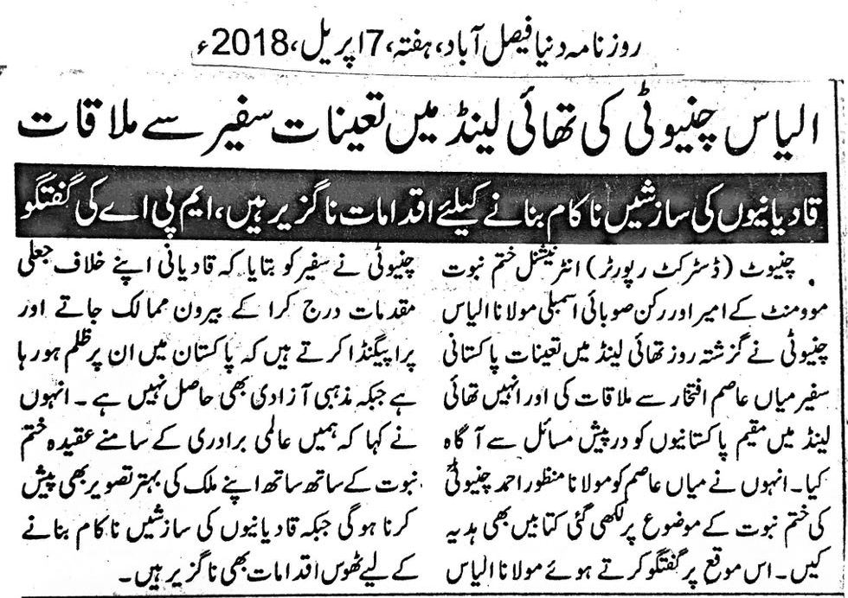

Meeting of Ilyas Chinioti with the ambassador posted in Thailnad.
The efforts to make the efforts of the Qadianis go fail are indispensable, Talk of MPA.
Chiniot (District Reporter) Ameer of International Khatm e Nabuat Movement and member of Provincial Assembly Maulana Ilyas Chinioti had a meeting yesterday with Paksitani Ambassador Miyan Asim Iftikhar appointed in Thailand, and made him aware about the problems of the Pakistanis residing in Thailand. He also gave the book of Manzoor Ahmed Chinioti on the topic Khatm e Nabuat to Miyan Asim. While talking on this occasion Maulana Ilyas Chinioti told the ambassador that the Qadianis register false cases against them and come to the foreign countries, and create propaganda that there is oppression being carried out against them, and they are denied religious freedom. He also said that along with the belief of khatm e Nabuat, we need to present a better picture of our country. Whereas in order to make the conspiracies of the Qadianis go fail, strong steps are indispensable.
Daily Duniya Faisalabad, Saturday, 7th April, 2018.

