Will persuade the evil of Qadianiat in a compete manner, Hafiz Iqbal Qadri
To make the general public aware of the basic belief of Islam the belief of khatm e Nabuat, is the basic responsibility of the Muslim Ummah.
Rinala Khord (Special Reporter) Chairman of Labbaik Ya Rasool Ullah Tehreek, and the organizer of Jamia Ghos Ul Azam Peer Tariqat Hafiz Iqbal Qadri said that they will continue the safeguard of the belief of khatm e Nabuat and the pursue of the evil of Qadianiat in full swing. It is the foremost responsibility of the Muslim Ummah to make the public aware from the basic belief of Islam that is the belief of khatm e Nabuat. This will become the source of intercession of the Holy Prophet (P B U H), on the last Day of Judgment. The safeguard of khatm e Nabuat is the basic responsibility of a Muslim according to his faith. The government should fulfill their responsibilities according to the law and constitution regarding the safeguard of the belief of khatm e Nabuat. These thoughts were expressed by him while talking to senior journalist Muhammed Kashif and Dilawar Hussainn Chaudary in a meeting. He was of the view that the internal conspiracies and the external pressure against the Blasphemy Law will be made unsuccessful.
Daily Ausaf, Lahore, Tuesday, 16th January, 2018.

Qadianis are active in Pakistan to an extent that is dangerous: The Clerics.
The Safeguard of the belief of Khatm e Nabuat is the basic belief of the faith of every Muslim: Maulana Mehboob, Ameer Noor Muhammed, Aziz Ur Rehman.
Bhalwal (Tehsil Reporter) The anti-Islam and anti-constitutional activities of the evil of Qadianis in the beloved country Pakistan has increased to such an extent that is dangerous. Whereas several steps taken to support the Qadianis on the government level, is cause of great disturbance and anxiety among the Muslims. The safeguard of the belief of Khatm e Nabuat is the basic responsibility according to the faith of every Muslim. These thoughts were expressed by the clerics in the office of Khatm e Nabuat in a gathering presided by Maulana Mehboob Tahir. In the gathering Ameer of Majlis Tahhafuz e Khatm e Nabuat district Sargodha Noor Muhammed, Central Leader Maulana Aziz Ur Rehman Sani, Peer Rizwan Nafeesi, General Secretary of JUI Lahore Maulana Hafiz Ashraf Gujjar, Maulana Khalid Mehmood, Maulana Akbar Naumani, Qari Liaquat Ali Qasmi, Hafiz Muhammed Abdullah, Maulana Muhammed Usman, Qari Muhammed Riaz and other clerics including Maulana Qamr Ul Hasnain were present there. The clerics said that the Khatm e Nabuat Conference going to be held in the Badshahi Mosque in Lahore on the 10th March, will be of historical nature. It will be matchless and will prove to be a milestone in the safeguard of the belief of Khatm e Nabuat. In the Conference the clerics from all sects of the Muslims, religious and political leaders, lawyers, students and journalists by gathering there, will make the conference a sign of solidarity and unity among the Muslim Ummah. Committees were formed on regional basis in the gathering to take a look on the preparation of Khatm e Nabuat Conference, which will take a look on the preparation of the Khatm e Nabuat Conference. Also in the gathering there was a decision made to further enhance the publicity movement through Pena flex, and also to publish advertisements.
(Daily Ausaf, Lahore, 16th January, 2018)
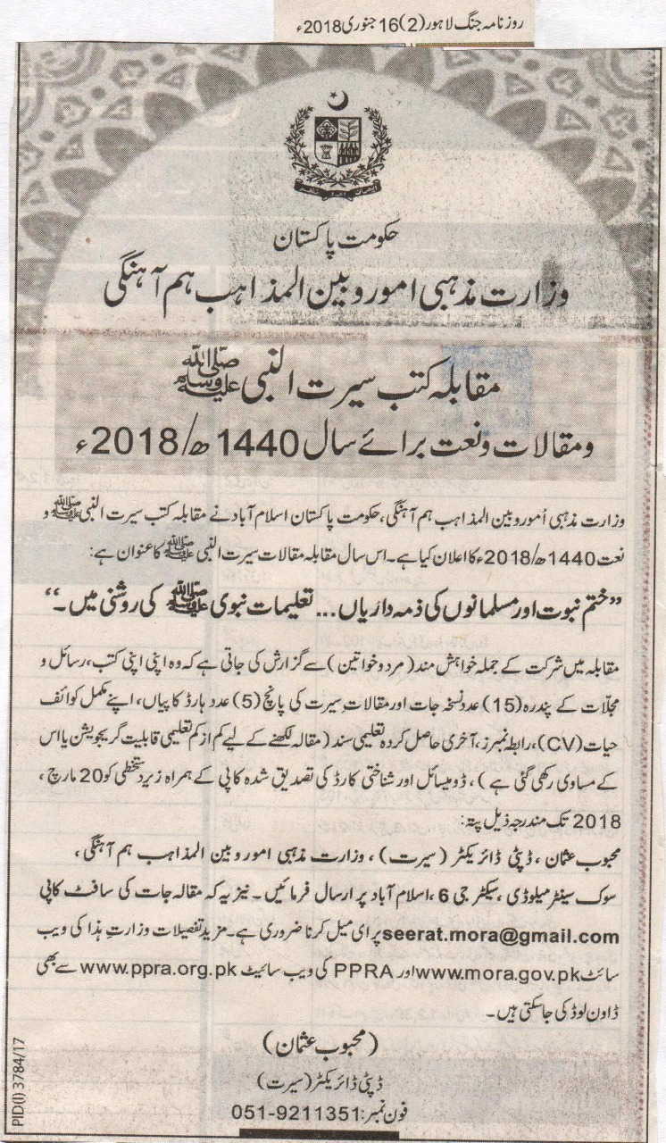

The Government of Pakistan
Ministry of Religious Affairs and Inter-Religious Harmony
The Book Competition on the life of the Holy Prophet (P B U H)
And Thesis as well as Naat for the Year 1440 Hijri/2018.
Ministry of Religious Affairs and Inter-Religious Harmony, the Government of Pakistan, Islamabad has announced the Book and Naat competition on the life of the Holy Prophet (P B U H) of 1440 Hijri/2018. This year the topic of thesis will be The Life of the Holy Prophet (P B U H).
“Khatm e Nabuat and the responsibilities of Muslims…. In the light of the teachings of the Holy Prophet (P B U H).”
It is a request to all the participants (Male and Females) that they should send 15, 15 copies of their books, magazines and periodicals, and 5 hard copies of their thesis on the life history of the Holy Prophet (P B U H), with their complete details (CV), contact numbers, last acquired degree (the minimum degree for writing the thesis is Graduation or equal to that), Domicile and the attested copy of their Identity Card with their signature on 20th March, 2018 on the following address:
Mehboob Usman, Deputy Director (Life), Ministry of Religious Affairs and inter-religious Harmony, Civic Centre Melody, Sector G-6 Islamabad. Moreover the Soft copy of these theses should be mailed on the following address seerat.mora@gmail.com, and it is necessary. Further details can be downloaded from the website of this ministry www.mora.gov.pk, also from the Website of PPRA www.ppra.org.pk.
(Mehboob Usman)
Deputy Director (Seerat)
Contact Number:051-9211351

Qadianis are altering Islamic beliefs to deceive Muslims: Farooq ul Hassan
It is our duty to save the Ummah from Qadiani insurgence, those defending Khatme Nabuwat are serving and aiding Islam
We need to follow in the footsteps of those Ulemas and the religious scholars who have played a key role to reform the society.
Sheikhupoora (Bureau report): Allama Farooq ul Hassan, spiritual leader of Tehreek e Labaik Ya Rasulallah has stated that to defend Khatme Nabuwat is to defend Islam. Those who are busy in the aforementioned endeavor are performing the highest of service [to Islam]. It is our duty to save the Ummah from Qadiani insurgency. To safeguard the sanctity of the Holy Prophet^{saw}is the means to redemption in this world and the Hereafter. Qadianis are altering Islamic beliefs to deceive Muslims. He expressed these views at Labaik Ya Rasulallah conference. Mufti Abdul Haseeb, Professor Fiaz Maqsood, Sheraz Qadri, Amjad Ali, Gulfam Ali, Chaudhary Shahid Mahmood, Syed Ali and various others partook in the conference. Allama Farooq ul Hassan added that we need to follow in the footsteps of those Ulemas and the religious scholars who have played a key role to reform the society. They have played a great part to promote and give an Islamic identity to the society and their work is continued to date. Their endeavors are worth praising. With the grace of Allah, not only in Pakistan but also Muslims from all around the world, perceive Pakistan to be a state in which Ulemas and the religious leaders are playing an important role to promote Islamic culture.
Daily Ausaf, Lahore, Sunday, 14th January, 2018

