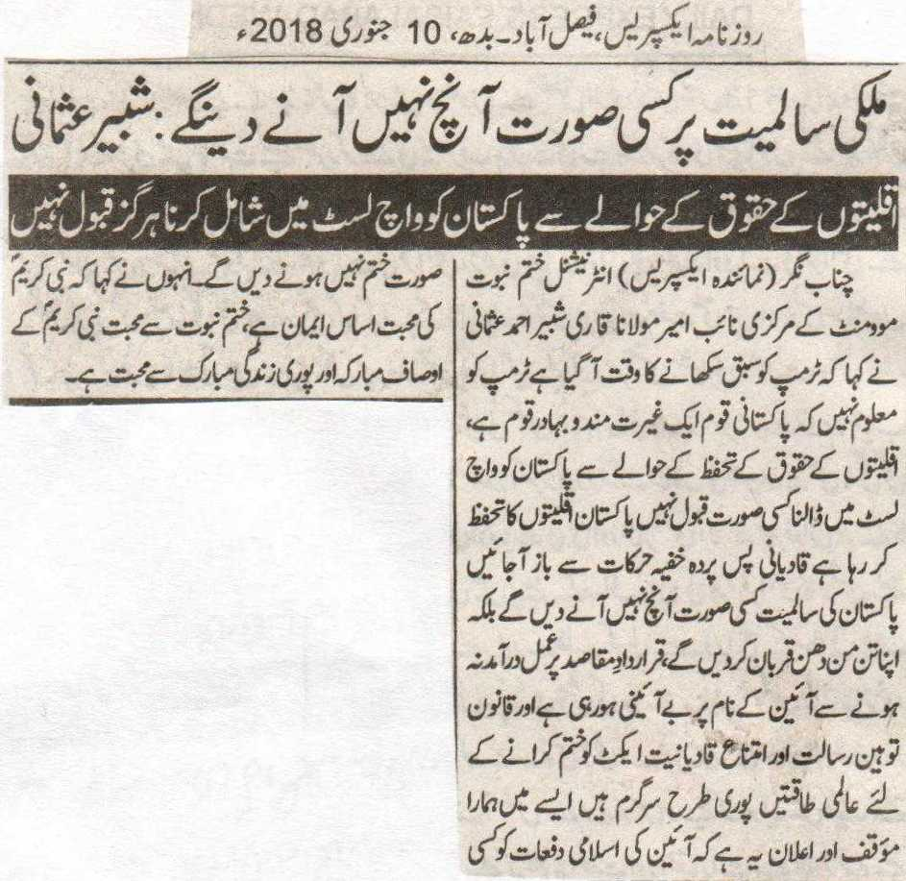
Won’t let anything happen to the integrity of the country: Shabbir Usmani.
To put Pakistan on watch list regarding the rights of the minorities is not acceptable at all.
Chenab Nagar (Representative Express) Central DeputyAmeer of International Khatm e Nabuat Movement Mualana Shabbir Ahmed Usmani said that now is the time to teach Trump a lesson. Trump is unaware of the fact that Pakistani nation is a nation with honor and a brave nation. To put Pakistan on the watch list regarding the rights of the minorities is unacceptable. Pakistan is safeguarding the rights of the minorities, Qadianis should refrain from their undercover secret activities, Won’t let anything happen to the integrity of Pakistan, but on the other hand we will sacrifice everything. Because of no action upon the Objective Resolution, there is unconstituency in the name of constitution. The International forces are fully active in order to remove the laws of Blasphemy and the anti-Qadiyaniat Act. Keeping this in mind we are of the view and make this announcement that we will not allow the removal of the Islamic Clauses at any cost. He was of the view that the love of the Holy Prophet (P B U H) is the foundation of the faith. Love for khatm e Nabuat is the love with the attributes and the whole life of the complete holy life of the Holy Prophet (P B U H).
Daily Express, Faisalabad, Wednesday, 10th January, 2018.

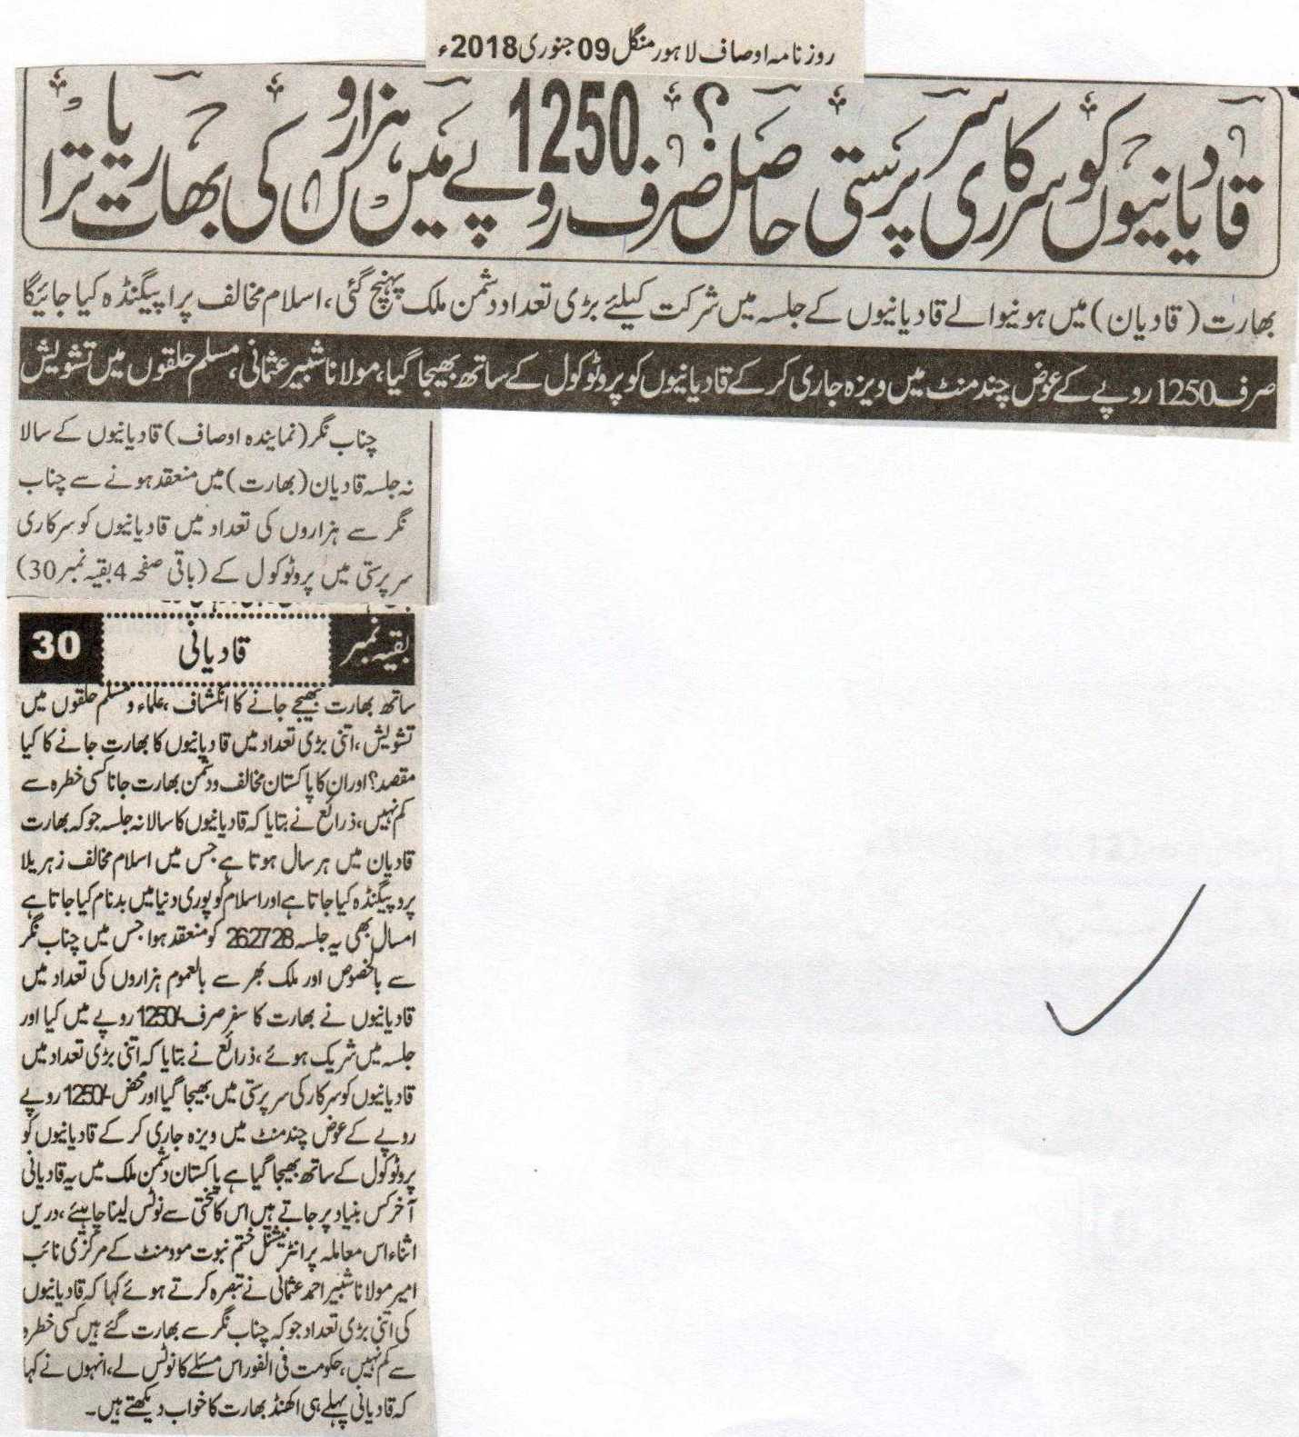
Qadianis have the support of the government? A visit to India of thousands in only 1250 Rupees.
Large number of Qadianis have reached the country of the enemy to participate in the convention of the Qadianis in India (Qadian), there will be anti-Islam propaganda in it.
Qadianis were sent with protocol with the visa being issued in few minutes for only 1250 rupees, Maulana Shabbir Usmani, concern among the Muslims.
Chenab Nagar (Representative Ausaf) The revealing of the fact on the occasion of the annual convention of the Qadainis in Qadian (India), thousands of Qadianis were sent to India under the supervision of government protocol. Concern among the Muslims and the Clerics. What is the reason of such a huge number of Qadianis visiting India? Their visit to the enemy and the opponent of Pakistan, India is a cause of great concern. According to sources the annual convention of the Qadianis held in Qadian India, in which anti-Islam propaganda is being done, in which Islam is being defamed. This year too this convention was held 26, 27 and 28 in which thousands of Qadianis from all around the world in general and from Chenab Nagar in special went to India in only 1250 rupees and attended the conference. According to sources Qadianis were sent under the supervision of government protocol and just in 1250 rupees they were given the visas in few minutes. On what basis does these Qadianis visit anti-Pakistan country, it should be taken notice off. While commenting on this issue Central Deputy Ameer of the International Khatm e Nabuat Movement Maulana Shabbir Ahmed Usmani said that the Qadianis who visited Qadian from Chenab Nagar, is nothing less than a danger. The government should take notice of this issue at once. He also said that the Qadianis already dream of the undivided India.
Daily Ausaf, Lahore, Tuesday, 9th January, 2018.

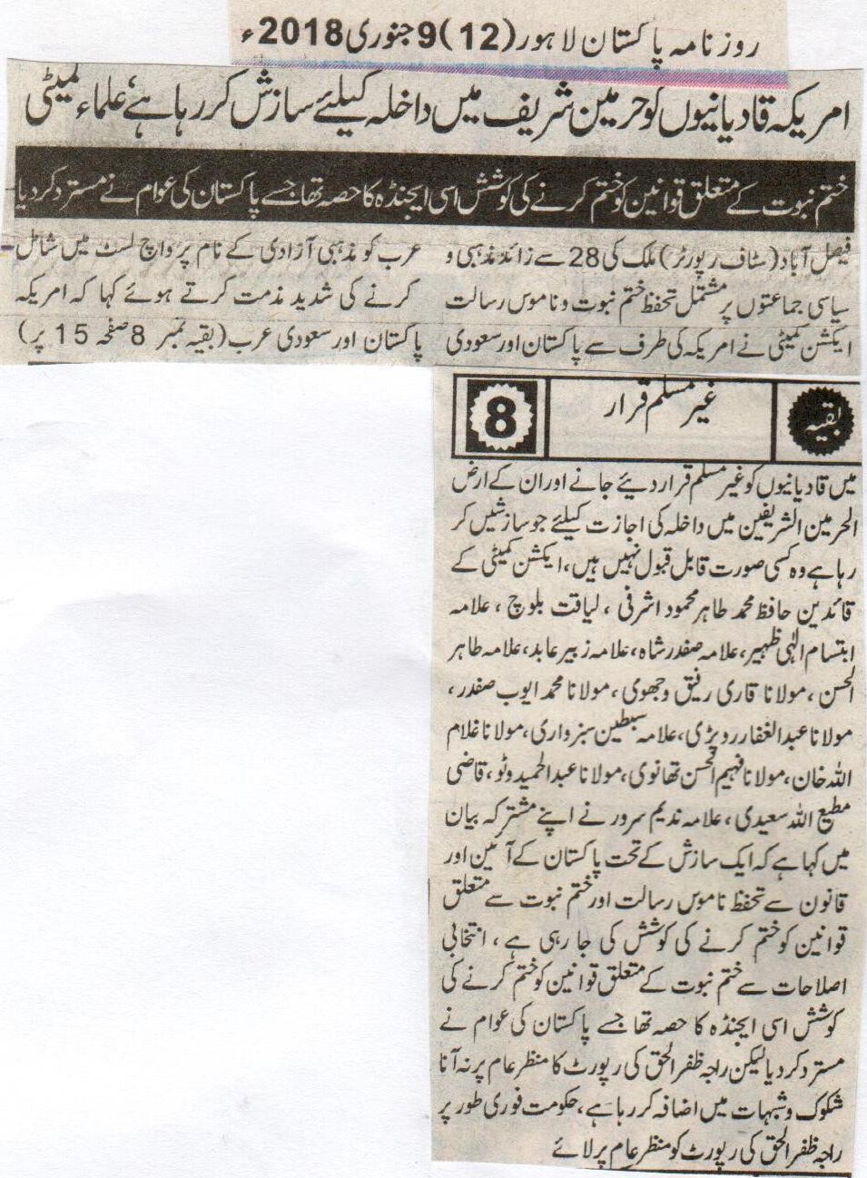
America is making conspiracies for the admission of Qadianis in the Holy Kabba, the Clerics Committee.
The effort to remove the laws related to Khatm e Nabuat was part of this agenda, the one which has been rejected by the population of Pakistan.
Faisalabad (Staff Reporter) the Safeguard of Khatm e Nabuat and the Blasphemy Action Committee comprising of more than 28 religious and political parties while condemning the act of America of including Pakistan and America on the watch list of countries related to the rights of the minorities said that the conspiracies done by America against Pakistan and Saudia Arabia for declaring the Qadianis as non-Muslims, and for the admission of them in the sacred land, is unacceptable at all costs. Among the leaders of the Action Committee Hafiz Muhammed Tahir Mehmood Ashrafi, Liaquat Baloch, Allama Ibtisam Ali Zaheer, Allama Safdar Shah, Allama Zubair Abid, Allama Tahir Ul Hasan, Maulana Qari Rafiq Wajhvi, Maulana Muhammed Ayub Safdar, Maulana Abdul Ghaffar Raropari, Allama Sabtain Sabzwari, Maulana Ghulam Ullah Khan, Maulana Fahim Ul Hasan Thanvi, Maulana Abdul Hamid Watoo, Qazi Mutti Ullah Saeedi, Allama Nadeem Sarwar said in their joint statement that under a conspiracy that from the law and constitution of Pakistan there is an attempt on the removal of the safeguard of the Blasphemy laws and Khatm e Nabuat laws. The effort of the removal of the Khatm e Nabuat Laws from the bill of Election reformations was part of this agenda, the one which has rejected by the Pakistani public. But not making the report of Raja Zafar Ul Haq public is increasing the doubts. The government should at once make the report of Raja Zafar Ul Haq public.
Daily Pakistan, Lahore, 9th January, 2018.
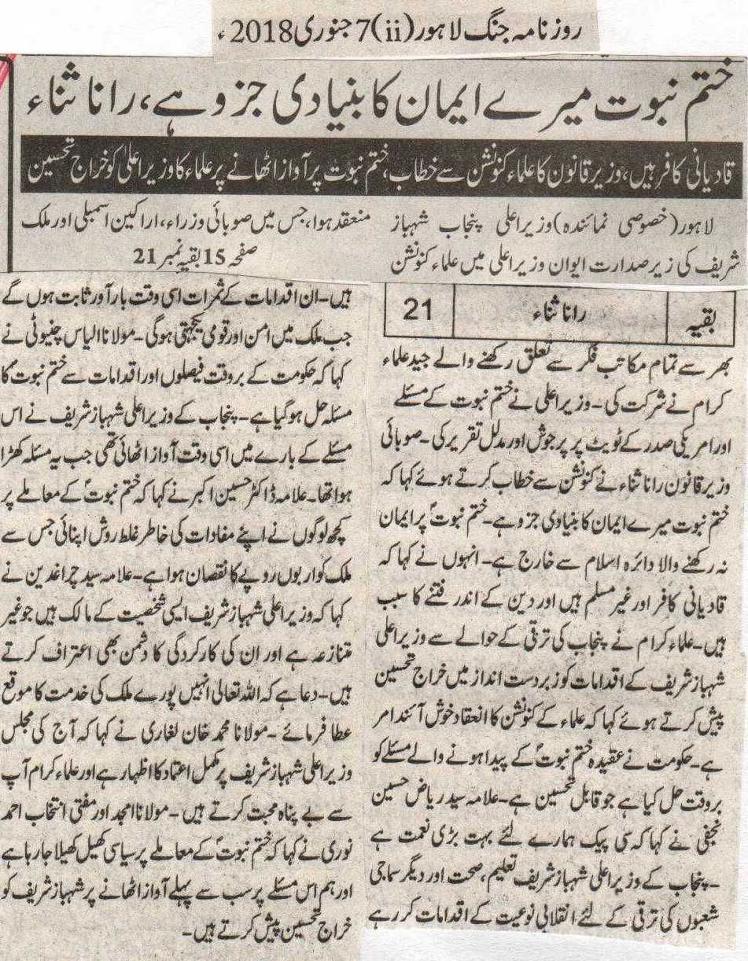
Khatm e Nabuat is the basic element of my faith, Rana Sana Ullah.
Qadiyanis are infidels, Law Minister's address to Ulamaa convention; on raising voice for Khatm e Nabuat scholars pay their salute to Cheif Minister.
Lahore (special reporter) under Chief Minister's presidency held an Ulamaa Comvention at Chief Minister's residency, in which provincial ministers, members of parliment, and scholars of different fields took part in it. Chief Minister delivered a pumpy and evident speech on Khatm e Nabuat and Trupms tweet. Provincial Law Minister Rana Sana Ullah said to the convention that Khatm e Nabuat is the basic element of my belief. Non believer of Khatm e Nabuat is excluded from Islamic circle. He said that Qadiyanis are infidels and non Muslims and are the reason of chaos in the faith. Scholars said appreciating punjab development programs that organizing Ulama Convention is a good thing. Govt. has solved the Khatm e Nabuat issue on time, which is appreciative. Allama Sayed Riaz Hussain Najfi said that CPEC is a great blessing for us. Chief Minister Punjab Shahbaz Sharif is taking revolutionary steps in promoting education, health and other social fields. Fruits of these steps will only be sweet if accompanied by peace and nation unity. Maulana Ilyas Chinioti said that Govt. has solved Khatm e Nabuat issue on time. Chief Minister Punjab raised voice for it as the Khatm e Nabuat issue started. Allama Doctor Hussain Akbar said that some people took wrong steps for their own benefits eegarding Khatm e Nabuat which gave country a loss of billion rupees. Allama Sayed Charagh Deen said that Cheif Minister Shahbaz Sharif is of a character who is non controvercial and even enemies recognize their efforts. Pray that Allah gives him the oppertunity to serve the whole country. Maulana Mohammad Khan Laghari said that todays sitting is an emblem of complete trust on Shahbaz Sharif and relegious scholars love you alot. Maulana Amjad and Mufti Intekhab Ahmad said that a political game is being playe on Khatm e Nabuat issue and we congratulate Shahbaz Sharif to raise the first voice at it.
Daily Jang, Lahore, 7th Jan, 2018

