A day of protection the honor of Holy Prophet was celebrated on the appeal of World Paasban e Khatm e Nabuwat, condemnable resolutions were also passed in Jumma gatherings.
Religious leaders declared the conversion bill of death sentence for a blasphemer into life sentence by Functional Committee of Senate against the Quran and Sunna.
A protest was lead by Mumtaz Awan from Jamia Mosque Shimla Pahari to Press Club in Lahore. Ulama declared this amendment as a conspiracy of Jews and Qadianis.
Lahore (Reporter) All religious groups including Jameeat Ulma e Islam, Jameeat Ulama e Pakistan, World Pasban e Khatm e Nabuwat, Jamaat Islami, Jamat ud Dawa, Jameeat Ehlhadees, Jameeat Ehl e Sunnat, Tehrik Millat Jafaria, and an organization of Ulama and Mashaikh celebrated a Day for the Protection the Honorof the Prophet (PBUH). Maulana Mumtaz Awan, Maulana Naeem Badshah, Maulana Hanif Haqani, Allama Younas Rehan, Dr Shahid Naseer, Peer S A Jaferi, Shan Ali Qadri, and Hafiz Umar Mumtaz Awan addressed the protesters. They said in their addresses that a chaos was created in our beloved country by amending Khatm e Nabuwat from the oath and now Islam and Pakistan enemy lobbies are trying to drag the country into a new crisis by referring to such sensitive issue regarding the Honor of the Holy Prophet (PBUH). All Patriot Muslims must get united in this situation to fail the conspiracies as this is our national and religious duty.
Daily Ausaf Lahore, Saturday 24th February, 2018.
OP-ED

Ahmed and Khurshid — brothers in grief
It would not be an exaggeration to say that Pakistan is the only country where Ahmadis are living hardest lives
Rana Tanveer
FEBRUARY 23, 2018
They spent 85 years together, struggling for a better life for their rancorous community. There’s was an unusual and difficult life – a life that no other citizens of Pakistan were living.
The way they opted for themselves was not an easy one as it was an addition to many other hardships they were already braving; they had to go behind the bars together and face the persecution not only from people but also state itself. This is what defined their life. They witnessed riots of 1953, they saw the move which led the parliament to declare them as non-Muslims in 1974; promulgation of Ordinance XX in 1984 barring them from posing like Muslims; provision of oath to denounce their leadership to avail democratic and citizenship rights; apart from sporadic target killings of their community members, killings of more than 90 of their community members in two barbaric terrorist attacks on their places of worship in Lahore in one go on May 28, 2010; and in addition to many discriminations imposed by the state and society of main stream Muslims, constitutional shutting doors of democracy on them in 2017 after the protest of religious bigots in the name of protecting finality of the Holy Prophet (peace be upon him). It is justified to say that Pakistan is the country where Ahmadis are spending hardest lives than in any other part of the world.
Being highly educated, Khurshid and Ahmed played an active role throughout these circumstances in a bid to make life easy for their marginalized community. They taught their community to bear all discriminations and hardships stoically without resorting violence.
At the end, both of them breathed their last with a short span of three weeks — Mirza Khurshid Ahmed on 17 January and Mirza Ghulam Ahmed on February 05 this year. Mirza Khurshid was heading his community in Pakistan since May 8, 2003, and Mirza Ahmed was elevated as his community head after Khurshid’s death.
Both of them were highly qualified even the younger Mirza had passed competitive exams of Punjab Public Service Commission but did not join the service.
Mirza Khurshid Ahmed, born on 12 Sep 1932 in Lahore, passed his matriculation from High School Qadian and done his masters in English from Government College, Lahore. He taught English language at TI College for 17 years. After being selected for a fellowship, he participated in one-year English phonetic course in Leads University London in 1964. He is said to be a very good teacher of English and his services could have been utilized for society in general had they not been religiously excluded. He was also a teacher of present head of Jamat-e-Ahmadia.
As part of suffering for his community, Mirza Khurshid himself led funeral prayers of all those deceased on May 28 incidents who were buried in Chenab Nagar. He married on 26 December, 1955, and left 6 sons out of whom two are doctors, one is a PhD scholar, and one is an LLD. Mirza Khurshid died on January 18.
Throughout their lives, Khurshid and Ahmed urged their community to demonstrate patience on the face of persecution
Sahibzada Mirza Ghulam Ahmed, who died on February 05 at the age of 78, had done masters in Political Science from Government College, Lahore. He remained editor of monthly Review of Religions. He married in 1964 with sister of present leader of Jamaat-e-Ahmadia. He left 3 sons and 2 daughters. One of his sons in in UK and another is in USA.
Ahmed remained head of Jamaat-e-Ahmadia Pakistan for less than three weeks after death of his elder brother Mirza Khurshid.
He always stood by his brother and felt pain whenever an Ahmadi family would fall prey to religious intolerance. In 1989, he was also jailed with Khurshid for religious beliefs. As a head of the delegation, he went to Lahore from Chenab Nagar on 28 May, 2010, after attacks on two of their worship places. He also welcomed the slain Punjab Governor Salman Taseer when he visited the injured people at Jinnah Hospital.
Despite the life threats, he stayed in Lahore for two weeks and led funeral prayers in Garhi Shahu worship place. On the behalf of his Jamaat, he addressed press conferences after the attacks and appeared on different TV programs to give his point of view on terrorist attacks. He made arrangements for the bereaved families to take bodies of their loved ones as ambulances were demanding huge money for the services. He visited every injured and met with every family of those who had lost their lives to terrorist attacks. He also provided food to the brereaved families.
Throughout their lives, Khurshid and Ahmed urged their community to demonstrate patience, steadfastness and hope having at the face of persecution. No doubt hearing more and more news about Ahmadis being killed across the country, both brothers continued recounting the history of violence against their community and observed the process which distorted their identity.
During the initial days of declaration that declared Ahmadis non-Muslims, both the brothers might have started to become a bit paranoid wondering if the people treating their community so inconsiderately were doing it because they don’t like Ahmadis or have strict theological disagreements with their faith. At last they must have realised that it was bit of both. These state of affairs not only had made every Ahmadi but also both brothers less afraid of the verbal diatribes therefore they simply ignore such incidents and focus on incidents posting threats to lives.
Out of this hatred, not a single newspaper published even a single column news after death of these both heads of a community having its members in about 100 countries of the world.
The writer is a journalist currently based in Canada. He can be reached at rana.tanver@gmail.com and @RanaTanver
Published in Daily Times, February 23rd 2018.
https://dailytimes.com.pk/206230/ahmed-khurshid-brothers-grief/

Chiniot, Weekly Khatm e Nabuat Course (Ladies) finished.
During the course there was light shed on the beleif of khatm e Nabuat, the life history of Jesus Christ (P B U H), and the basic beliefs of faith

Chiniot (Special Reporter) weekly Khatm e Nabuat Course (ladies) finished in the Centre of Khatm e Nabuat Chenab Nagar. 46 female students attended the course.
During the course there was light shed on the beleif of khatm e Nabuat, life history of Jesus Christ (P B U H), and the basic beleifs of Islam and faith. The female missionaries delivered their lectures for the audience. While addressing the Khatm e Nabuat Seminar at the end of the gathering chairman of Anwar e Khatm e Nabuat Trust Pakistan Maulana Qari Muhammed Rafiq Nafeesi, Finance Secretary of International Khatm e Nabuat Movement Pakistan Haji Mehboob Ahmed Malik, renowned religious scholar Peer Tariqat Maulana Qari Abdul Karim Naqshbandi while delivering their address said that mortality and survival of the Muslim Ummah rests in the beleif of khatm e Nabuat. The mission of Difa e khatm e Nabuat is not that of rationality but it is related to the love and affection with the Holy Prophet (P B U H). The attempt to change the Khatm e Nabuat law is equal to be playing with blood and fire and blood. Qadianis hiding in the halls of the government are using the selfish and faithless politicians as a tool. Those having Qadianis as friends should keep the fact in mind that the Qadiani friendship is more dangerous than their opposition. Every satanic force including America and all the forces in the world cannot do any amendment in the thing related to the Qadianis in the constitution.
Daily Pakistan Lahore, 23rd February, 2018.

Khatm e Nabuat Conventions held under the supervision of International Majlis Tahaffuz khatm e Nabuat.
The leaders have closed their eyes on the anti-Islam activities of the Qadianis: Speakers.
Lahore (Special Reporter) khatm e Nabuat conventions were held in Orica centre and Anarkali Dhobi Mandi under the supervision of international Majlis Tahaffuz khatm e Nabuat under the presidency of deputy Ameer of Majlis Lahore Peer Miyan Rizwan Nafees. Maulana Muhammed Ismael Shujabadi, Maulana Aziz Ur Rehman Sani, Maulana Qari Aleem Uddin Shakir, Maulana Abdul Naeem, Qari Abdul Aziz and Maulana Muhammed Farman delivered their addresses in the conventions. The speakers said that the safeguard of the beleif of khatm e Nabuat and the Blasphemy laws is the basic responsibilty and a religious duty of every Muslim. All Muslims will have to speed up their struggle for the safeguard of Islam, beleif of khatm e Nabuat and the Honor of the Prophet. The leaders have not only closed their eyes on the anti-Islam, anti-Muslims and anti -Pakistan activities of the Qadianis, but on the other hand their supervision is becoming a source of strength for the Qadianis. The leaders and the nation should be aware of the fact that Qaidianis are more dangerous to Islam, Muslims and Pakistan as compared to the Jews and the Hindus.
Daily Duniya Faisalabad, Friday, 23rd February, 2018.

IHC asks scholars to assist in identifying non-Muslims
The Newspaper's Staff Reporter
February 22, 2018
ISLAMABAD: The Islamabad High Court (IHC) has appointed four Islamic scholars as amicus curie and sought their assistance on six questions regarding the identification of non-Muslims.
IHC Justice Shaukat Aziz Siddiqui during Wednesday’s hearing of a petition filed on the identification of non-Muslims in government, semi-government and autonomous organizations who have not identified themselves as non-Muslim, posed six questions to the amicus curie.
Amicus Curie, which is Latin for ‘friend of the court’, is a person of group who is not a party to an action but has a strong interest in the matter.
The court has appointed Prof Dr Hafiz Hassan Madni from Punjab University, former Council of Islamic Ideology (CII) member Dr Mohsin Naqvi, CII member Prof Dr Sahbzada Sajidur Rehman and Mufti Mohammad Hussain Khalil Khel.
The questions are: ‘Whether an Islamic state could evolve a law to determine identity of Muslims and non-Muslims’, ‘Whether non-Muslims should be allowed to introduce themselves Muslims’, ‘Whether such concealment falls into the ambit of fraud’, ‘What is the responsibility of the state in such a situation”, and ‘Whether it is a violation of fundamental rights if the state inquires about the religion or religious beliefs of citizens’.
The court asked the registrar’s office to inform the aforementioned scholars and sent a copy of the writ petition and responses submitted so far.
The court also directed that the scholars be requested for their availability from Feb 26 onwards.
Published in Dawn, February 22nd, 2018
https://www.dawn.com/news/1390920

Committee of Raja Zafrul Haq presented its report. High Court ordered to separate Faizabad sit in and Khatm e Nabuwat case.
Court showed its wrath over not presenting the report regarding the case and announced to call Prime Minister personally; Justice Shoukat Aziz Sidique.
Prime Minister has no link with the report; Deputy Attorney General. Shahid Khaqan Abbasi is the Chief Executive of the country, remarks.
Report should not be opened till the orders, Khatm e Nabuwat case should be preceded on daily bases, Court.
Islamabad(Online, NNI, INP) Qadianis are not Muslims according to the constitution of Pakistan. They can stay only in Pakistan as simple citizens. No compromise will be made on on Khatm e Nabuwat. Justice Shoukat Aziz Sidique of Islamabad High Court remarked yesterday when Deputy Attorney General was unable to present his report that your attitude is very non serious, we would call Prime Minister then. Justice Aziz said that issue of Khatm e Nabuwat is very sensitive if Raja Zafar ul Haq committee is not going to present its report till one o clock then we will call prime minister and a contempt of court will be sent to deputy attorney general. He further said that there is no big issue other than the amendment in election act. Court is continuously issuing orders but Federal government is continuously working against the orders. A contempt of court will be applied on Interior and Law Ministers if court orders are not followed.
Daily Pakistan Lahore, 21st February, 2018.

Khatm e Nabuwat report of the committee led by Zafar Ul Haq represented in Islamabad High Court.
It is decided to conduct hearing on daily basis. You are playing strange games with the court. Why didn’t I call Prime Minister? Justice Shaukat Siddique
Prime Minister doesn’t relate to the report: Deputy Attorney General
How is it possible? We will not make any compromise on Khatm e Nabuwat: Justice Siddique
Islamabad (NNI) Report pertaining to the amendment in the affidavit of Khatm e Nabuwat represented in the court. Justice Siddique conducted hearing of the case related to Faizabad sit-ins and the amendment in election act 2017 on Tuesday. The lawyer of the government who was representing Raja Zafar Ul Haq requested judge to give him the extension of one day. Court refused to grant him the extension and ordered to represent report till one O’ clock. Lawyer represented the report on time following the orders of judge. Justice Siddique gave remarks that party doesn’t understand the sensitivity of the issue. Court adjourned the hearing till Wednesday 11 am and ordered the lawyer, Hafiz Arafat to give arguments.
(Daily Khabrain Lahore, 21st February, 2018)

Mirza’it is a dangerous evil, have clarified the difference between a Muslim and a Non-Muslim inside Azad Kashmir, Farooq Haider.
There have been more eligible and powerful persons more than me on this post, but Allah has given me this honor, now this constitution is officially part of the constitution.
In the light of the recommendations of the Clerics related to the Shariah Court Shariah Appellant Bench was formed, the title of the commander of Khatm e Nabuat which I have received is an investment of my life, address to the gathering.
Muzaffarabad (Correspondent) The Prime Minister of Azad Kashmir Raja Muhammed Farooq Haider Khan has said that Islam is the religion of peace security for mankind, there is no place for extremism and disturbance in Islam. The right for the declaration of Jihad rests with the state. The greatest jihad is with one’s own self. The personality of the Holy Prophet (P B U H) is a Blessing for the entire universe, and is combination of all the good things. The way to attain nearness to Allah is the personality of the Holy Prophet (P B U H) and his teachings. I am thankful to all the Clerics and the religious persons on the appreciations and the honor given to me regarding the amendment in the constitution related to khatm e Nabuat. Being given the title of the commander of khatm e Nabuat is an honor for me. The clerics and the students of the Madrassas are not the ordinary people, the love and affection given by them will be remembered forever. These thoughts were expressed by him in a welcome dinner arranged in his honor by PML-N, and the Clerics wing of Muzaffarabad Division in Jamia Islamia Barkartia. On this occasion Muhammed Saleem Chishti, Peer Hamid Uddin Barkati, Allama Ubaid Ullah Farooqi, Zahid Ameen Kashif, Maulana Muhammed Ishaq Naqvi and others delivered their address. The Prime Minister of Azad Kashmir said that there was extreme pressure earlier on as well to present the declaration regarding khatm e Nabuat in the legislative assembly of Azad Kashmir. There was a conspiracy against the elective government, and the no confident resolution was presented. After this control was taken back from the legislative assembly of Azad Kashmir, but now there is an amendment in the constitution and in sha Allah there will be improvement in all other things. During all this process of carrying forward the resolution of late Major Ayub, two members of the legislative assembly Raja Muhammed Siddique Khan and Peer Syed Ali Raza Bukhari have shown great resolve. I consider myself to be lucky, that many people who were more eligible and powerful than me who were on this post, but Allah has blessed me with this honor that I have clarified the difference between Muslim and Non-Muslim inside Azad Kashmir. The evil of Mirza’it is a very dangerous evil that always attacks while hiding. Although there were rights present there, but they were devoid of constitutional safeguard. Now this constitution is officially part of the constitution. It is also written by Allah the Almighty in our fate that while accepting the recommendations of the Ulemas regarding the Shariah Court, and has formed Shariah Appellant Bench. The amount of honor received from a renowned personality of Ahl e Sunnat Hadhrat Peer Hussain Uddin Shah, also the title of the commander of Khatm e Nabuat is an asset of my life. Prime Ministership is everlasting, but this title will stay with me till my last breath.
Daily Ausaf Lahore, Monday, 19th February, 2018.

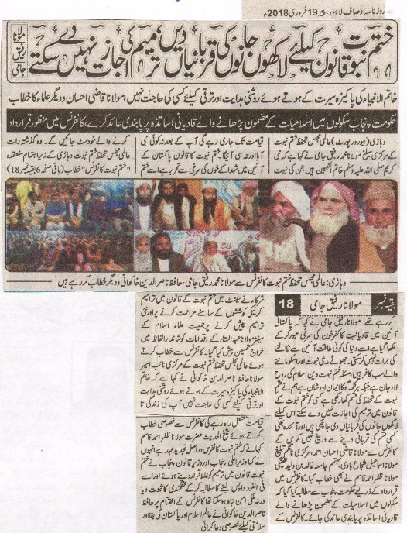
Sacrificed thousands of lives for Khatm e Nabuat law, won’t allow amendment in it: Maulana Rafiq Jami.
In the presence of the Blessed biography of the Holy Prophet (P B U H) there is no need of anything for guidance and progress, Maulana Qazi Ahsan and address of other clerics.
The government should impose ban on the Qadiani teachers teaching Islamiat in the schools, Resolution approved in the conference.
Vihari (Beauru Report) Central Missionary of International Majlis Tahhafuz e Khatm e Nabuat Maulana Muhammed Rafiq Jami said that the Holy prophet (P B U H) is the seal of all the Prophets, whose Prophet Hood will continue till the day of judgment. There has not been any Prophet and nor there be any Prophet after him. The law of khatm e Nabuat is written with the blood of the martyrs in the constitution of Pakistan, the ones wanting to dismiss it will themselves be dismissed. He was addressing the “Khatm e Nabuat Conference” organized by International Khatm e Nabuat Conference Vihari. Maulana Rafiq Jami said that the infidelity of Qadiyaniat is written after crossing the redness of the blood, no power in the world can dare to dismiss it from the constitution. The false claimer of Prophet Hood and its followers are all infidels. The issue of Khatm e Nabuat is the soul and honor of Islam, whereas on the other hand it is the faith and honor of everyone who recites the Kalima. We have sworn in for the safeguard of Khatm e Nabuat, and cannot allow anyone to do amendment in the Khatm e Nabuat law. We have sacrificed thousands of lives for this, and will not hesitate from any kind of sacrifice in the future too. Maulana Qazi Ahsan Ahmed, Central Organizer of Preaching Maulana Ismael Shujabadi, the organizer of Jamia Khalid Bin Waleed and Maulana Zafar Ahmed Qasim addressed the conference. The demand was made to the government of Punjab in the conference through resolution that there should be ban on the Qadiani teachers teaching the subject of Islamiat in the schools. The participants of the conference paid tribute to the Senator of Jamiat Ulema e Islam Maulana Abdul Sattar in strong words on showing struggle on the amendment of khatm e Nabuat law and also on presenting new amendments. While addressing the conference deputy Ameer of International Majlis Safeguard of Khatm e Nabuat Maulana Hafiz Nasir Uddin Khakwani said that in the presence of the teachings and the life history of the Holy Prophet (P B U H) there is no need for guidance and progress for anything. His life will be an excellent example till the Day of Judgment. Sheikh Ul Hadis Hadhrat Maulana Zafar Ahmed Khan in his special address to the conference said that Khatm e Nabuat conference is a time for a renewal of faith. He also said that the Prime Minister of Punjab and the Law Minister of Punjab has given the proof of rationality by declaring the amendment in the Khatm e Nabuat law as wrong, and have decided to take this amendment back at once. Otherwise the peace of the country could be damaged. At the end of the conference Hafiz Nasir Uddin Khakwani made special prayers from the prosperity and survival of the Islamic world and Pakistan.
Daily Ausaf Lahore, Monday, 19th February, 2018.

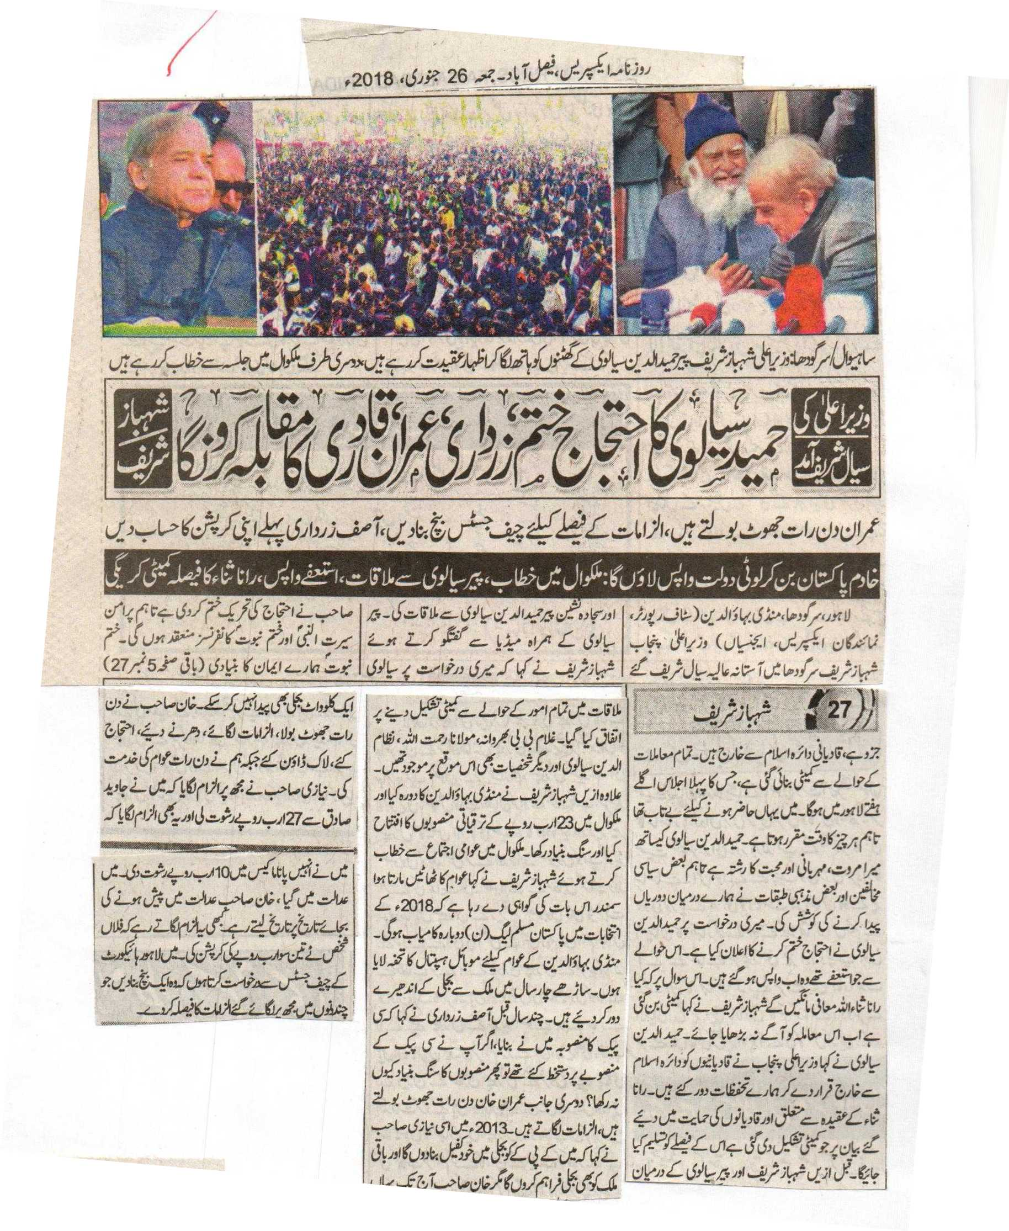Chief Minister arrived in Sial Sharif, Hamid Sialvi announced to finish his protest where as Shahbaz Sharif told to confront against Zardari, Imran and Qadri.
Imran Khan is a Liar, Chief justice must create a bench to decide about the allegations, Asif Zardari must be accountable about his corruption.
I will bring back the looted money of Pakistan serving as the humble servant of Pakistan, Shahbaz Sharif addressed in Malikwal, also met Pir Sialvi who took back resignation whereas a committee will decide the fate of Rana Sanaullah.
Lahore, Sargodha, Mandibahauddin (Reporter) Shahbaz Sharif went to Sargodha Sial Sharif to meet Pir Hamid ud Din Sialvi. They both held a press conference where they declared to hold Khatm e Nabuwat and Seeratn Nabi conferences peacefully. Khatm e Nabuwat is part of our faith and Qadianis are out of the dimension of Islam. A committee is formed and its first session will be next week. I was eager to visit you but everything is done on its specific time. I have a strong relation with Sialvi Sb based on love, and generosity. Some political and religious opponents tried to create differences between us. Our objectives are removed by Shahbaz Sharif by declaring Qadianis Non Muslims. Ghulam Bibi Bharwana, Maulana Rehmatullah, Nizam ud Din Sialvi and others were present on this occasion. Shahbaz Sharif also visited Mandibahaud Din and laid the foundation stone of various projects worth of 23 billion. He said in his public address that the huge number of people gathering here is an announcement of the victory of PML N in elections of 2018. He gave a present of mobile ambulance to the people of Mandibahauddin. We have enlightened the whole country by removing the darkness of load shedding. Asif Zardari declared to start the project of CPEC a few years back, but if you have signed the projects why did not you laid the foundation stones? On the other hand Imran Khan constantly tells lies and accusations. He himself declared to make country load shedding free in 2013 but he is still unable to produce even a single mega watt. He locked down the whole country by sit ins and protest whereas we served the nation. He accused me of bribery taken from Javed Sadiq worth of 27 billion and giving him 10 billion during Panama Case. I sued him and instead of providing evidence he is taking dates from the court. I request chief justice of Lahore High Court to form a bench to decide over all accusations on me.
Daily Express Faisalabad, Friday, 26thJanuary, 2018.

