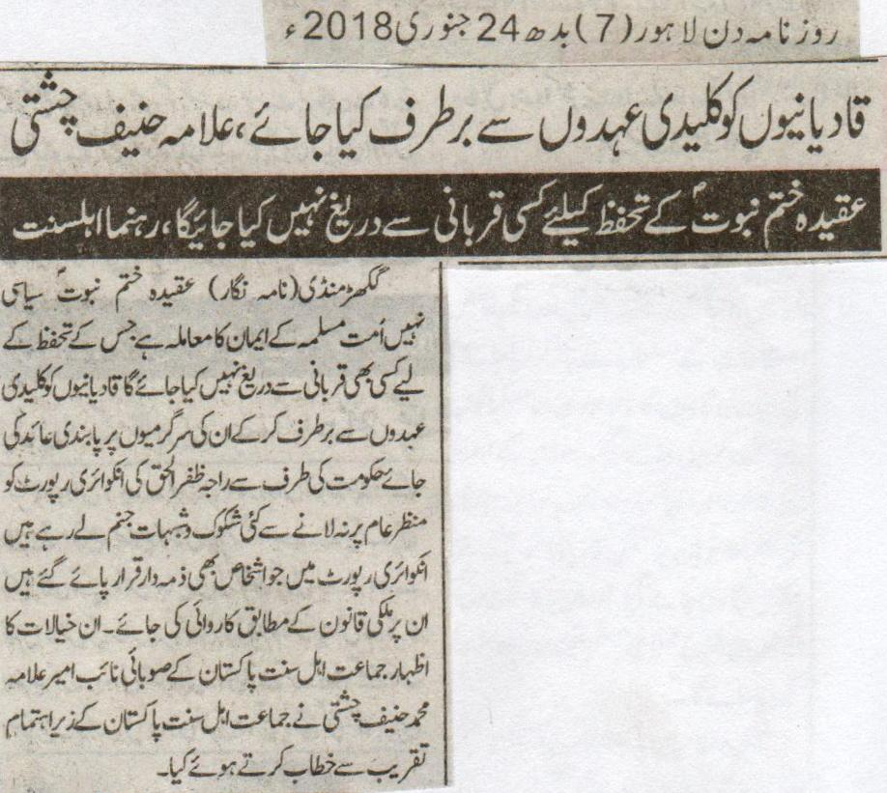
Qadianis should be removed from key posts, Allama Hanif Chisti.
Won’t hesitate from any kind of sacrifice for the safeguard of the belief of Khatm e Nabuat (P B U H), Leaders of Ahl e Sunnat.
GhakarMandi (Correspondent) The belief of khatm e Nabuat (P B U H) is not a political matter, but a matter of faith for the Muslim Ummah and will not hesitate from any kind of sacrifice for its safeguard. Qadianis should be removed from key posts and their activities should be banned. He also said that there are number of doubts that are coming up with the inquiry report of Raja Zafar Ul Haq not being made public. The action against the responsible persons according to the report should be done according to the law of the country. These thoughts were expressed by the District Deputy Ameer of Jamaat Ahl e Sunnat Pakistan Allama Muhammed Hanif Chishti while delivering an address in a gathering held under the supervision of Jamaat Ahl e Sunnat Pakistan.
Daily Din Lahore, Wednesday, 24th January, 2018.

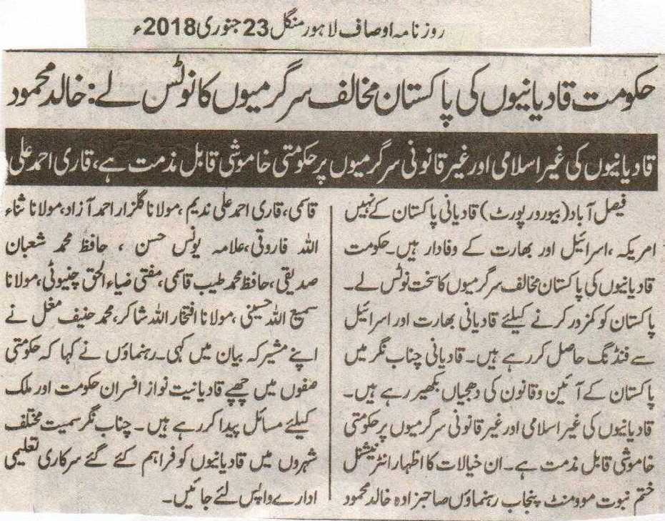
The government should take notice of the anti-Pakistan activities of the Qadianis: Khalid Mehmood.
The Silence of government on the anti-Islam and anti-law activities of the Qadianis is indeed condemnable, Qari Ahmed Ali.
Faisalabad (Beauru Report) Qadianis are loyal to America, Israel and India rather than loyal to Pakistan. The government should take notice of the anit-Pakistan activities of the Qadianis. The Qadianis are receiving funds from India and Israel in order to make Pakistan become weak. Qadianis are violating the constitution and the law in Chenab Nagar. The Silence of government on the anti-Islam and anti-law activities of the Qadianis is indeed condemnable. These thoughts were expressed by the leaders of Khatm e Nabuat Movement Punjab Sahibzada Khalid Mehmood Qasmi, Qari Ahmed Ali Nadeem, Maulana Gulzar Ahmed Azad, Maulana Sana Ullah Farooqi, Hafiz Muhammed Tayyab Qasmi, Mufti Zia Ul Haq Chinioti, Maulana Sami Ullah Hussaini, Maulana Iftikhar Ullah Shakir and Maulana Hanif Mughal in their joint statement. Leaders also said that the supporters of the Qadianis hiding in the government circles are creating problems for the government and the country. The Government Educational institutes provided to the Qadianis should be taken back.
Daily Ausaf, Lahore, Tuesday, 23rd January, 2018.

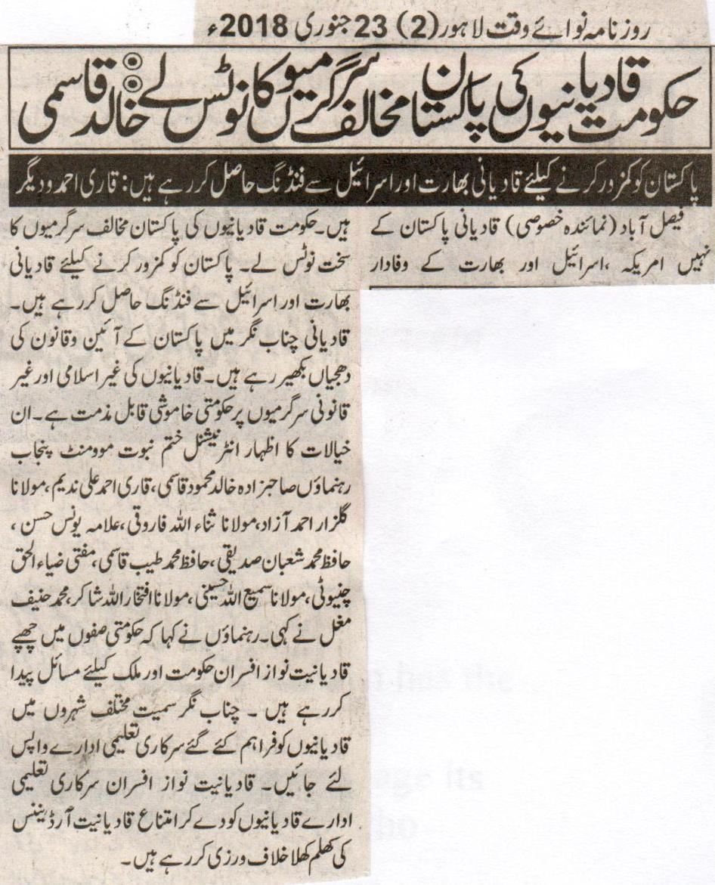
The government should take notice anti-Pakistan activities of the Qadianis: Khalid Qasmi
Qadianis are getting funds from India and Israel to weaken Pakistan: Qari Ahmed and Others.
Faisalabad (Special Reporter) Qadianis are loyal to America and Israel, but not to Pakistan. The government should take notice of the anti-Pakistan activities of the Qadianis. For the sake of weakening Pakistan Qadianis are getting funds from India and Israel. Qadianis are violating the law and constitution in Chenab Nagar. The Silence upon the anti-Islam and anti-law activities of the Qadianis is indeed condemnable. These thoughts were expressed by the leaders of Khatm e Nabuat Movement Punjab Sahibzada Khalid Mehmood Qasmi, Qari Ahmed Ali Nadeem, Maulana Gulzar Ahmed Azad, Maulana Sana Ullah Farooqi, Allama Younis Hasan, Hafiz Muhammed Tayyab Qasmi, Mufti Zia Ul Haq Chinioti, Maulana Sami Ullah Hussaini, Maulana Iftikhar Ullah Shakir and Maulana Hanif Mughal. The leaders also said that the supporters of the Qadianis hiding in the government circles are creating problems for the government and the country. The Government Educational institutes provided to the Qadianis should be taken back. The officers supporting the Qadianis are openly violating the anti-Ahmadiya Ordinance by giving them the government educational institutes.
Daily Nawa I Waqt, Lahore, 23rd January, 2018.

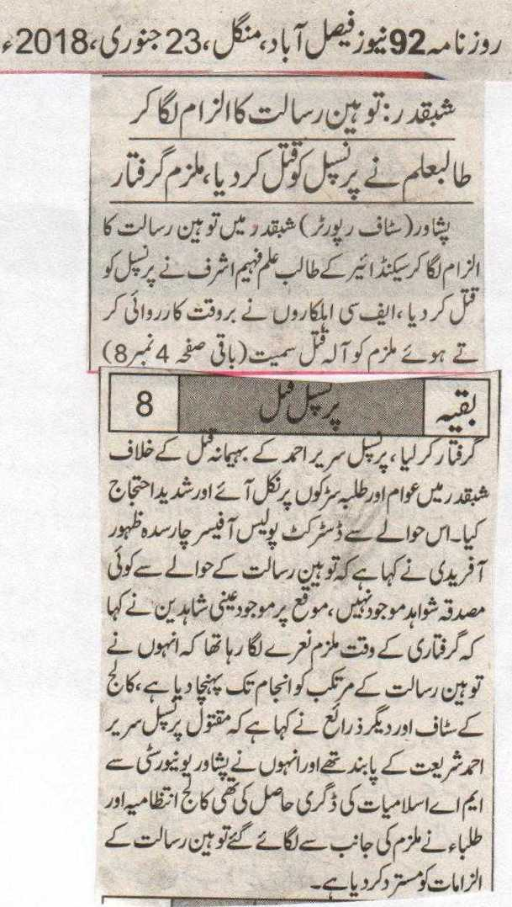
Shabaqadar: The Student killed the Principal on the accusation of Blasphemy, the accused arrested.
Peshawar (Staff Reporter) on being accused of Blasphemy a student of Second Year Faheem Ashraf killed the principal. The FC personals acted timely and arrested the accused with the weapon used for the murder. The students and the public came out on roads in Shabqadar and staged a huge protest against the brutal killing of Principal Sareer Ahmed. District Police Officer Charsadda Zahoor Afridi has said that there is no evidence present in this case related to Blasphemy. The eyewitnesses present said that the accused was raising slogans at the time of his arrest, that I have send the Blasphemer to his end. The College Staff and other sources have said that the killed Principal was a follower of Shariat, and he had acquired the degree of Masters in Islamiat from Peshawar University. The College administration and the students have rejected the claim of Blasphemy made by the accused.
Daily 92 News Faisalabad, Tuesday, 23rd January, 2018.
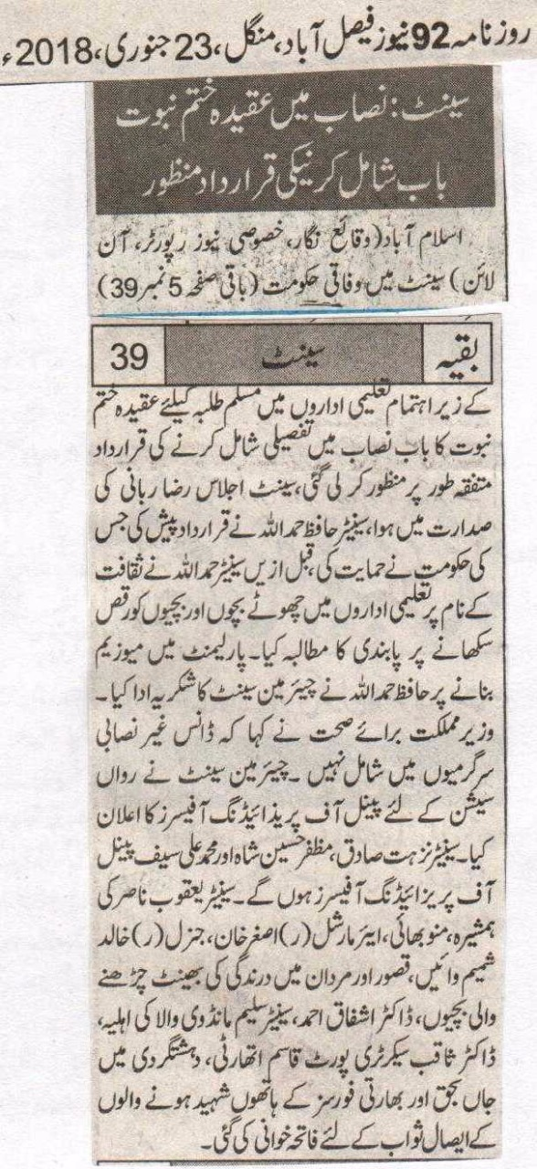
Senate: The approval of resolution of the inclusion the chapter of of belief of Khatm e Nabuat in the curriculum
Islamabad (Correspondent, Special News, Reporter, Online) the resolution of including the chapter of the belief of Khatm e Nabuat in the curriculum in the educational institutes running under the supervision of the Federal Government for Muslim students was passed unanimously. The Senate session was presided by Raza Rabbani. Senator Hafiz Hamd Ullah presented the resolution, which was supported by the government. Before this Senator Hamd Ullah also demanded a ban on teaching dance to young boys and girls in the educational institutes. He thanked the Chairman Senate on making museum in the Parliament. Minister of State for Health said that Dance does not include in extra-curricular activities. Chairman Senate announced the penal of Presiding officers for this session. Senators Zihat Sadiq, Muzaffar Hussain Shah and Muhammed Ali Saif will be Panel of Presiding Officers. There were silent prayers for seeking good in remebrance for the sister of Senator Yaqoob Nasir, Munnu Bhai, Air Marshal ® Asghar Khan, General ® Khalid Shamim Waeen, the girls who were the target of brutality in Kasur and Mardan, Dr.Ashfaq Ahmed, the wife of Senator Saleem Mandvi Wala, Secretary Port Qasim Authority Dr.Saqib, those who were killed in terrorism and those who received martyrdom from the Indian forces.
Daily 92 News Faisalabad, Tuesday, 23rd January, 2018.

