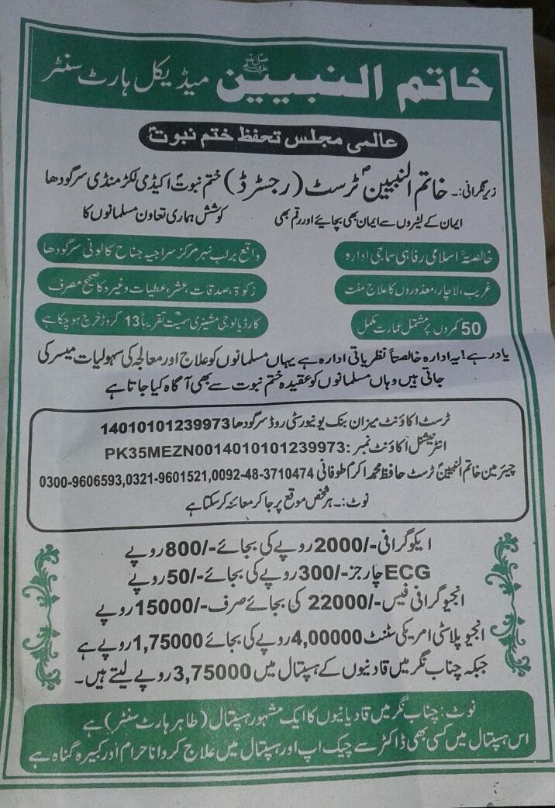
Khatam un Nabiyyeen Heart Centre
International Majlis Protection of Khatm e Nabuwat
Supervised by; Khatam un Nabiyeen trust (Registered) Khatm e Nabuwat Academy Lakar Mandi Sargodha

Protect your faith and money from burglars
All our efforts are based on the support of Muslims.
Pure Islamic social welfare institute located nearby canal Sirajia centre Jinnah Colony Sargodha
Free treatment of poor, needy and disabled, accurate usage of Zakat, Sadaqat and charity
Completion of 50 room building, 13 crore is spent including on cardiology machinery
Remember this is an ideological institute. Muslims are given treatment here and they are also informed about the faith of Khatm e Nabuwat.
Trust account Mezan bank University Road Sagodha 14010101239973
International account number PK35MEZN0014010101239973
Chairman Khatm un Nabiyeen Trust Hafiz Mohammad Akram Toofani 0092-483710474, 03219601521, 03009606593
Ecography only of 800 instead of 2000
ECG charges 50 rupees instead of 300
Angiography fee 15000 instead of 22000
Angioplasty with American stunt 175000 instead of 400000 whereas in Qadiani hospital 375000 is taken in Chenab Nagar.
Note; A famous hospital of Qadianis named Tahir Heart Centre is in Chenab Nagar. It is an immense sin to have any treatment or even a check up from any doctor of this hospital.
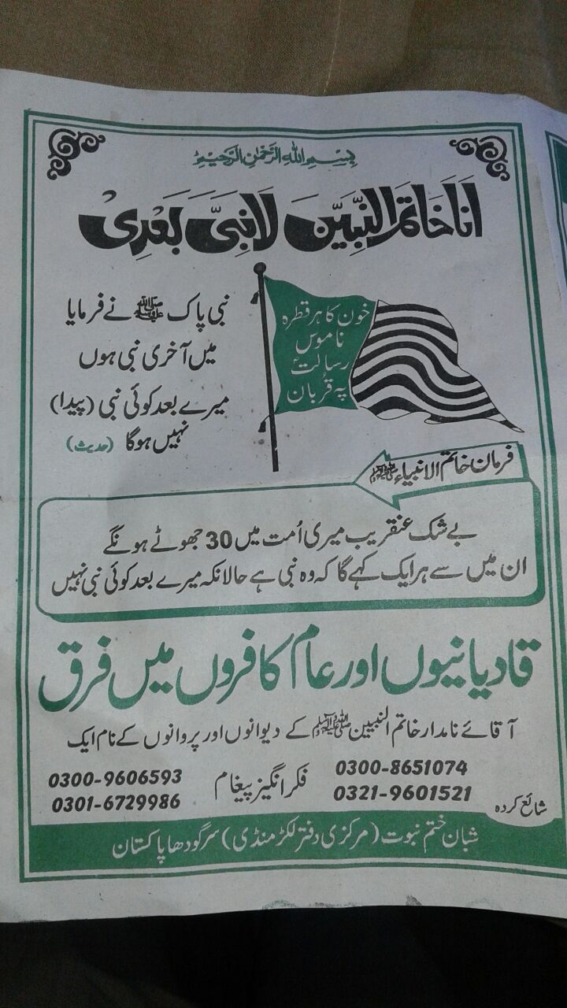
In the name of Allah, the most gracious, ever merciful.
I am the seal of Prophets; there is no prophet after me.
Every drop of our blood is sacrificed on the prophet hood of Mohammad (PBUH)
Holy Prophet (PBUH) said I am the seal of Prophets; there is no prophet after me.
He (PBUH) said 30 liars will emerge in my Umma and every one of them will claim to be a prophet where as there is no prophet after me.
Difference between Qadianis and common pagans
A thoughtful message for the lovers and true followers of Holy Prophet (PBUH)
03009606593, 0301 6729986, 0300 8651074, 0321 9601521
Published by: Shaban Khatm e Nabuwat, Central Office Lakkar Mandi, Sargodha, Pakistan.

