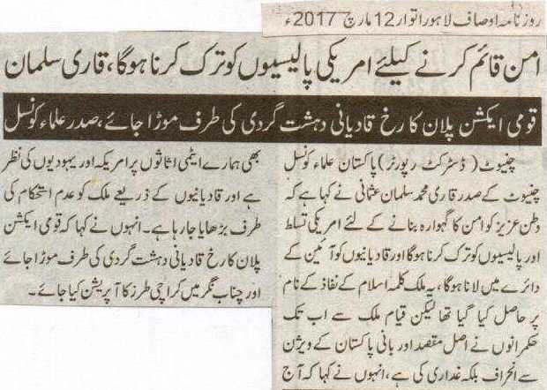
To seek peace, we have to renounce American policies: Salman Usmani
The focus of National Action Plan should be directed to the terrorist activities of Qadianis: head of the ulema council
Chiniot (district reporter): Head of the Pakistan Ulema Council Chiniot Qari Muhammad Salman Usmani stated that to seek peace we have to renounce American influence and policies. Qadianis should be made to abide by the constitution. This nation was formed in the name of Kalima e Islam [in the name of Allah and His Prophet^{sa} ]. The leaders forsook and betrayed the real motive and vision envisaged by the founder of this nation. American and Jews have their eyes set on country’s atomic arsenal and Qadianis seek to destabilize the country. The focus of National Action Plan should be directed to the terrorist activities of Qadianis and an operation, on the footsteps of Karachi, should also be done in Chenab Nagar

Daily Jang Lahore- 12 March 2017

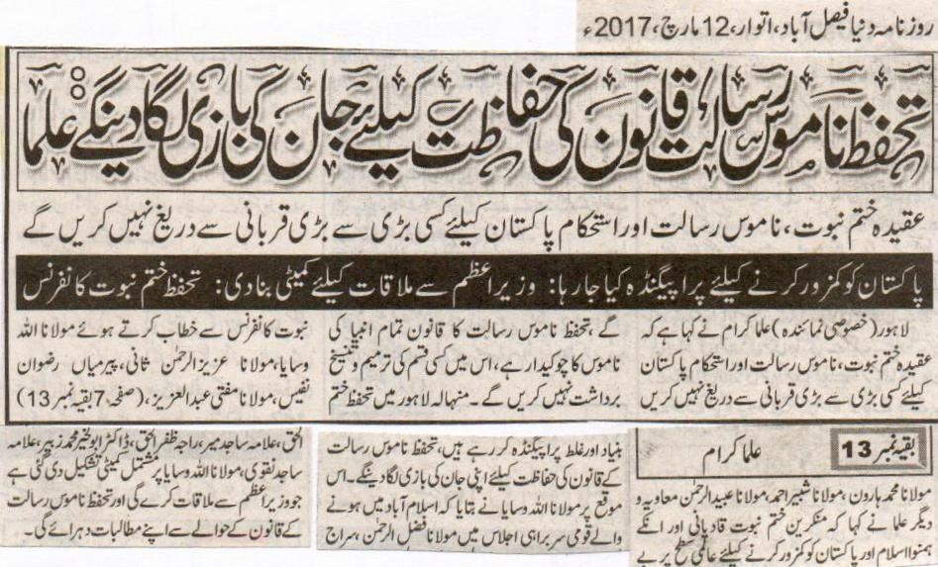
We will protect The Blasphemy Law at the cost of our lives: Ulema
We will not fall short of sacrificing everything for the protection of the blasphemy law, the belief in the finality of the prophet and for a steady Pakistan.
Propaganda being inserted to weaken Pakistan; A committee has been formed to meet the prime minister
Lahore (special correspondent): Ulema have stated that we will not fall short of sacrificing everything for the protection of the blasphemy law, the belief in the finality of the prophet and for a steady Pakistan. The Blasphemy law guards every prophet; we will not tolerate any amendment. Talking to [the attendees of] Khatme Nabuwat conference Minhala Lahore, Maulana Allah Wasaya, Maulana Aziz ur Rehman Sani, Pir Mian Rizwan Nafees, Maulana Mufti Abdul Aziz, Maulana Muhammad Haroon, Maulana Shabeer Ahmad, Maulana Ubaid ur Rehman Muawiyya and several other Ulemas stated that Qadianis and their associates who deny the finality of the Prophet^{sa} are trying to weaken Pakistan at international level by false propagandas. We would risk our lives for the protection of The Blasphemy Law. Maulana Allah Wassaya added that at the national conference held in Islamabad a committee was formed which included Maulana Fazlur Rehman, Siraj ul Haq, Alama Sajid Mir, Raja Zafrul Haq, Doctor Abul Khair Muhammad Zubair, Alama Sajid Naqvi and Maulana Allah Wasaya. The committee would meet the prime minister and present the demands on The Blasphemy law again.
Daily Duniya Faisalabad-Sunday, 12 March 2017.

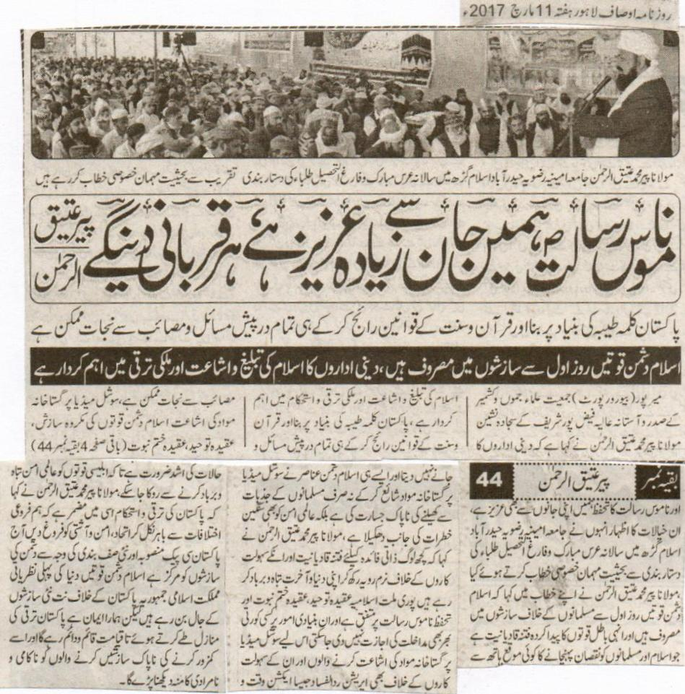

We are ready to protect the honor of the Holy Prophet (PBUH). Peer Ateeq ur Rehman.
The base of Pakistan is Kalima Tayyaba. We can get rid of all the problems by implementing the laws of Quran and Sunna.
Enemies of Islam are making conspiracies from day one. Religious institutes play a vital role in the progress of the country and in spreading Islam.
Mirpur (Bureau Report) President Jameeat Ulama Jammo Kashmir and Sajjada Nasheen of faizpur Shareef Maulana Peer Mohammad Ateeq ur Rehman said printing of blasphemous material on social media is a filthy conspiracy of the enemies of Islam. We will sacrifice to protect the honor of the faith on Tauheed and Khatm e Nabuwat. He was addressing the convocation anmd annual urs of Jamia Ameenia Rizwia Hyderabad as chief guest. Qadianiat is the conspiracy of these evil powers that do not let go any chance of manipulating Islam and Muslims. Such factors publish blasphemous material on social media to provoke Muslims and derive world peace towards insecurity. He further said that some people are ruining their lives and lives hereafter by keeping a biased behavior towards qadianis and their facilitators. Nobody is allowed to change the slightest part of the basic laws of blasphemy that is why an operation just like Rudd ul Fsad is required against social media blasphemers. Prosperity of Pakistan is hidden in the fact that we step out of our differences and promote peace. Today Pakistan is the centre of attention of our enemies because of C Pack. But it is our faith Pakistan will progress and prosper till the doomsday.

Daily Ausaf 17 March 2017

