March 14, 2017

Symbolic Gestures Not Enough for Pakistan’s Minorities
Farahnaz Ispahani
The role of religious identity in Pakistan has been an important part of the history of Pakistan. Many of the present day conflicts, from intercommunal violence to blasphemy laws, occur along the fault lines of religious communities. As Farahnaz Isphani has argued in her recent book, Purifying the Land of the Pure, there has been a sense in which rather than protecting the rights of all religious groups, the Pakistani state and society has sought to “purify” the community. From its pre-independence population of 20.5% non-Muslims, the present number of non-Muslim minorities is estimated at less than 4%. The factors that have contributed to this are numerous and the present day implications for all Pakistanis – Muslim and non-Muslim alike – are concerning. Hostilities and restrictions have been directed not only at non-Muslims, but non-Sunnis or those who would defend views considered outside the accepted orthodoxy.
What are the current challenges that are faced by Pakistan’s religious minorities? What can be done to promote a religious freedom that protects the rights of all Pakistani’s to freely believe as they wish, act on those beliefs, and participate in all of life?

Pakistan’s treatment of its religious minorities has attracted global condemnation for years. Aware that the world sees Pakistan as insecure for religious minorities, Pakistan’s leaders are now engaging in symbolic gestures of concern for minorities after years of appealing just to majority sentiment. But positive gestures such as Muslim politicians attending Diwali celebrations alongside Hindus or showing up at Christian Christmas events has done little to abate the wave of extremism that has progressively endangered all of Pakistan’s minorities.
Christians still continue to be charged with ‘blasphemy.’ The Ahmadi community still remains besieged and terrorist attacks on Shia Muslims have not ceased.
Asia Bibi, the unlettered Christian woman who was accused of blasphemy after being involved in an argument with a group of Muslim women with whom she had been picking berries in 2009, still sits on death row in a Pakistani prison. Last December, she spent her seventh Christmas in prison after a judge abruptly refused to hear her appeal.
The dedication last December of the ‘Abdus Salam Physics Center’ in Islamabad, named after Pakistan’s only Nobel laureate in the sciences who was not honored in the country of his birth because he belonged to the Ahmadiyya community, was meant to signal tolerance towards the Ahmadis. But the official Council on Islamic Ideology expressed concern over the renaming of the Center and a mob attacked an Ahmadi mosque in Chakwal the very next day.
As if to demonstrate that Pakistan had not suddenly become tolerant towards those of faiths other than the majority’s Sunni Islam, the Punjab government’s counter-terrorism department raided the Ahmadi headquarters.
The state of Pakistan’s minorities has consistently deteriorated since the country’s creation in 1947. My book, Purifying the Land of the Pure, is a short history of that state-supported process of otherization, marginalization, and even attempted elimination of religious minorities –both non-Muslim and Muslim.
Different minorities have borne the brunt of state-sanctioned attacks at different times. In Pakistan’s early years, Hindus and Sikhs were the major target while Christians, Ahmedis and Shias have become the focus of hatred in succession over time.
My book begins with a description of the Pakistan I was born in. It was a more tolerant period in my hometown Karachi, which was then home to many places of worship for Shias, Sunnis and Ahmadis as well as Jews, Christians of several denominations, Zoroastrians and Jains.
Since then, much has changed. Most of Karachi’s churches have shut down, and the few that remain have a dwindling number of worshippers. Many Pakistani Christians have emigrated to North America or Australia. Most Jain and Hindu temples have either been destroyed or taken over by squatters or land-grabbers and property developers. The Jewish synagogue has been replaced by a Shopping Plaza. The Parsi population has also declined, though its temples still exist.
Walls along the road from Karachi airport to the city are painted with graffiti declaring Shias as “kuffar” (unbelievers). Shia and non-Muslim families often have armed security guards, if they can afford them, or avoid a high profile.
The Muslim call to prayer no longer sounds from Ahmadi places of worship. The community has been declared non- Muslim through an amendment to the Pakistani Constitution. Ahmadis are forbidden by law from describing themselves as Muslims, from using the term mosque for their places of worship and from issuing the azan before prayers.
They risk a stiff jail sentence for violating ordinances that forbid them from any act that might identify themselves as followers of Islam, which they believe themselves to be.
Pakistan’s Blasphemy laws disproportionately target the country’s minorities. Of the 1,274 people charged for blasphemy between 1986 and 2010, forty-nine percent of the accused were members of minority communities– 26% Ahmadis and 21% Christians. Considering that communities regarded as non-Muslim comprise no more than 3 percent of Pakistan’s population, the discrimination is obvious.
Much of the prejudice in Pakistan against religious minorities can be traced to the effort by Islamist radicals to make Pakistan “purer” in what they conceive as Islamic terms. The process has gone through several stages. Given the denominational differences among various groups of Muslims, this concept of an Islamic state has led to unending debate over the role of religion in the life of Pakistanis.
This is not what Pakistan’s secular founding fathers had in mind when they sought a separate homeland for South Asia’s Muslims. They did not speak of an Islamic state and certainly did not envisage a country that would be described by the rest of the world as one of the worst violators of the freedom of belief.
In its 2013 annual report, the United States Commission on International Religious Freedom (USCIRF) described Pakistan’s failure in protecting its minorities as having reached “crisis proportions”. According to the report, “The government of Pakistan continues to engage in and tolerate systematic, ongoing, and egregious violations of freedom of religion or belief.”
Violations reached unprecedented levels, USCIRF said, because of growing incidents of sectarian violence against Shia Muslims. The government also failed to protect Christians, Ahmadis and Hindus, it said.
That view is shared by fair-minded Pakistanis. According to the independent Human Rights Commission of Pakistan (HRCP), “pervasive intolerance [is] widely tolerated” in the country, and the “religious and sectarian minorities [pay] the price for that with their blood.”
The Commission’s director, I.A. Rehman, asserts that “Pakistan continues to offer evidence of its lack of respect for the rights of religious minorities.” He attributes this to “the virus of intolerance” that he maintains “has infested the Pakistani people’s minds.” Human Rights advocates like Rehman demand “visible action to end abuse of minorities’ rights” instead of the “half-truths and subterfuge in defending the State” that they feel have been consistently employed by Pakistan officials over the years.

Farahnaz Ispahani is a Global Fellow, Woodrow Wilson Center for Scholars, Author of Purifying the Land of the Pure: Pakistan's Religious Minorities (Oxford 2017) and Former Member of the Pakistani Parliament.
https://www.religiousfreedominstitute.org/cornerstone/2017/3/14/symbolic-gestures-not-enough-for-pakistans-minorities

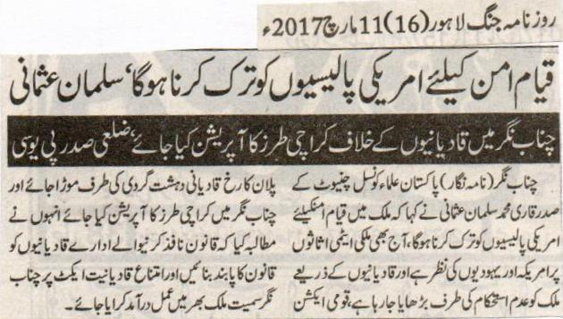
To seek peace, we have to renounce American policies: Salman Usmani
An operation, similar to Karachi, should also be done at Chenab Nagar: District Head PUC.
Chenab Nagar: Head of the Pakistan Ulema Council Chiniot Qari Muhammad Salman Usmani stated that to seek peace we have to renounce American policies. American and Jews have their eyes on country’s atomic arsenal and Qadianis have been attempting to undermine this nation. The focus of National Action Plan should be diverted to their terrorist activities and an operation, similar to that of Karachi, should also be done at Chenab Nagar. He demanded that Qadianis be brought under the law and the blasphemy law should be implemented in Chenab Nagar as well as the whole country.
Daily Jang Lahore- 11 March 2017

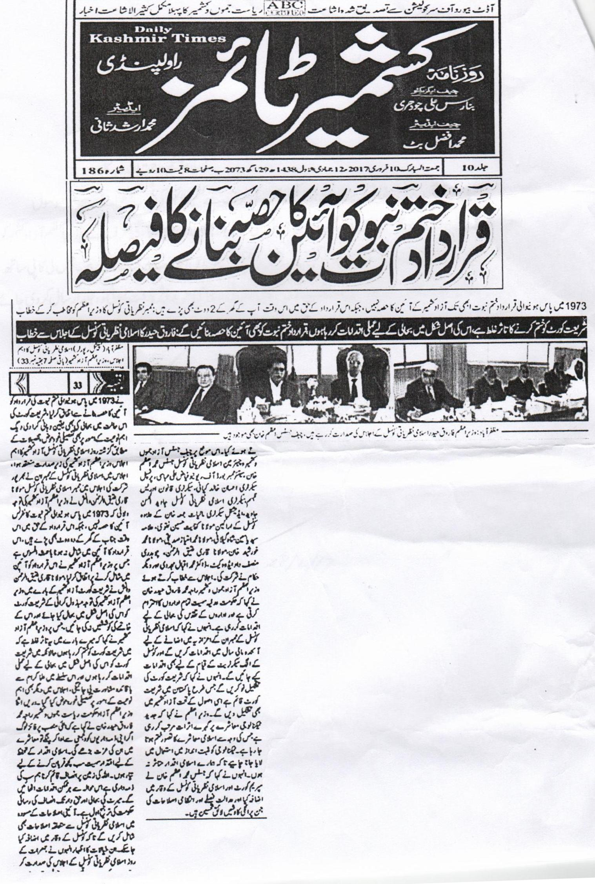It is decided to include Khatm e Nabuwat resolution in the constitution.
Resolution that was passed in 1973 is still not a part of the constitution of Azad Kashmir.
Impression that Shariat court has been dissolved is incorrect. I am planning to restore it in its actual form: Farroque Haider
Muzafarabad (Special reporter) Prime Minister of Azad Kashmir presided over the important meeting of Islamic Nazrayati Council. He said in his address that government gives respect to every institute along with judiciary. Government is making reforms to restore the pride of all the institutes. We will reestablish shariat court in Azad Kashmir on the similar pattern to Pakistan. Islamic symbols are greatly affected by the advancement of technology. We should use technology positively so that our Islamic symbols are not affected. He praised Justice Muhammad Azam Khan for making outstanding administrative reforms. Meeting was attended by many prominent figures. Member of Islamic Nazrayati Council, Qari Attiq drew the attention of Prime Minister towards 1973 Khatm e Nabuwat resolution that is still not the part of constitution. Attiq termed the move melancholic. Farroq Haider agreed to include the resolution in the constitution. Prime Minister said that if prominent officials perform their duties diligently, society will give them respect. He said that he is ready to sacrifice everything for the protection of Islamic symbols. It is the responsibility of everyone to establish peaceful society. (Kashmir Times 10th February, 2017)

