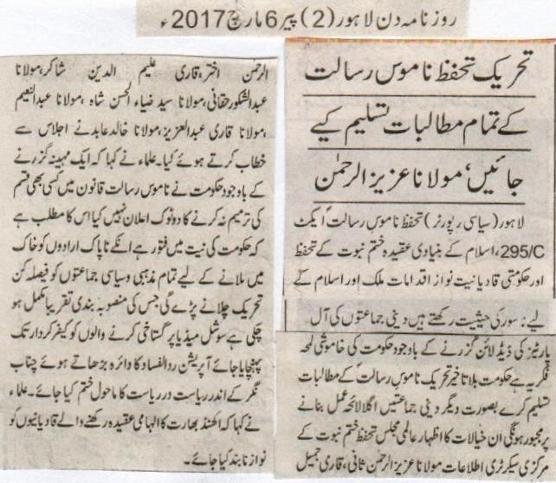

All demands of Tehrik Khatm e Nabuwat must be accepted immediately, Maulana Aziz ur Rehman.
Lahore (Political Reporter) Blasphemy act 295-C is the protector of the faith of Khatm e Nabuwat and the government`s biased policies for Qadianis are nothing but a curse for the country and Islam. Silence of the government after the deadline given by all religious parties is making the situation quite alarming. Government must accept our demands immediately otherwise religious parties would be forced to take the next step. Central Information secretary of worldwide Khatm e Nabuwat Maulana Aziz ur Rehman Sani, Qari Jameel Ur Rehman Akhtar,Qari Aleem Ud Din Sakir, Maulana Abdul Shakoor Haqani, Maulana Syed Zia ul Hassan Shah, Maulana Abdul Naeem, Maulana Qari Abdul Aziz, Maulana Khalid Abid address the meeting. They said that government has not yet declared their clear stance regarding the amendment which means government is biased. Social media Blasphemer must be held accountable. Condition of state within the state in Chenab Nagar must be abandoned by extending operation Rad ul Fasad. They said that the believers of reunion with India must not be blessed any more.
(Daily Din Lahore, Monday 6 March 2017)

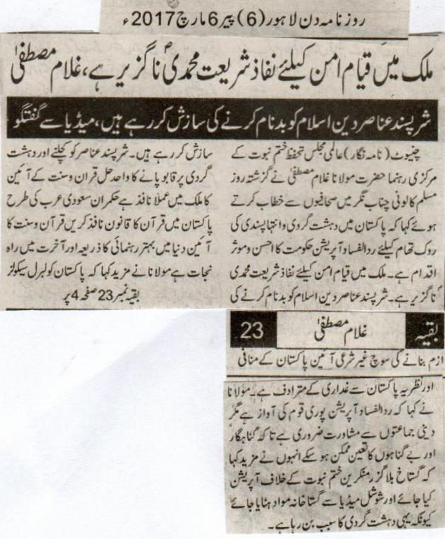

Implementation of Shariah Mohammadi PBUH is very important to bring peace in the country, Ghulam Mustafa.
Extremists are making conspiracies to defame Islam.
Chiniot( Reporter) Central leader of Worldwide Khatm e Nabuwat Maulana Ghulam Mustafa talked to media yesterday in Muslim Colony, Chenab Nagar that operation Rad ul Fasad is effective step to prevent terrorism and extremism. Extremists are making conspiracies to defame Islam. The only solution to crush the extremists and terrorists is the implementation of the constitution accordind to Quran and Sunna. Leaders must implement the laws of Quran just like Saudi Arabia. Quran o Sunna constitution is the best way of guidance in the world and way of protection on the justice. The idea of making Pakistan liberal and secular is to legitimate the constitution of Pakistan and betrayal to the ideology of Pakistan. He said that operation Rad ul Fasad is the voice of the whole nation. But the consultation with the religious parties is necessary so that the guilty and innocent are determined. He said that operation against the perky bloggers and unbelievers of khatm e Nabuwat must be done and the blasphemous material must be removed from the social media as it is the main cause of terrorism.
(Daily Din Lahore Monday 6 March 2017)

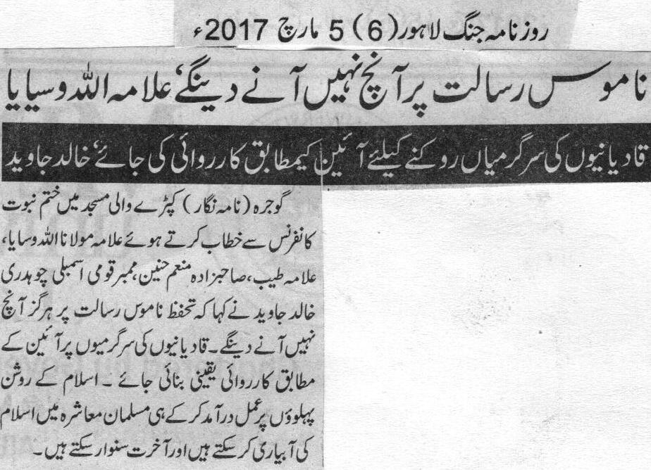

We will sacrifice to protect the honor of the Holy prophet (PBUH) Allama Allah Wasaya
Constitutional actions must be taken against Qadianis to stop their activities, Khalid Wasaya.
Gojra( Reporter) allama Maulana Allah Wasaya, Allama Tayyab, Sahibzada Monnim Hunain, MNA Ch Khalid Javed addressed Khatm e Nabuwat conference held in Kapray wali Masjid. They said in their addresses that we will sacrifice to protect the honor of the Holy prophet (PBUH.). Constitutional actions must be taken against Qadianis to stop their activities. Promotion of true Islam in a Muslim society is only done by following its shining examples.
(Daily Jang Lahore, 5 March 2017)

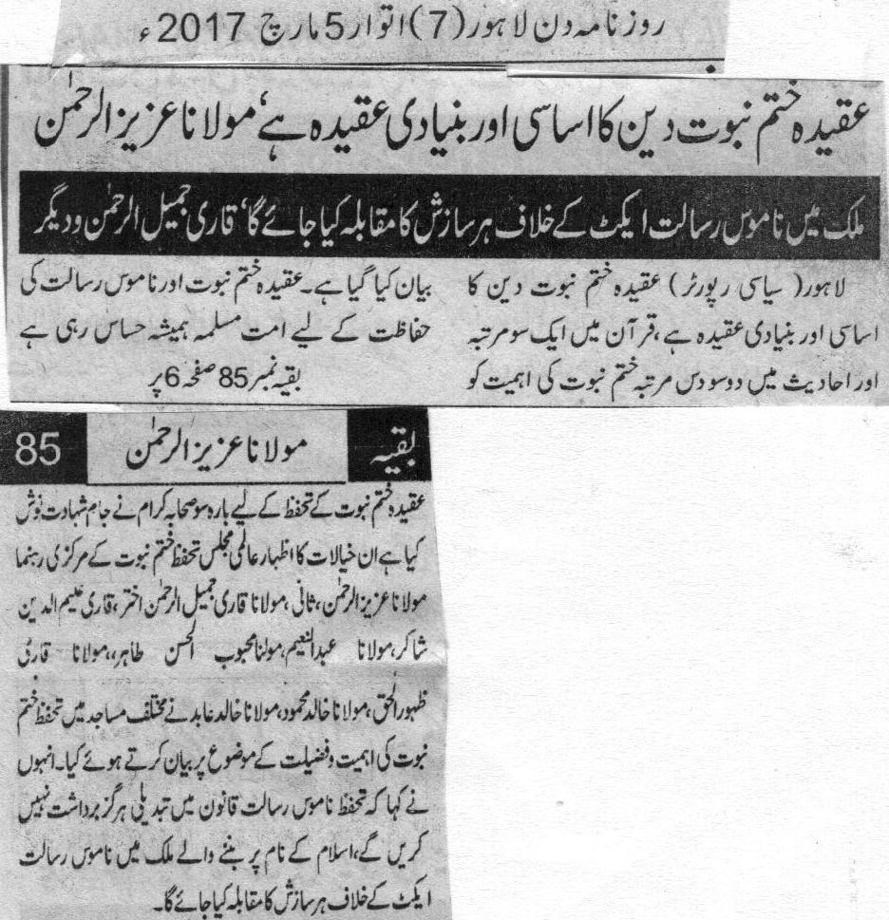
Faith on Khatm e Nabuwat is the base of our believes, Maulana Aziiz ur Rehman.
We will fight aginst every conspiracy held in the country for Blasphemy act, Qari Jameel ur Rehman and others.
Lahore (Political Reporter) the importance of Khatm e Nabuwat is explained in Quran more than hundred times and more than two hundred times in Hadees.Muslims have always been sensitive regarding this issue. Twelve hundred companions of Holy Prophet PBUH were martyred for the protection of Khatme Nabuwat. Central Leader of Khatm e Nabuwat Maulana Aziz ur Rehman, Maulana Qari Jamil ur Rehman Akhtar, Qari Aleem ud din Shakir, Maulana Abdul Aleem, Maulana Mehboob ul Hasan Tahir, Maulana qari Zahoor ul Haq, Maulana Khalid Mehmood, Maulana Khalid abidaddressed in various mosques to enlighten the significance of this topic. We will fight aginst every conspiracy held in the country for Blasphemy act.
(Daily Din Lahore, 5 March 2017)

