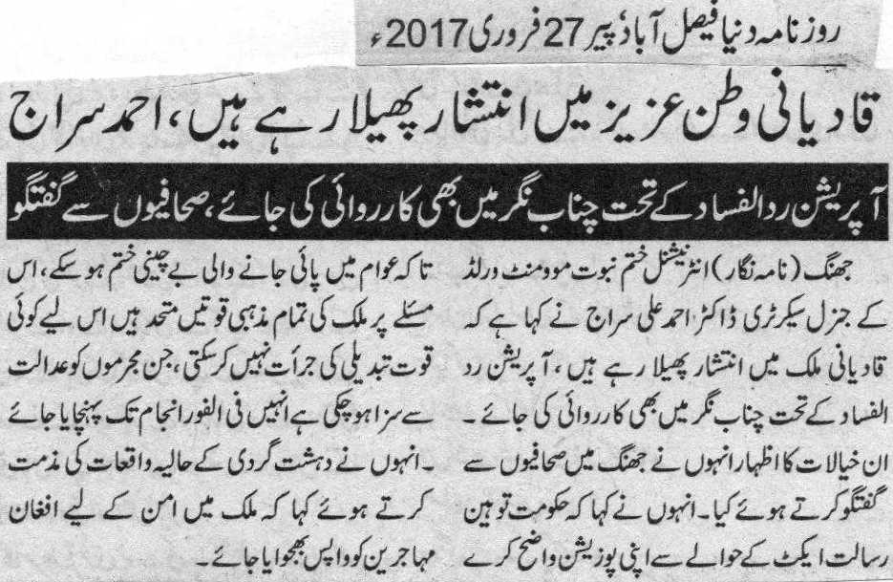

Qadianis creating disorder in the country: Ahmad Siraj
Operation Radul Fasad should also be imposed in Chenab Nagar: A statement to journalists.
Jhang (Correspondent): Doctor Ahmad Ali Siraj, General Secretary International Khatme Nabuwat, expressed that Qadianis are creating disorder in our beloved nation. Operation Radul Fasad should also be held in Chenab Nagar. He expressed his views whilst talking to journalists. He demanded the government to clear its stance on the Blasphemy Laws to remove discomfort among the people. All religious bodies are united in the aforementioned matter and do not intend to change its position. Government should carry out the sentences of those who have been convicted. He criticized the current terrorist attacks and requested government to send Afghan immigrants back to maintain peace.
Daily Dunya - Monday February 27, 2017
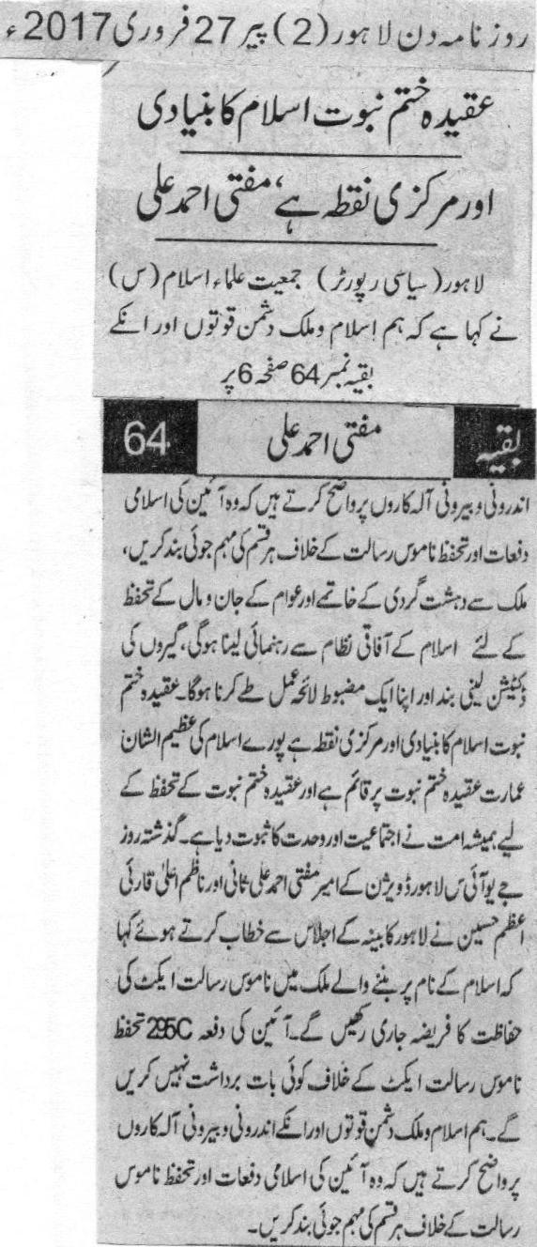
The faith of Khatm e Nabuwat is a center point of Islam: Mufti Ahmad Ali
Lahore (Political reporter) President of JUI (F), Lahore division, Mufti Ahmad Ali Sani and in charge,Qari Azam Hussain said in their addresses during the meeting of Lahore cabinet that we want to make it clear to the enemies of Islam to end all the campaigns against Islamic sections of the constitution. We will have to consul holy religion of Islam in order to end terrorism and ensure complete protection to the citizens of Pakistan. Entire building of Islam is based upon the faith of Khatm e Nabuwat. Muslim community has always shown unity on the faith. Sani and Azam urged to continue the duty of protecting the law of blasphemy in the country that was established on the name of Islam. They said that Muslims will not tolerate any statement made against the law. (Daily Din 27th February 2017)

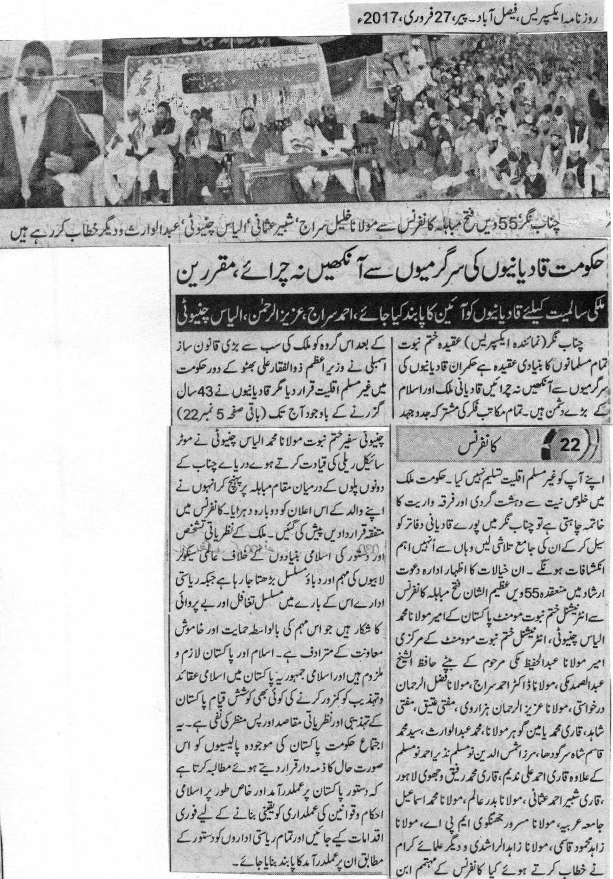
Government must not close its eyes and keep monitoring the activities of Qadianis: Participants
Qadianis must be made abide by the constitution for the integrity of Pakistan: ahmad Siraj, Aziz Ur Rehman and Ilyas Chinioti
Chenab Nagar (Express Correspondent) Leaders of Worldwide Khatm e Nabuwat Movement said in their addresses during 55th annual “victory of dialogue” conference that the faith of Khatm e Nabuwat is a primary faith of all Muslims. As a result of joint efforts of all schools of thoughts, national assembly of Pakistan declared Qadianis non Muslims during the tenure of Zulfiqar Ali Bhutto. But, Qadianis refuse to accept their constitutional identity till today. They urged government to initiate search operation in the offices of Qadianis in order to eliminate terrorism. Many resolutions were passed during the conference. Campaigns against the ideological identity of the country are kept on rising whereas state agencies are continuously ignoring these campaigns of secular lobbies. This ignorance is equivalent to indirect support to the campaign. Any effort of weakening Islamic culture is against the motives of the establishment of Pakistan. Participants ask government to ensure the implementation of Islamic system in the country and make all citizens abide by Islamic laws.
(Daily Express 27th February 2017)

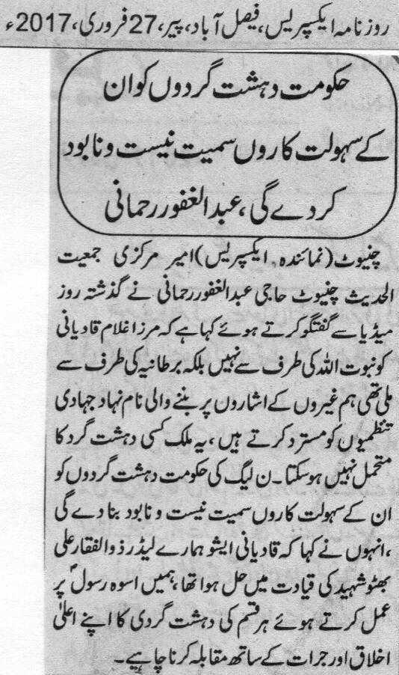
Government of PML (N) will destroy all terrorists along with their aides: Abdul Ghafoor Rehmani
Chiniot (Express Correspondent) President of Jamiat Ahle Hadees, Abdul Ghafoor Rehmani said in his interview to journalists that Mirza Ghulam Qadiani got prophecy from the Queen of Britain not from the God. We reject all criminal institutes that were founded as per the instructions of foreigners. Country cannot sustain terrorism anymore. Qadiani issue was resolved under the supervision of our leader, Zulfiqar Ali Bhutto. We should tackle terrorism boldly by following the teachings of Holy Prophet (PBUH). (Daily Express 27th February 2017)

