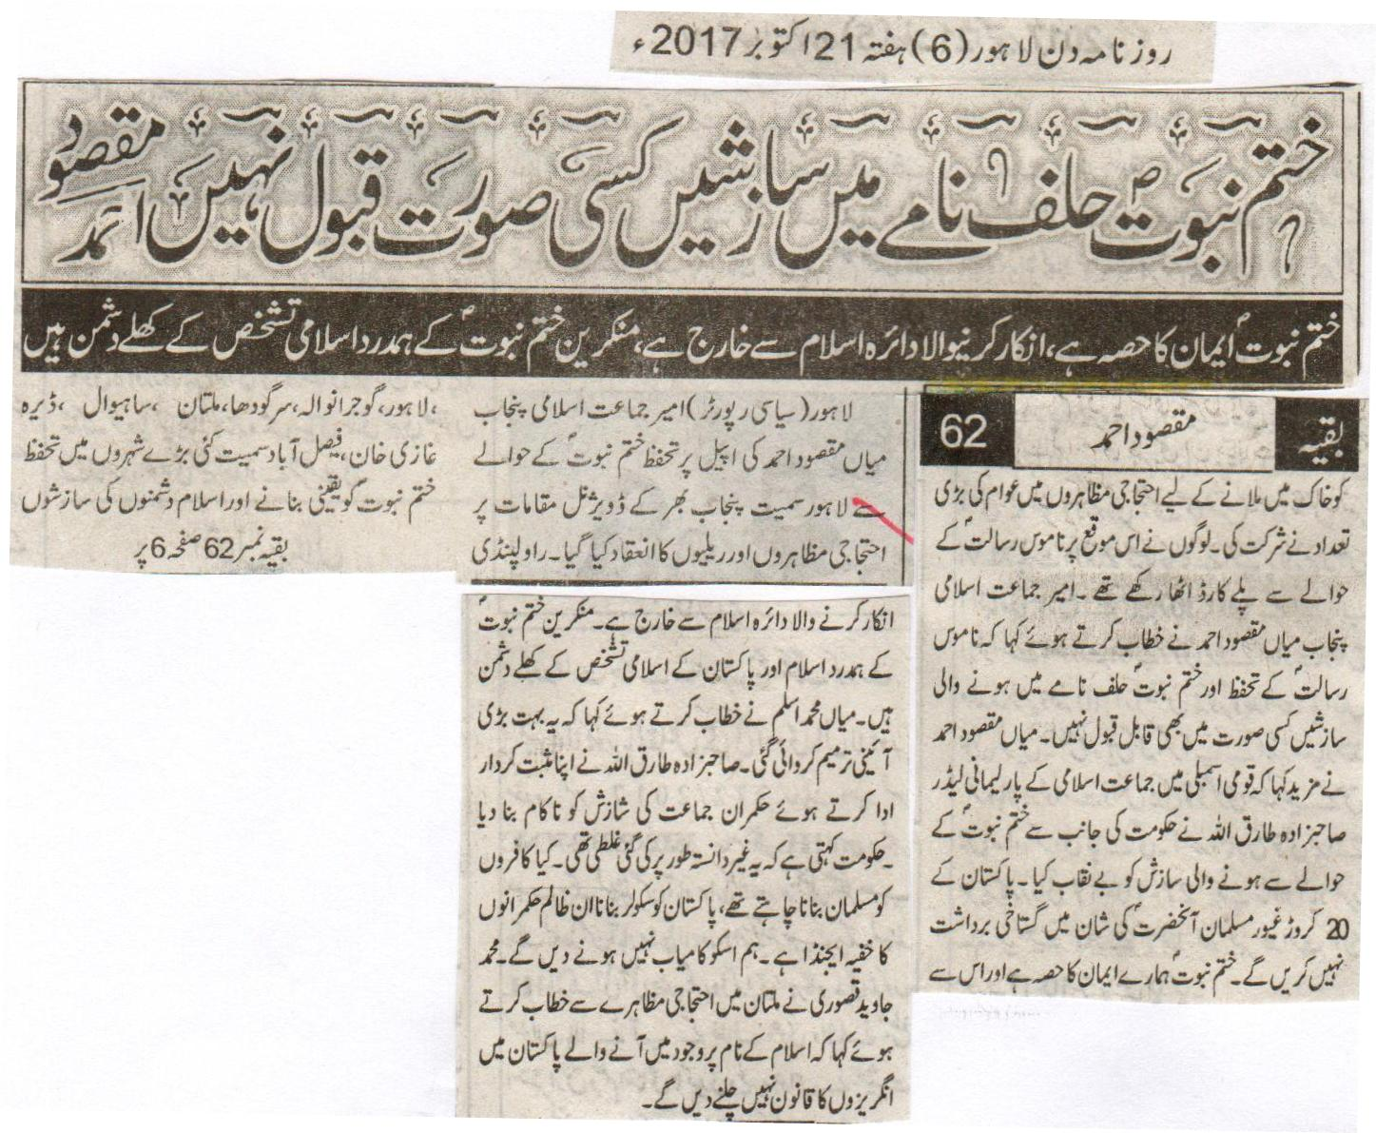
Any conspiracy in the Oath-Declaration of Khatm e Nabuat is unacceptable at all costs: Maqsood Ahmed.
Khatm e Nabuat is part of the faith, and the one denying it is excluded from the circle of Islam, those showing sympathy with the deniers of the Khatm e Nabuat are an open enemy to the Islamic identity.
Lahore (Official Reporter) on the request of the Ameer of Jamaat e Islami Punjab Miyan Maqsood Ahmed protests and rallies were held in divisional places all over Punjab including Lahore regarding the safeguard of khatm e Nabuat. Large number of people attended the protests for assuring the safeguard of Khatm e Nabuat and to fight the conspiracies of the anti-Islamic forces in many big cities including Lahore, Gujranwala, Sargodha, Multan, Sahiwal, Dera Ghazi Khan, and Faisalabad. People were seeing carrying playing cards on this occasion. Ameer Jamaat e Islami Punjab while delivering his address Miyan Maqsood Ahmed said that any change in the safeguard of the Blasphemy Law and the conspiracies of the Oath-Declaration of khatm e Nabuat is unacceptable at all costs. Miyan Maqsood Ahmed further stated that the Parliamentary leader of Jamaat e Islami Sahibzada Tariq Ullah revealed the conspiracy of the government regarding Khatm e Nabuat. There are 20 Million keen minded Muslims in Pakistan that cannot bear the insult for the personality of the Holy Prophet (P B U H). Khatm e Nabuat is part of our faith and the one denying it is excluded from the circle of Islam. The supporters of the deniers of Khatm e Nabuat are the open enemies of Islam and the Islamic identity of Pakistan. Miyan Muhammed Aslam while delivering his address said that a huge constitutional amendment has been made. Sahibzada Tariq Ullah while playing a positive role and made the conspiracy of the ruling government party unsuccessful. This was a mistake done non-deliberately. Do they want to make the infidels, Muslims; it is the secret agenda of these tyrant rulers to make Pakistan a secular state. We will not let it become successful. Muhammed Javaid Qusoori while addressing a protest in Multan said that won’t allow the law of the British to be applied in the country of Pakistan that came into existence in the name of Islam.
Daily Din, Lahore, Saturday, 21st October, 2017

The government should announce clear cut policy on Khatm e Nabuat, Ajmal Qadri
Lahore (Official Reporter) Central Ameer of the International Anjuman Khuddam Uddin and the leader of the JUI-C Maulana Muhammed Ajmal Qadri has made a demand to the sitting government that the Prime Minister should announce a clear cut policy of the government regarding Khatm e Nabuat, the Blasphemy Law and the Islamic clauses. They should make those forces that are making conspiracies and showing evil courage and making amendments in the belief of khatm e Nabuat a lesson, so that in future no one has the courage to touch the laws of khatm e Nabuat and the Blasphemy law. While addressing the International Khatm e Nabuat Conference yesterday he said that the Qadianis are illegally using the Islamic terminologies and the religious terms of the Muslims in their magazines and periodicals and by doing that they are going against the constitution of Pakistan.
Daily Din, Lahore, Saturday, 12th October, 2017

The statement of Rana Sana Ullah in the favor of the Qadianis is indeed condemnable, Makhdoom Arshad Qamar.
The belief of khatm e Nabuat is part of faith, the amendment in it is unacceptable, President Ulema Wing N-League.
Chiniot (Correspondent) President of the Muslim League Ulema elderly wing Punjab Makdoom Arshad Qamar while talking to the journalists yesterday said that we strongly condemn the attempt to finish the Oath-Declaration of khatm e Nabuat. The statement of the Interior law minister of Punjab Rana SanaUllah in the favor of Qadianis is indeed condemnable. We immediately demand the removal of the federal law Minister from his post. He further said that the belief of khatm e Nabuat is part of our faith and the amendment in it is unacceptable. The attempt made by the government to make amendment in it is indeed condemnable.
Daily Din, Lahore, Saturday, 21st October, 2017

Translation of the Saying of the Holy Prophet (P B UH) (HADITH): I am the final Prophet, there is no Prophet after me. (TRIMDHI).
The Finality of the Prophet Hood (KHATM E NABUAT)
Part of the faith of every Muslim.
A few days ago the Parliamentary committee consisting of all political parties jointly finalized the draft of Election bill 2017. Regarding the approval of that upon the demand of the restoration of the Khatm e Nabuat clause, the government and all the political parties restored the same mentioned clause in its original manner. Now the Khatm e Nabuat clause is restored in its original condition without any change.
The democratic government is full of energy regarding that they will not let anything happen to this basic belief of the Muslims. Khatm e Nabuat is part of our faith, so the public should be aware of those using this sensitive issue for the political purposes, and also those sources that are using this to ignite the feelings of the public. And they will make their evil desires go fail. This is also the demand of the Honor of the Prophet (P B U H).
Daily Nawa I Waqt, Saturday, 21st October, 2017

Highlights of the International Khatm e Nabuat Conference Chenab Nagar.
Chenab Nagar (Hafiz Muhammed Salman Usmani) Conference was cordoned off by the Police and the Intelligence authorities from all sides, also there were police officials present in civilians dress. As compared to last year the attendance in conference was greater in number. Mufti Shihab Uddin Popalzai delivered an address in Pashto language on the importance on the belief of khatm e Nabuat, which was liked by the audience. He also received a huge round of applause from the audience. During the conference the convocation ceremony of the Huffaz and the organizers of the Madrassa Khatm e Nabuat Muslim Colony also took place. The Friday prayers were lead and the Friday sermon was delivered by the Saint of Khanqah e Sirajia Sahibzada Khuaja Khalil Ahmed. On the other hand Maulana Ghulam Rusool Deen Puri led the Friday prayers and delivered the Friday sermon in the central khatm e Nabuat mosque. Renowned poets and Naat reciters presented several things of sanctity for the Holy Prophet (P B U H), upon which the attendees kept enjoying the thing, and were raisings slogans for the personality of the Holy Prophet (P B U H). The efforts of Bhutto (Late) in declaring Qadianis as non-Muslim minority, similarly the efforts regarding the implementation of the anti-Ahmadiya Ordinance Act the mentioning President Zia-ul-Haq late also happened.
Daily Ausaf, Lahore, Saturday, 21st October, 2017

All the departments of the faith were made available through the belief of khatm e Nabuat: Maulana Abu Ul Khair Muhammed Zubair
Chenab Nagar (Representative Ausaf) President of of Jamiat Ulema e Islam Pakistan Maulana Abu Ul Khair Muhammed Zubair while addressing a conference in Chenab Nagar said that the complete availability of different departments of faith were made available through the belief of khatm e Nabuat. Matters related to ethics, faith, practice, and the base of all the social matters is the belief of khatm e Nabuat. Without the belief of khatm e Nabuat no prayer can reach the point of acceptance with Allah. Qadianis are misleading the younger generation through change and amendment in the belief of khatm e Nabuat in a cunning manner. Mirza Qadiani used foul language against his opponents throughout his life.
Daily Ausaf, Lahore, Saturday, 21st October, 2017.

Talking about the economy
October 20, 2017

M. A. Niazi
Interior Minister Ahsan Iqbal and ISPR DG Maj Gen Asif Ghafoor introduced a bemused nation to a new concept of ‘proxy war.’ Both persons represented their respective chiefs in their quibbling over the state of the economy, which incidentally is one of the main selling points of Ahsan Iqbal’s erstwhile boss, Mian Nawaz Sharif. This coincides with an escalation of US interest in the region, with the release from captivity of a Canadian-American couple coinciding with US President Donald Trump upping the ante against Iran’s nuclear deal.
The spat over the economy represents an induction of Ahsan Iqbal into the PML(N)’s sniping against the military. Mian Nawaz had first of all been at the vanguard of this insinuation, regardless of the fact that he had appointed Gen Qamar Javed Bajwa COAS. It was thus of significance when his son-in-law, Capt (retd) Muhammad Safdar, made a speech criticizing Ahmedis for being in the Army, and for the renaming of the Quaid-e-Azam University’s physics center after Dr. Abdus Salam, the Nobel Physics laureate, and an Ahmadi. It was of significance not just because Ahmadis were being targeted, but also because General Bajwa’s opponents and detractors have made hints about his belonging to this community.
There are some reasons why this rumour may have gained traction. First, some Jats were converted. As the COAS’s surname says, he makes no secret, instead takes pride in, being a Jat. However, though many Jats, including Bajwas, converted (including from Hinduism and Sikhism), not all Jats are Ahmedi. Also, there was an era, dating back to the Raj, when some Ahmedis sought careers in the armed forces. First, they were encouraged by the British, as they thought that the anti-jihad edicts of Mirza Ghulam Ahmed inoculated them against any such venture as the 1857 Mutiny, which was deemed a jihad by many Muslim mutineers. This trend was ended by the declaration of the community as non-Muslim in 1974, and of the Ahmadis in service then, none would still be in service. Some Ahmadi officials, both civil and military, converted at that time to Islam. All told, Captain Safdar’s may well be the last hurrah of the rousing of anti-Ahmadi sentiment in the armed forces.
Ahsan Iqbal’s tigerish defense of the economy was not directly a rebuttal of General Bajwa’s remarks to a seminar in Karachi, but the DG ISPR’s. His remarks on the economy provided an easier target, but one which was more dangerous. It was one thing for the COAS to speak about the economy; it was another for a two-star general to do the same. Though General Ghafoor has defended himself strongly, his example would discourage officers from speaking about the economy. The Prime Minister’s sanction is not an encouragement, but a way of putting the lid on this latest example of civil-military friction.
The military’s increasingly public attention to the economy is an indication that it is increasingly worried about the way the relationship with the USA is going. The armed forces claimed the recovery of the Boyle family as a military success. Significantly, the recovery was made from the Haqqani Network, which had been mentioned by the USA precisely as one of the groups which Pakistani intelligence was supporting. The Boyles’ release might have assuaged US feelings to the extent that President Donald Trump said it showed that Pakistan no longer ‘disrespected’ the USA.
Ahsan Iqbal may feel strongly about the economy as it is Mian Nawaz’s favourite talking point. But also because he is likely to have an increased responsibility for it, as evidenced by him making a statement on returning from the USA, where he had gone to attend the World Bank’s annual meeting in place of the indicted Finance Minister Ishaq Dar. Ahsan Iqbal, who was Planning Minister before his current assignment was added, also took a lead role in the China-Pakistan Economic Corridor, another area where the armed forces have committed themselves. The armed forces see the relationship with China, and thus the CPEC, as the main alternative to the one with the USA.
The USA is increasingly tilting towards India, the latest example being Defence Secretary Jim Mattis’ comments about CPEC running through ‘disputed territory.’ Not only does this come from the Pentagon, which the armed forces had always thought was on their side as opposed to the pro-Indian State Department, but it targets push-button emotive issues, Kashmir and China.
It should be noted that the armed forces might subscribe, as General Bajwa said, to the view that the economy and security go hand in hand. However, they have not taken the position of many civilian economists, that military expenditure is too much for the economy to sustain. The size of the economy may well determine the size of the armed forces it can sustain, as well as the equipment they employ. However, the decision of how much security the economy needs is not related to the size or performance of that economy.
It is perhaps paradoxical that Ahsan Iqbal has plunged into this debate, for he not only started his politics in the Islami Jamiat Tulaba, the Jamaat Islami’s student wing, which is almost reflexively pro-Army, but his late mother, Apa Nisar Fatima, served in the 1985-88 National Assembly, and was a Ziaul Haq supporter. For him to take a stance even faintly critical of the military should be counter-intuitive. At the same time, it should be kept in mind that there are increasingly louder noises of the economy in trouble; mainly difficulties with foreign exchange. It must be worrying for the armed forces that the access that Pakistan needs to the international financial institutions is tightening because the USA controls those institutions, and is currently not pleased with Pakistan.
Pakistan’s establishment would like to help the USA, but for its veering towards India. This brings up the fundamental question of what would happen if the other superpower Pakistan wants to help it, China, was to end up supporting India. That might seem a remote possibility, as remote as the USA’s backing of India once did. At that point, the broad interest of the armed forces in the economy would not enable the country to have the security it needs.
It should be noted that the military has taken over four times in the past, and has not delivered a remarkably improved economy. The COAS mentioned the Ayub era, but not the Yahya era, when half the country seceded. The interplay of the economy under Ayub and the secession under Yahya need to be studied to achieve a correct understanding of the relationship between the economy and security. The Zia and Musharraf eras saw the regime repeat the Ayub experience of giving the bureaucracy its head, with diminishing returns. A paradigm shift is needed, and neither civilian nor military rule seems likely to provide it with.
It was one thing for the COAS to speak about the economy; it was another for a two-star general to do the same. Though General Ghafoor has defended himself strongly, his example would discourage officers from speaking about the economy.
http://nation.com.pk/columns/20-Oct-2017/talking-about-the-economy

