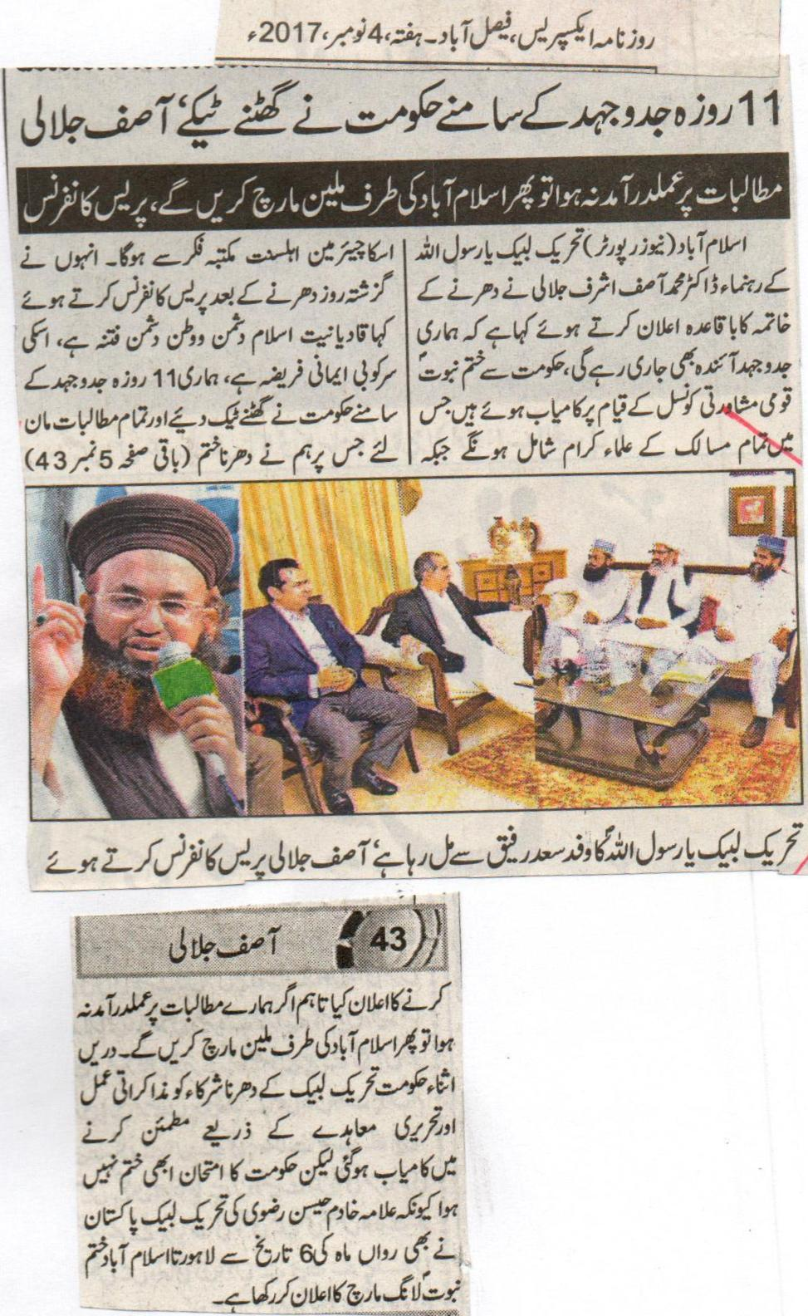
After 11 days of struggle the government has finally surrendered, Asif Jalali.
If the demands are not met then we will do a million march towards Islamabad, Press Conference.
Islamabad (News Reporter) Leader of Tehreek e Labbaik Ya Rasool Ullah Dr. Muhammed Asif Jalali while officially announcing the ending of the sit-in that our struggle will continue in the future too. We have succeeded in the formation of Khatm e Nabuat National opinion council, in which the scholars of all the sects are included, whereas the chairman of that will be from Ahl e Sunnat sect. While addressing a press conference yesterday after the end of the sit-in said that the evil of Qadianiat is anti-Islamic and anti-Pakistani, and its stoppage is a responsibly of our faith. The government has surrendered in front of our 11 days struggle and have accepted all the demands, upon which we announced the ending of the sit-in. if our demands are not acted upon, than we will do a million march towards Islamabad. Furthermore, the government has succeeded in convincing the participants of the sit-in of Tehreek e Labbaik Ya Rasool Ullah through the discussion process and written agreement, but the trial of the government is not finished yet, because Allama Kadim Hussain Rizvi of Tehreek e Labbaik Ya Rasool Ullah has also announced a Khatm e Nabuat long March from Lahore to Islamabad on 6th of this month.
Daily Express, Faisalabad, Saturday, 4th November, 2017
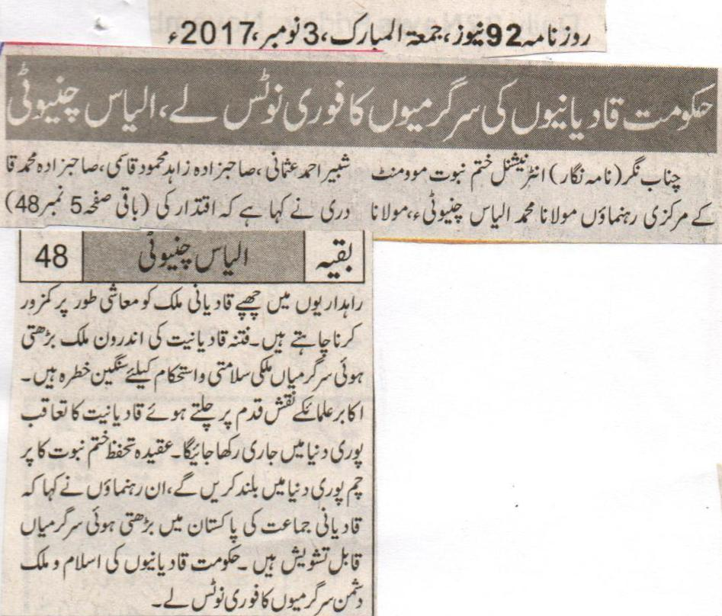
The government should take immediate notice of the activities of the Qadianis, Ilyas Chinioti.
Chenab Nagar (Correspondent) Central leaders of International Khatm e Nabuat Movement Pakistan Maulana Muhammed Ilyas Chinioti, Maulana Shabbir Ahmed Usmani, Sahibzada Zahid Mehmood Qasmi, Sahibzada Muhammed Qadri said that the Qadianis hiding in the covering of the power want to weaken the country financially. The increasing domestic evil activities of Qadianis are a severe concern for the security and stabilization of the country. While following the footsteps of our forefathers we will continue to persuade the Qadianis throughout the world. We will raise the flag of the belief of khatm e Nabuat throughout the world. These leaders also said that the ever increasing activities of the Qadiani community in Pakistan are a source of concern. The government should take immediate notice of the anti-Pakistan and Islam activities of the Qadianis.
Daily 92 news, Friday, 3rd November, 2017.

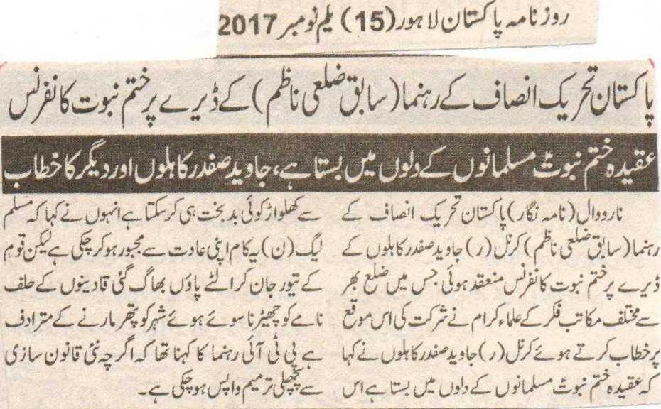
Khatm e Nabuat Conference at the farmhouse of leader of Pakistan Tehreek e Insaf (Former District Nazim)
The Belief of Khatm e Nabuat rests within the hearts of the Muslims, The address of Javaid Safdar Kahloon.
Narowal (Correspondent) Khatm e Nabuat conference was held on the farmhouse of (former District Nazim) of Pakistan Tehreek e Insaf Colonel (Retrtd) Javaid Safdar Kahloon. In this conference clerics of different sects took part. While speaking on this occasion Colonel (RETRD) Javaid Safdar Kahloon said that the belief of khatm e Nabuat rests in the heart of the Muslims, and only an accursed can do any change in it. He said that Muslim League (N) has done this being forced through their hobby, but when the nation became of this they ran away. Any activity regarding the Qadiani Oath-declaration is similar to slapping a sleeping lion. The PTI leader said that through new law, the previous amendment has been taken back.
Daily Pakistan, Lahore, 1st November, 2017.
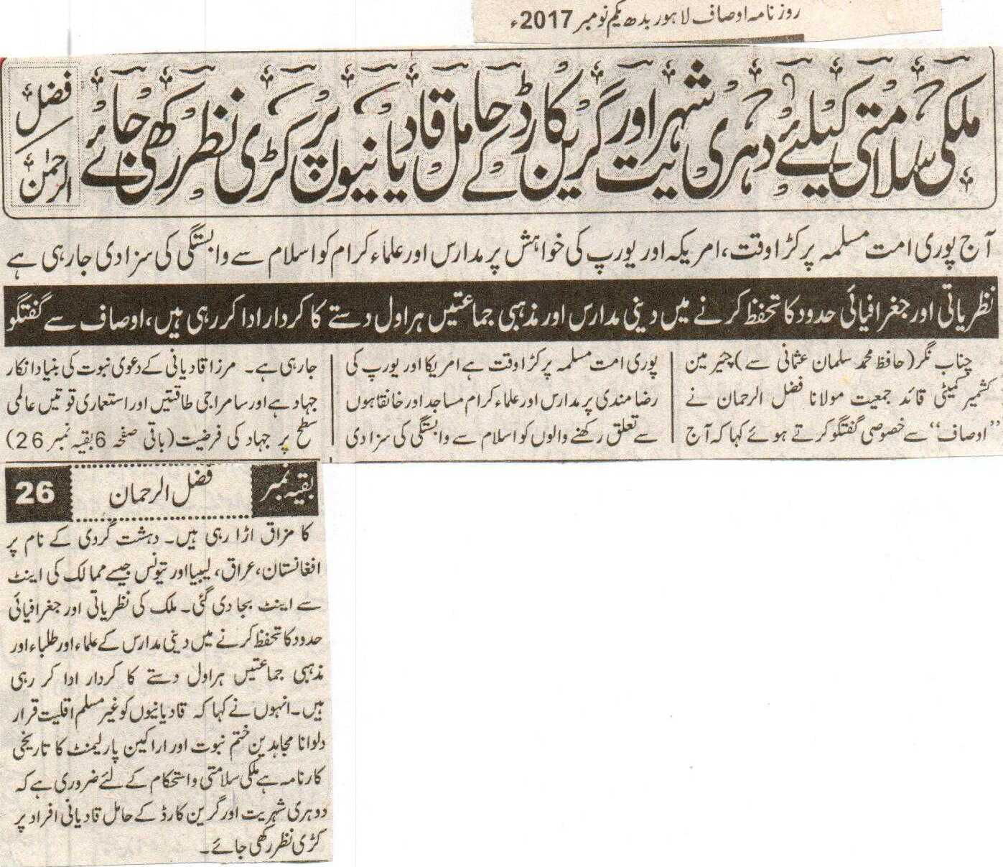
An eye should be kept on the Qadianis, the holders of Green Card and Dual Nationality a danger for the security of the country: Fazal Ur Rehman
Today whole Muslim Ummah is passing through a tough time; The Ulemas are being punished for their association with Islam on the will of America and Europe.
The religious institutes and the religious parties are playing a role at the fore-front while safeguarding the ideological and the geographical boundaries.
Chenab Nagar (From Hafiz Muhammed Salman Usmani) while speaking to “Ausaf” Chairman Kashmir Committee Head of Jamiat Maulana Fazal Ur Rehman said that the Muslim Ummah is going through a tough time. On the goodwill of America and Europe the ones having association with Madrassas, religious scholars, mosques and shrines are being punished because of association with Islam. The base of the claim of nabuat of Mirza Qadiani is the denial of Jihad, and the imperialist and the satanic forces are mocking Jihad on the international level. Countries like Afghanistan, Iraq, Libya and Tunisia have been completely destroyed. The religious institutes and the religious parties are playing a role at the fore-front while safeguarding the ideological and the geographical boundaries. He further said that the declaration of Qadianis as non-Muslims is a historical achievement of the warriors of Khatm e Nabuat. An eye should be kept on the Qadianis, the holders of Green Card and Dual Nationality a danger for the security of the country.
Daily Ausaf, Lahore, Wednesday, 1st November, 2017

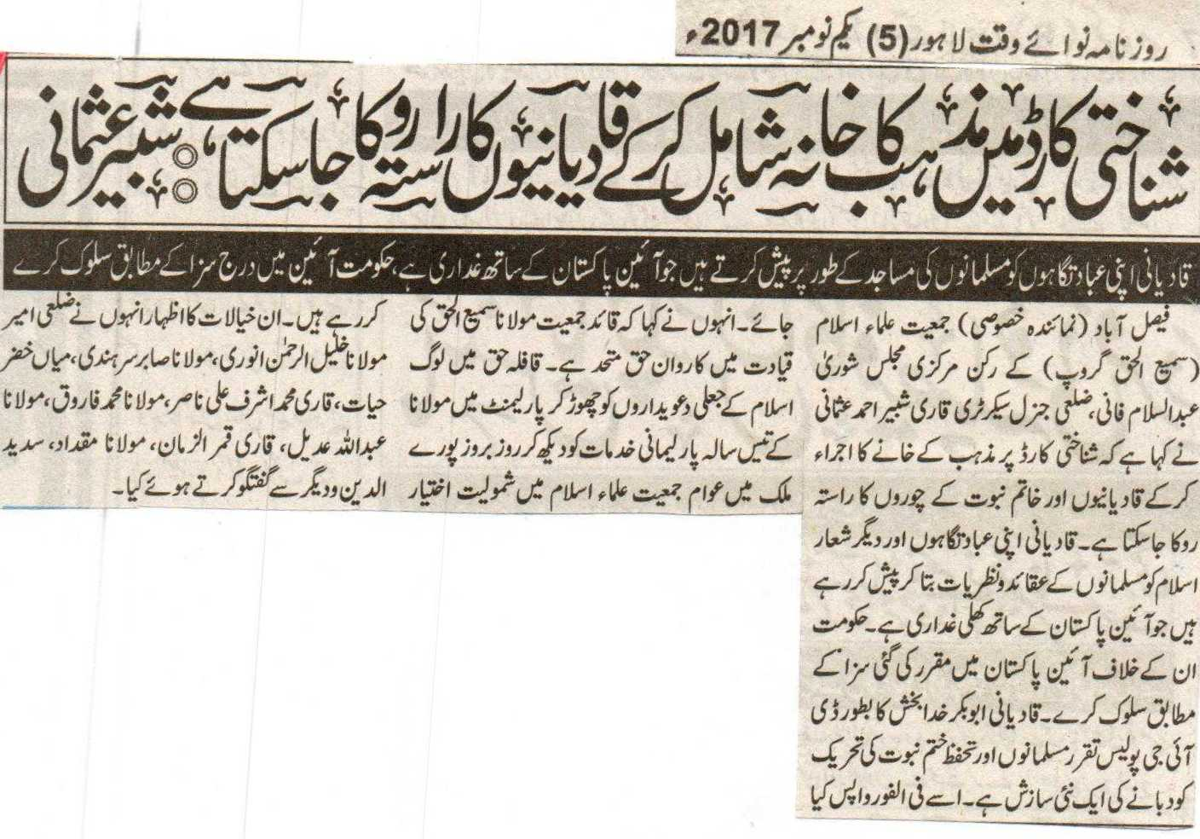

'Qadianis can be stopped with the addition of the religion column in the Identity Card' Shabbir Usmani
Qadianis present their place of worships as mosques, which is a trait with the constitution of Pakistan, the government should act according to the punishment in the constitution.
Faisalabad (Special Reporter) Member Central Opinion Council of Jamiat Ulema E Islam (Sami Ul Haq Group) Abdul Salam Fani, district General Secretary Qari Shabbir Ahmed Usmani said that the way of the Qadianis and the burglars of khatm e Nabuat can be stopped by adding the religion column in the identity card. Qadianis are presenting their place of worships and other Islamic terminologies as the beliefs and ideologies of the Muslims, which is a clear trait with the constitution of Pakistan. The government should act with them according to the punishment set in the constitution. The appointment of Abu Bakar Khuda Baksh as DIG police, and the stoppage of the Safeguard Khatm e Nabuat Movement is a new conspiracy. It should be taken back at once. He further said that the caravan is united under the leadership of the Jamiat Leader Maulana Sami Ul Haq. In this caravan people are leaving behind the false claimers of Islam, and by acknowledging the 30 years services of Maulana in the Parliament are becoming part of Jamiat Ulema e Islam day by day throughout the country. He expressed these thoughts while talking to district Ameer Maulana Khalil Ur Rehman Anwari, Maulana Sabir Sarhandi, Miyan Khizar Hayat, Qari Muhammed Ashraf Ali Nasir, Maulana Muhammed Farooq, Maulana Abdullah Adeel, Qari Qamar Ul Zaman, Maulana Miqdad, Sadeed Uddin and others.
Daily Nawa I Waqt, Lahore, 1st November, 2017.

